**System on chip**

**Individual logbook**

**6046CEM**

Word Count: 5400

Contents

**Lab 1- Vivado design flow** 8

**Introduction** 8

**Objectives** 8

**Results** 8

**Conclusion** 17

**Lab 2** 17

**Introduction** 17

**Objectives and aims.** 17

**Results** 17

**Conclusions** 26

**Lab 3** 26

**Introduction** 26

**Objectives and aim** 26

**Results** 26

**Conclusion** 30

**Lab 4** 30

**Introduction** 30

**Objectives and aims.** 30

**Results** 30

**Conclusions** 36

**Lab 5** 37

**Introduction** 37

**Objectives and aims.** 37

**Results** 37

**Conclusion** 43

**References** 43

List of figures

Figure 1: Adding the board. 9

Figure 2: The testbench shows simulation step size and resolution. instantiates the DUT. The testbench is stating the module functionality for the value, stimuli generation as well as comparing expected output with the DUT. 10

Figure 3: Showing top-level signals. waveform window. Simulating functionality of design. 10

Figure 4: Adding swt [7:0] and led [7:0]. Running the simulation for an additional 500 ns, Zoomfit to observe the output. 11

Figure 5: Synthesis design, synthesis will run in lab1.v and its hierarchal files.-visual representation. 11

Figure 6: Project summary. 12

Figure 7: Synthesized design schematic. 12

Figure 8: Net OBUF [0] selected, net displayed in x1y1 clock region in the device view tab. 13

Figure 9: Project summary for implementation. 13

Figure 10: Project summary for implementation utilization, presenting the resources of the design. 14

Figure 11: The utilization report path. 14

Figure 12: Figure 12: Zoom Fit button selected to see the waveform window from 0 to 200 ns. 15

Figure 13: Adding markers where the led changes. 15

Figure 14: Hardware manager unconnected status. 16

Figure 15: Hardware Session changes from unconnected to server name and the device is highlighted. 16

Figure 16: Verifying functionality of the FPGA board. 17

Figure 17: Tcl shell window, script creates block design called system, adds ZYNQ PS with one GPIO channel 49 and one EMIO channel. Creates a top-level wrapper file called system_wrapper.v. which adds system.bd. 18

Figure 18: Ps7_create.tcl. 18

Figure 19: Source files hierarchy. 19

Figure 20: CLOCK_RATE parameter changed to match the on-board clock rate of 125 Mhz. 19

Figure 21: U0 and uart_rx_io instance hierarchy, the meta_harden modules are used to synchronize the asynchronous reset and pushbutton inputs. 19

Figure 22: Timing constraint, has an on-board clock of 125 Mhz so Line 4 creates the period constraint of 8 ns with duty cycle of 50%. 20

Figure 23: Schematic, one-level down from the top in component U0. 20

Figure 24: uart_rx_io underlying components. 20

Figure 25: ssn_1 report. Details highlighted in red, as pin assignments aren’t done. Noise analysis is completed on the output pins. 21

Figure 26: Report noise, no more errors. 21

Figure 27: Project summary, table tab. 21

Figure 28: Schematics view, IBUF and OBUF automatically added as the input and output are buffered. 22

Figure 29: U0 instances, schematic view. 22

Figure 30: Uart_rx_i0 instances, schematic view. 22

Figure 31: Uart_baud_gen_rx_i0 instance, CLOCK_RATE and BAUD_RATE parameters passed to module being called. 23

Figure 32: Meta_harden_rxd_io instance, synchronization circuit being implemented. 23

Figure 33: Timing report, Design Timing Summary, and Inter-Clock Paths entry, indicating timing violations. 24

Figure 34: Worst failing path 25. 24

Figure 35: Report utilization summary. 24

Figure 36: Utilization by lower-level modules, complete hierarchy. 25

Figure 37: Estimated power consumption, no simulation run data. 25

Figure 38: Writing checkpoint. 25

Figure 39: Changing project settings. 26

Figure 40: Flatten design schematic view. 26

Figure 41: Timing report. 27

Figure 42: Output data path schematic. 27

Figure 43: Full schematic of U0. 27

Figure 44: Updated timing Constraints showing. 28

Figure 45: Design timing summary, Setup timing violations removed. 28

Figure 46: Path timing composition. Not including entire clock period. 28

Figure 47: Utilization, slice LUTs. 28

Figure 48: Timing summary report, timing violations. 29

Figure 49: Editing timing constraint, set output delay entry. 29

Figure 50: Clock nets, spread across multiple clock regions. 29

Figure 51: COM setting. 30

Figure 52: B. 30

Figure 53: BTNU, B. 31

Figure 54: Summary page- clock core being generated. 32

Figure 55: Updated clocking option, clocking wizard. 32

Figure 56: Updates output clocks, clocking wizard. 33

Figure 57: Summary page, clock core being generated. 33

Figure 58: clk_gen.v file, changed instance name and net names 33

Figure 59: Design source hierarchy, clk_core.xci. 33

Figure 60: clock resource utilisation, -design using clock resources. 33

Figure 61: Terminal display window. 34

Figure 62: Fifo generator instantiated in design canvas. 34

Figure 63: Configuring BRAM for separate read and write clocks. 35

Figure 64: Configuring port width and read mode. 35

Figure 65: Summary tab of selected options and listing resources for configuration. 35

Figure 66: FIFO generator renamed ports. 36

Figure 67: Validation successful. 36

Figure 68: various IP output products displayed in the IP Sources tab. 36

Figure 69: Wave_gen.v, instantiating char_fifo into the project. 36

Figure 70: Resource utilization report, only one FIFO being used. 37

Figure 71: Verifying on hardware, character R. 37

Figure 72: Launch on hardware. 37

Figure 73: Device view window and package pins tab. 38

Figure 74: Find form, Package Pins, typed *P16 in match criteria and name rst_pin. 39

Figure 75: Creating I/O Port for clk_pin input. Changing the name field, I/O standard. 39

Figure 76: Pin entries shown in the Package Pins tab select clk_pin same for btn_pin. 39

Figure 77: Assigning pin locations. 39

Figure 78: Create I/O ports form, led_pin will be displayed in the I/O tab. 39

Figure 79: Save constraints form as uart_led_. 40

Figure 80: uart_led_.xdc file is created and added to the Sources tab. 40

Figure 81: the design rules checker. 40

Figure 82: Report DRC, from the flow navigator pane under I/O planning. Ignore the warnings. 40

Figure 83: Report noise output, analysis is done on the output pins only (led_pins). 40

Figure 84: Migrating to RTL, changing top RTL file. 40

Figure 85: Uart_top.v file, module name with the ports listing. 41

Figure 86: Changing uart_top.v file. 41

Figure 87: Adding source files. 41

Figure 88: Changing the lab directory and generating the PS design. 41

Figure 89: Uart_led entry, changing clock_rate, on-board clock of 125 Mhz. 41

Figure 90: Timing wizard missing constraints. 42

Figure 91: Output delays, of -2ns for timing closure. 42

Figure 92: Input delays for btn_pin and rst_pin- tco min is -0.5. 42

Figure 93: Uart_led_.xdc, additional constraints added. 43

Figure 94: Tcl console constraints. 43

Figure 95: No more failing paths. 43

Figure 96: Right click on uart_led_zynq. 44

Figure 97: LED character ‘p’. 44

Figure 98: Defined parameters for baud_rate and clock_rate for uart_led.v. 45

Figure 99: Changing the probe1 port width to 8. 45

Figure 100: Changing the component pane and probe.no. 45

Figure 101: Generated output products for ila_led. 46

Figure 102: Ila core added to the source. 46

Figure 103: Adding the copied lines to uart_top.v. 46

Figure 104: ILA Core instance in the design hierarchy. 46

Figure 105: Mark debug on the rx_data bus. 47

Figure 106: Uart_led_timing_.xdc as the target file for new unsaved constraints. 47

Figure 107: Debug net groups both assigned and unassigned. 47

Figure 108: Clk_pin_IBUF_BUFG, the clock net used for the debug nets. 48

Figure 109: Debug nets are appended to the bottom of the uart_led_pins_.xdc file. 48

Figure 110: Waveform window, verifying 55 after the trigger. 48

Figure 111: Project summary for lab 7. 49

Figure 112: Adding the ZYNQ processing system. 49

Figure 113: Run block automation window- default settings. 50

Figure 114: Deselecting the I/O peripherals. Selecting only one uart. 50

Figure 115: Imported peripherals settings, selected peripherals with a tick. 50

Figure 116: Deselecting M AXI GP0 interfaces. 50

Figure 117: Deselecting FCLK_CLK0. 50

Figure 118: Updated zynq block diagram. 51

Figure 119: VHDL file is set as top module. 51

Figure 120: SDK C/C++ system.hdf file. 52

Figure 121: Naming project, new application run on ps7_cortexa9_0 i.e. core 0 of the two available processor cores. 52

Figure 122: Content inside memorytest.c. This project verifies functionality. 53

Figure 123: Opening the terminal window. 53

Figure 124: SDK terminal output. 54

Figure 125: Renaming lab 7 and creating new directory -Creating new directory. 55

Figure 126: Configuring 32b Master GP Block, enabling FCLK_RESET0_N port. 55

Figure 127: Configuring 32b Master GP Block, enabling AXI GP0 port. 55

Figure 128: Configuring 32b Master GP Block, enabling FCLK_CLK0 port. 56

Figure 129: M_AXI_GPO interface, and M_AXI_GPO_ACLK, FCLK_CLK0, and FCLK_RESET0_N ports on the updated zynq block. 56

Figure 130: Configuring GPIO instance. 56

Figure 131: Configuring GPIO instance. 56

Figure 132: Running automation connect- Connect slave and master interfaces. 57

Figure 133: Design, switches are automatically connected. 57

Figure 134: Adding the master port to AXI Interconnect 57

Figure 135: System Assembly View after manually connecting ports adding the Peripherals. 58

Figure 136: Both peripherals are assigned in the address range. 58

Figure 137: Make GPIO external port, named gpio. 58

Figure 138: Changing Buttons GPIO interface. 59

Figure 139: Validating the design. 59

Figure 140: Constraints for IP port pins. 59

Figure 141: Board support package name, hardware platform. 60

Figure 142: New application project TestApp. 60

Figure 143: Output on the terminal. 61

Figure 144: New IP location form. 61

Figure 145: Updating the peripheral details. 62

Figure 146: Peripheral summary and next step. 62

Figure 147: led_ip_v1_0.v file, adding users parameter, and port definition. 63

Figure 148: led_ip_v1_0.v file, adding port connection with a lower-level module. 63

Figure 149: led_ip_v1_0_S_AXI.v,I instantiating lower-level user module. 63

Figure 150: led_ip_v1_0_S_AXI.v, declaring users port in the lower-level module. 63

Figure 151: Synthesis complete no errors. 64

Figure 152: Package IP tab. 64

Figure 153: Choosing IP category, basic elements for this lab. 64

Figure 154: File group after Merge changes from File Groups Wizard, expanded Verilog synthesis. 65

Figure 155: Families available to choose the compatibility. 65

Figure 156: Customized parameters after Merge changes. 65

Figure 157: User customisation parameters. 66

Figure 158: Finished packaging, closing Vivado and the original Vivado window. 66

Figure 159: Specifying repository IP. 66

Figure 160: Configuring the LED IP LED_WIDTH. 67

Figure 161: Adding created IP led_ip_v1_0 by selecting ‘add ip’ above the block diagram. 67

Figure 162: Led_ip, led made external port. 67

Figure 163: Verifying that an address has been added to led-IP. 67

Figure 164: Customizing block by changing the interface. 68

Figure 165: Adding BRAM IP. 68

Figure 166: Run connection automation, selecting axi_bram_ctrl_0/BRAM_PORTA. 68

Figure 167: Complete block diagram. 69

Figure 168: Updated address editor. 69

Figure 169: Updated constraints file. 69

Figure 170: Exporting the hardware. 70

Figure 171: Adding lab10.c file, including some errors. 70

Figure 172: Lab10.c content-populate the outline tab. 71

Figure 173: Containing address map for peripherals. 71

Figure 174: Available function calls for the GPIO. 71

Figure 175: Updated c code. 72

Figure 176: Assigning led_ip driver. 72

Figure 177: Led_ip.c, includes the header file for the IP. 72

Figure 178: Header file led-ip.h, including the macros. 72

Figure 179: Completed c file. 73

Figure 180: Sections of the program, including the starting address and size of each section. 73

Figure 181: Launching on hardware. 74

Figure 182: Programming the FPGA. 74

Figure 183 Flipping the 4th switch. 74

Figure 184: Flipping the 2nd switch. 74

Figure 185: Flipping the 3rd switch. 74

Figure 186: Changing the code and data section leaving the place heap and stack the same. 75

Figure 187: Flipping the 2nd switch and multiple switches then 4th switch- slower output. 75

Figure 188: Heap and stack section target BRAM, rest target DDR. 75

# **Lab 1- Vivado design flow**

## **Introduction**

In Lab 1 is an introduction to Vivado IDE to create a simple HDL design for the Zybo board. This lab is to guide how to synthesize, implement and simulate the design. In addition to this, this lab will also generate the bitstream allowing to verify the hardware functionality. The procedure for this lab is crucial as this will help understand the main purpose of synthesizing, implementing, and simulating. The process is as follows; creating a Vivado project, simulating the design using XSIM simulator, synthesizing the design, implementing the design, performing the timing simulation, generating bitstream finally verifying the functionality of the design created in this lab using the Zybo Z7-10 board.

## **Objectives**

Objectives for this lab is to create a Vivado project using the Zybo board, using the provided Xilinx design constraint file to constrain the pin location, simulate the design using the Vivado simulator and synthesize and implement the design. Finally configure the design by generating a bitstream and verify the functionality.

## **Results**

Step 1- Create a Vivado project.

A new RTL project named lab 1 is created, design simulation file, constraints file and testbench file are added. Figure 1 illustrates Zybo the board.

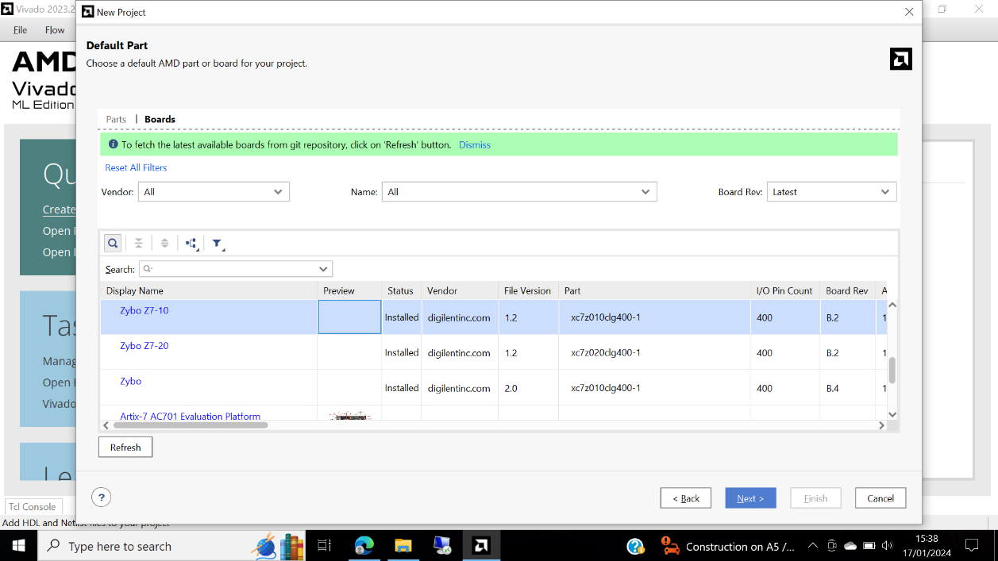

Figure 1: Adding the board and the provided files.

Step 2: Simulate

The content in the test bench file is shown on figure 2.

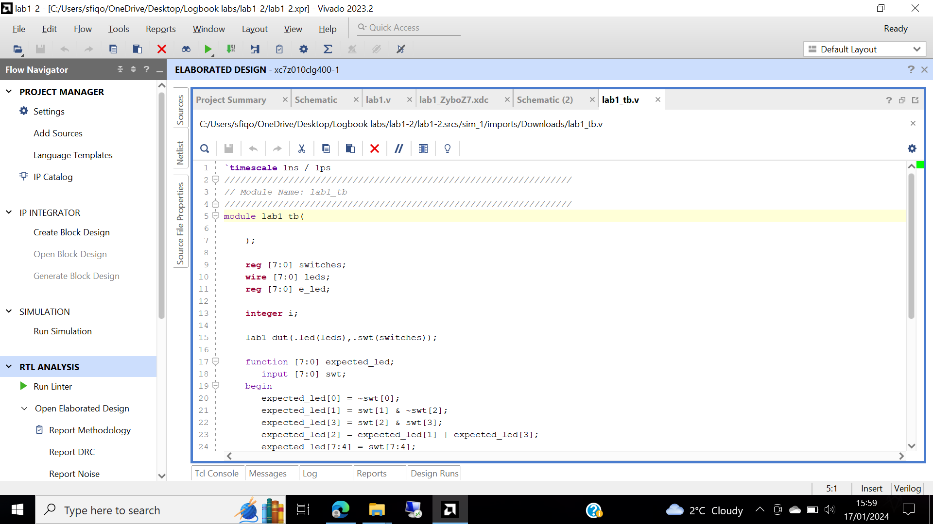

Figure 2: The testbench file

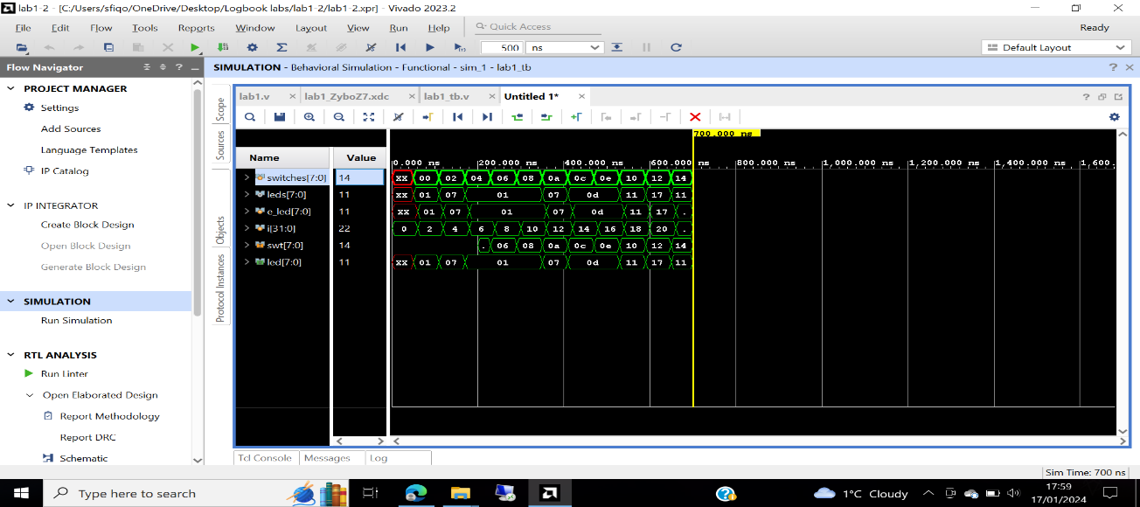The Simulation run time is changed to 200 ns from 500ns, figure 3 shows behavioural simulation being run. Figure 4 shows the signals that have been added.

Figure 3: Waveform window is opened. Simulating functionality of design.

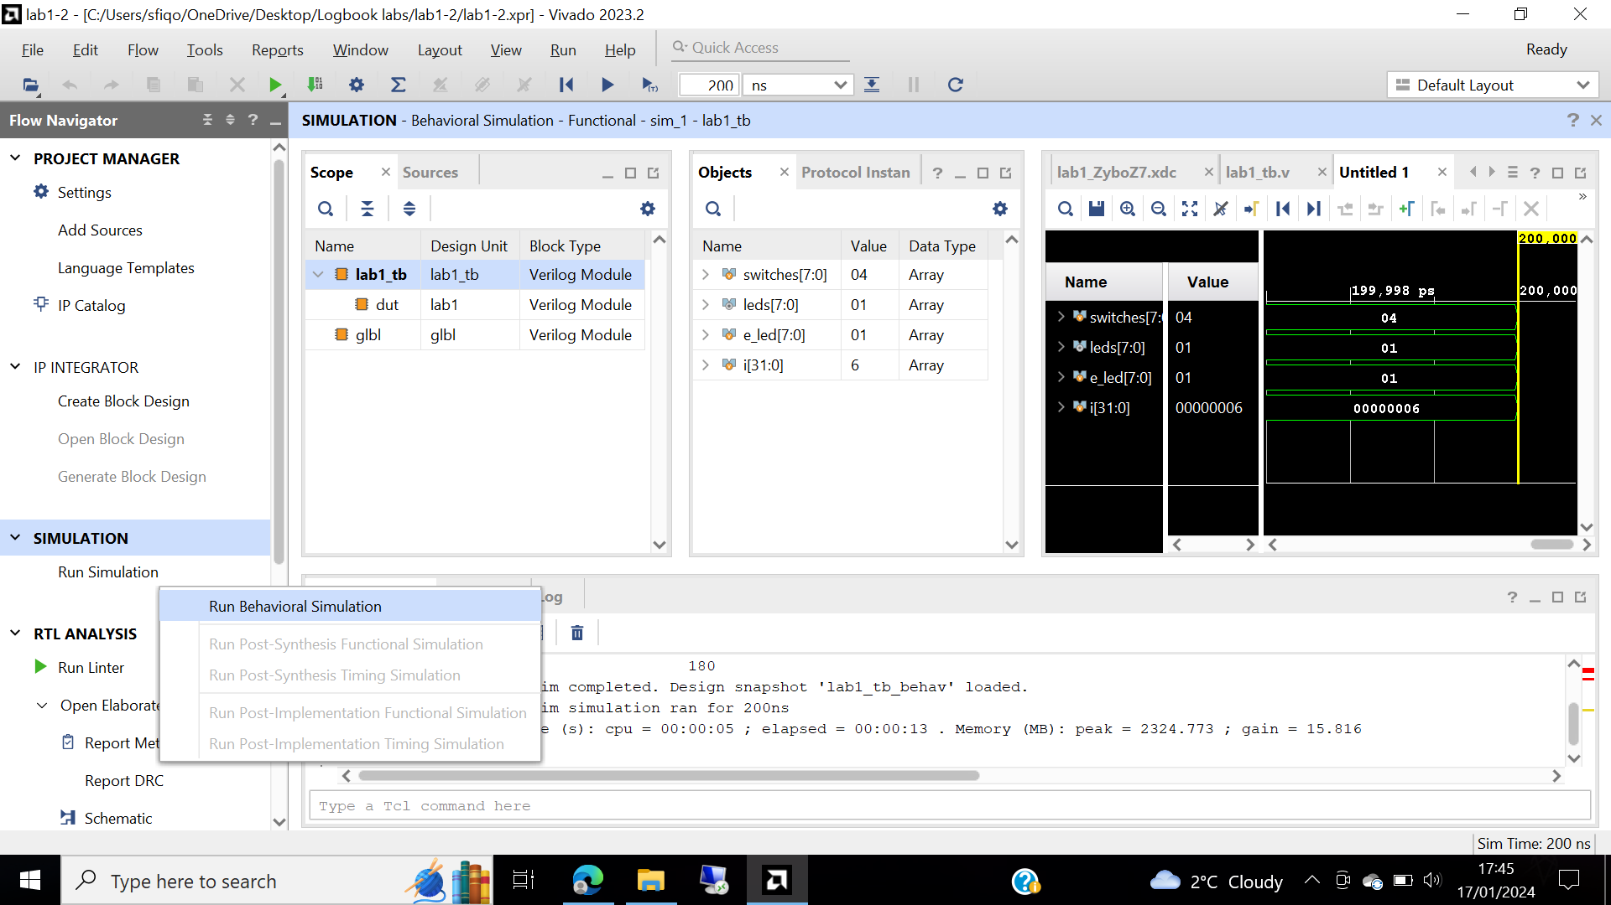

Figure 4: Added the swt [7:0] and led [7:0] to the waveform window to monitor the lower level signals.

Step 3:

The synthesis tool will run on the lab1.v file, figure 5 shows the synthesized design, which is achieved by selecting on Open synthesized design, we want to look at the design prior the implementation stage.

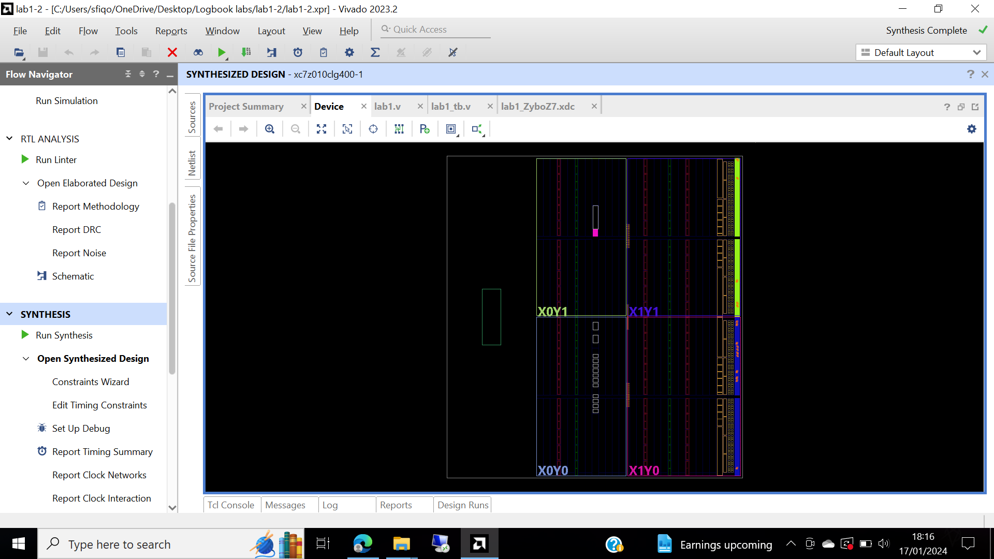

Figure 5: Opened synthesized design

Figure 6 shows the project summary, clicked on the links to understand the information provided

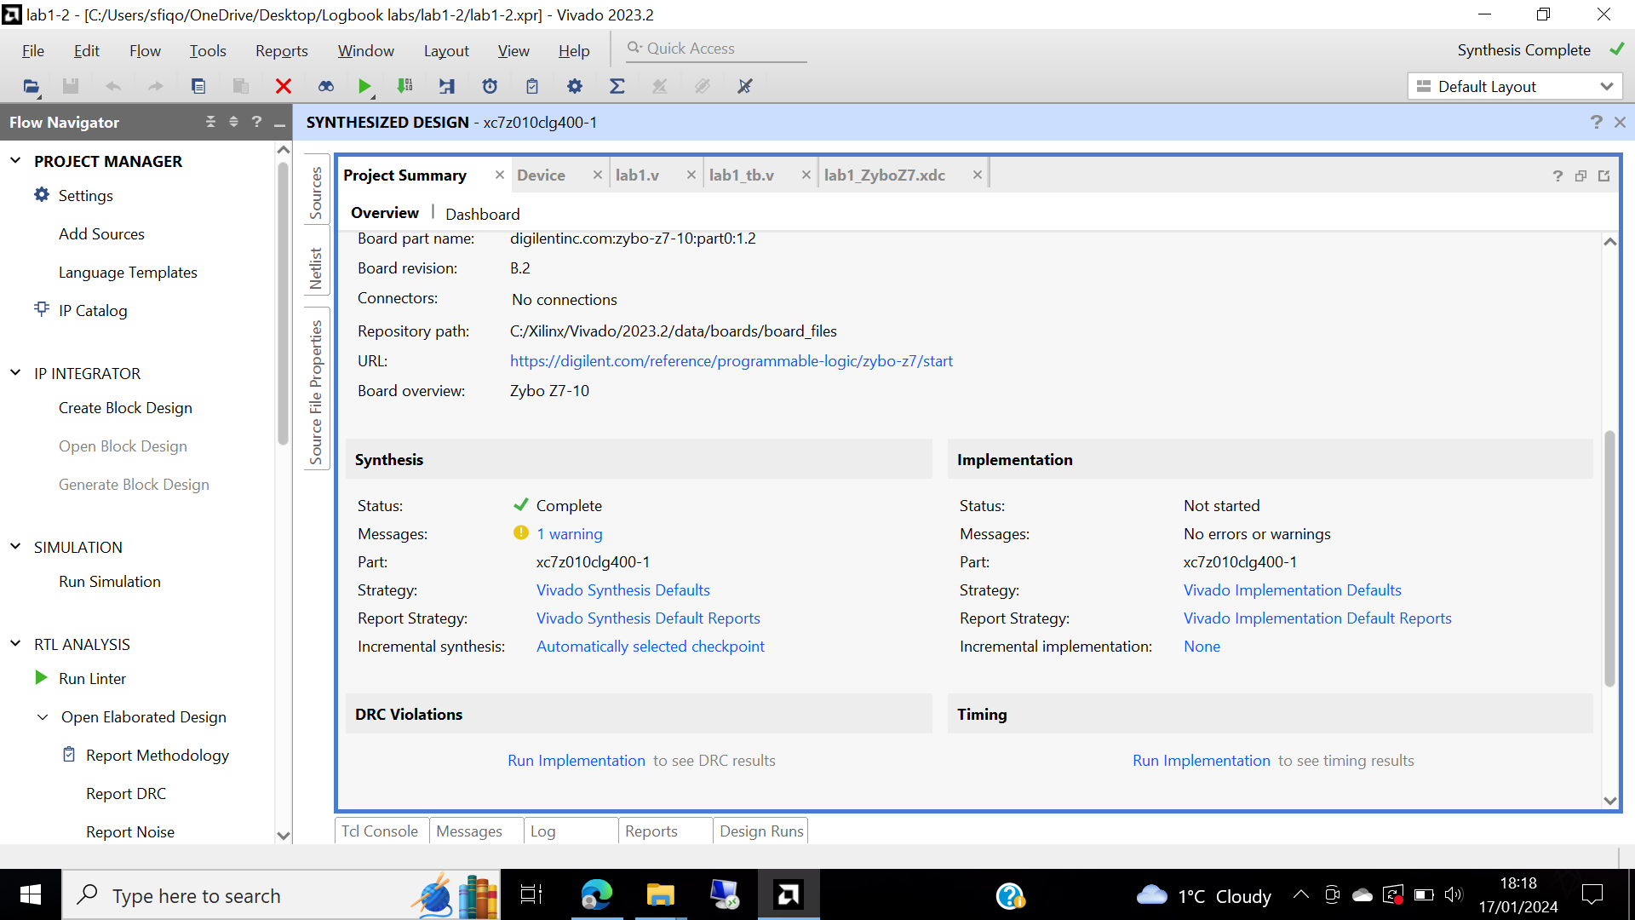

Figure 6: Project summary.

The schematic on figure 7 presents the IBUFs and OBUFs which are instantiated as input and output buffers. The logic gates are implemented in LUTs.

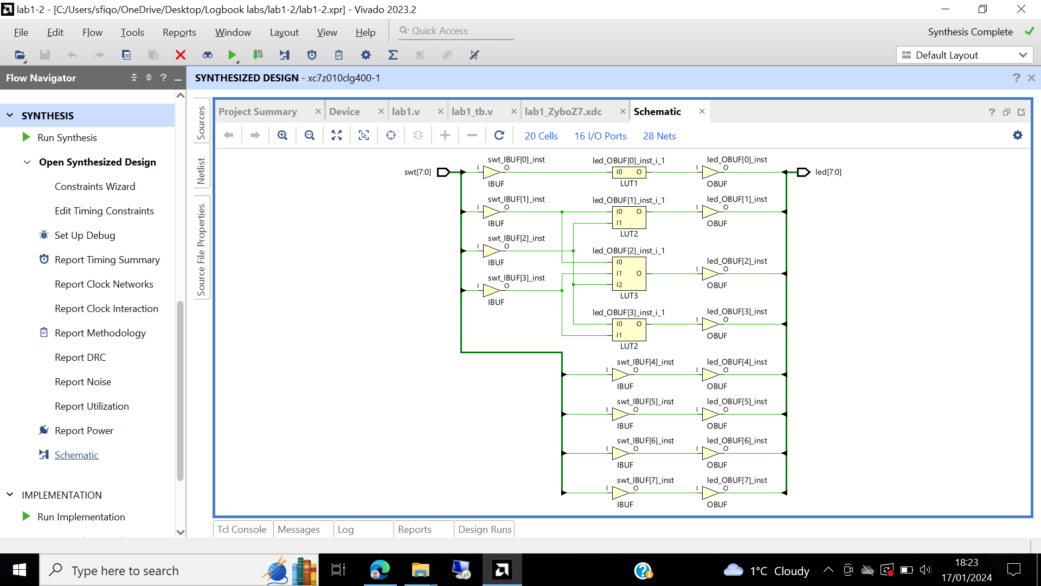

Figure 7: Synthesized design schematic

Step 4:

Implementation is being run on the synthesized design, in the netlist figure 8 shows the synthesized design.

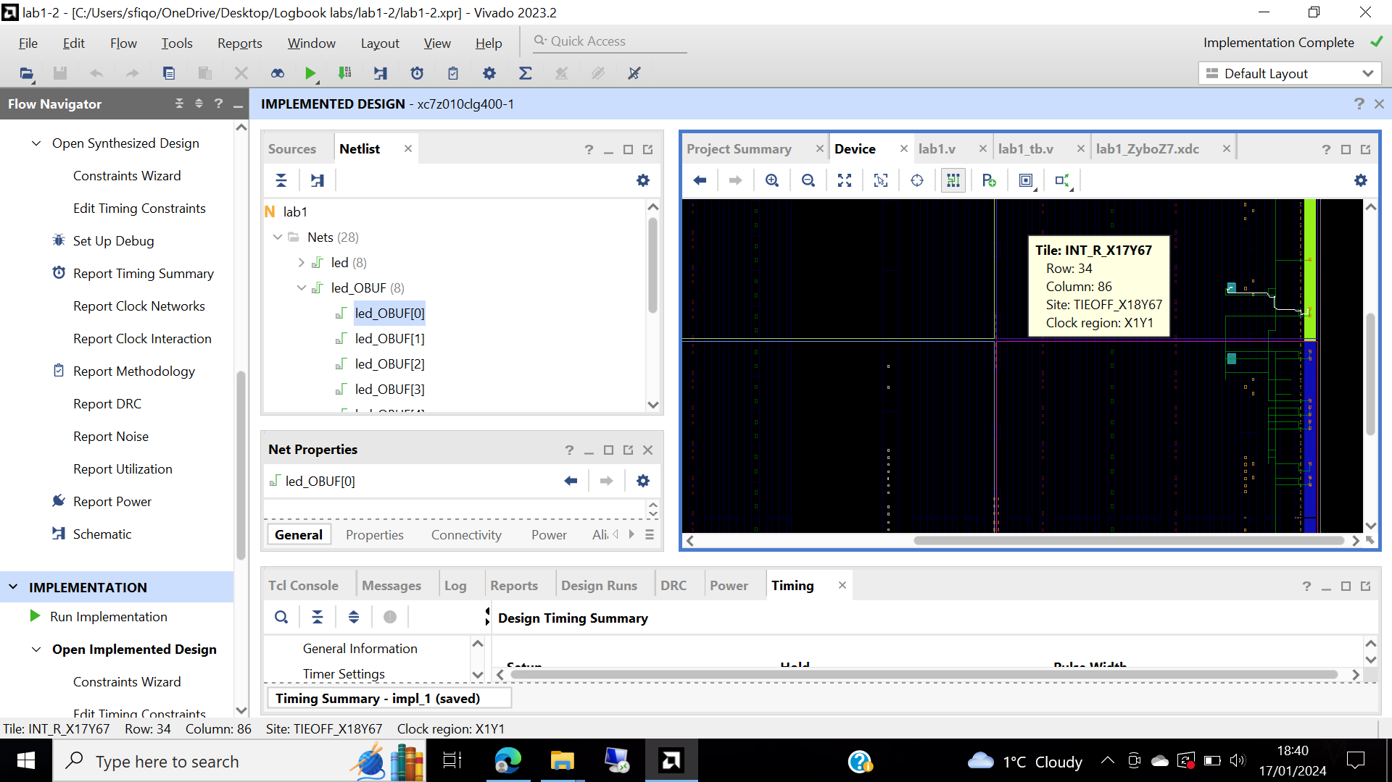

Figure 8: Net OBUF [0] is selected, net displayed in x1y1 clock region shown on the device view tab.

Figure 9 shows the project summary

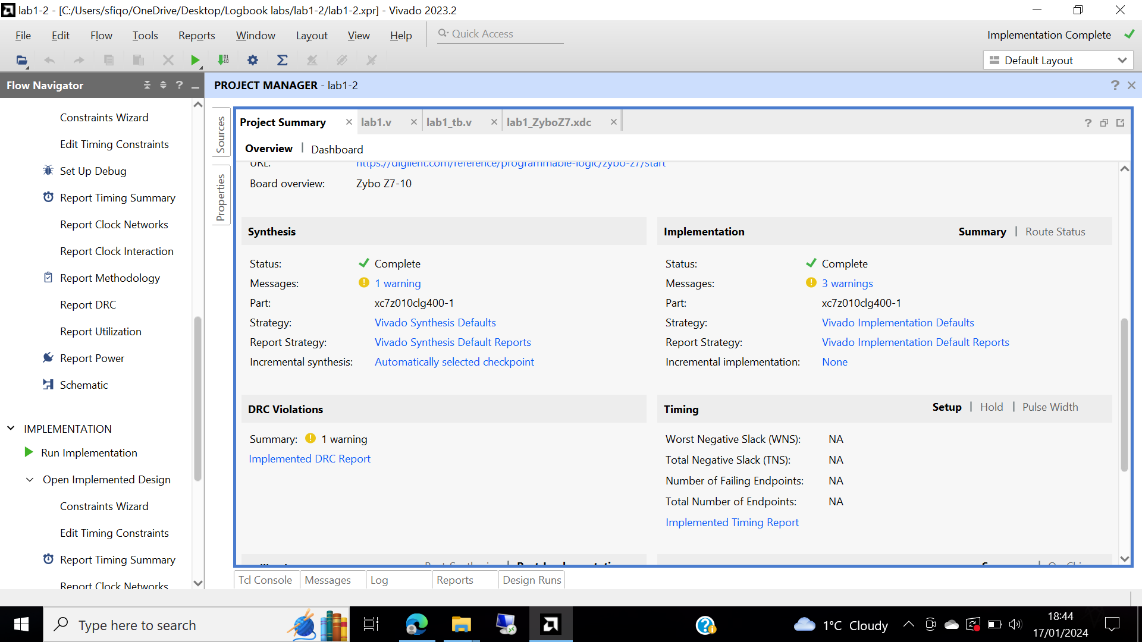

Figure 9: Project summary for implementation of the design.

The implementation table is showed in figure 10.

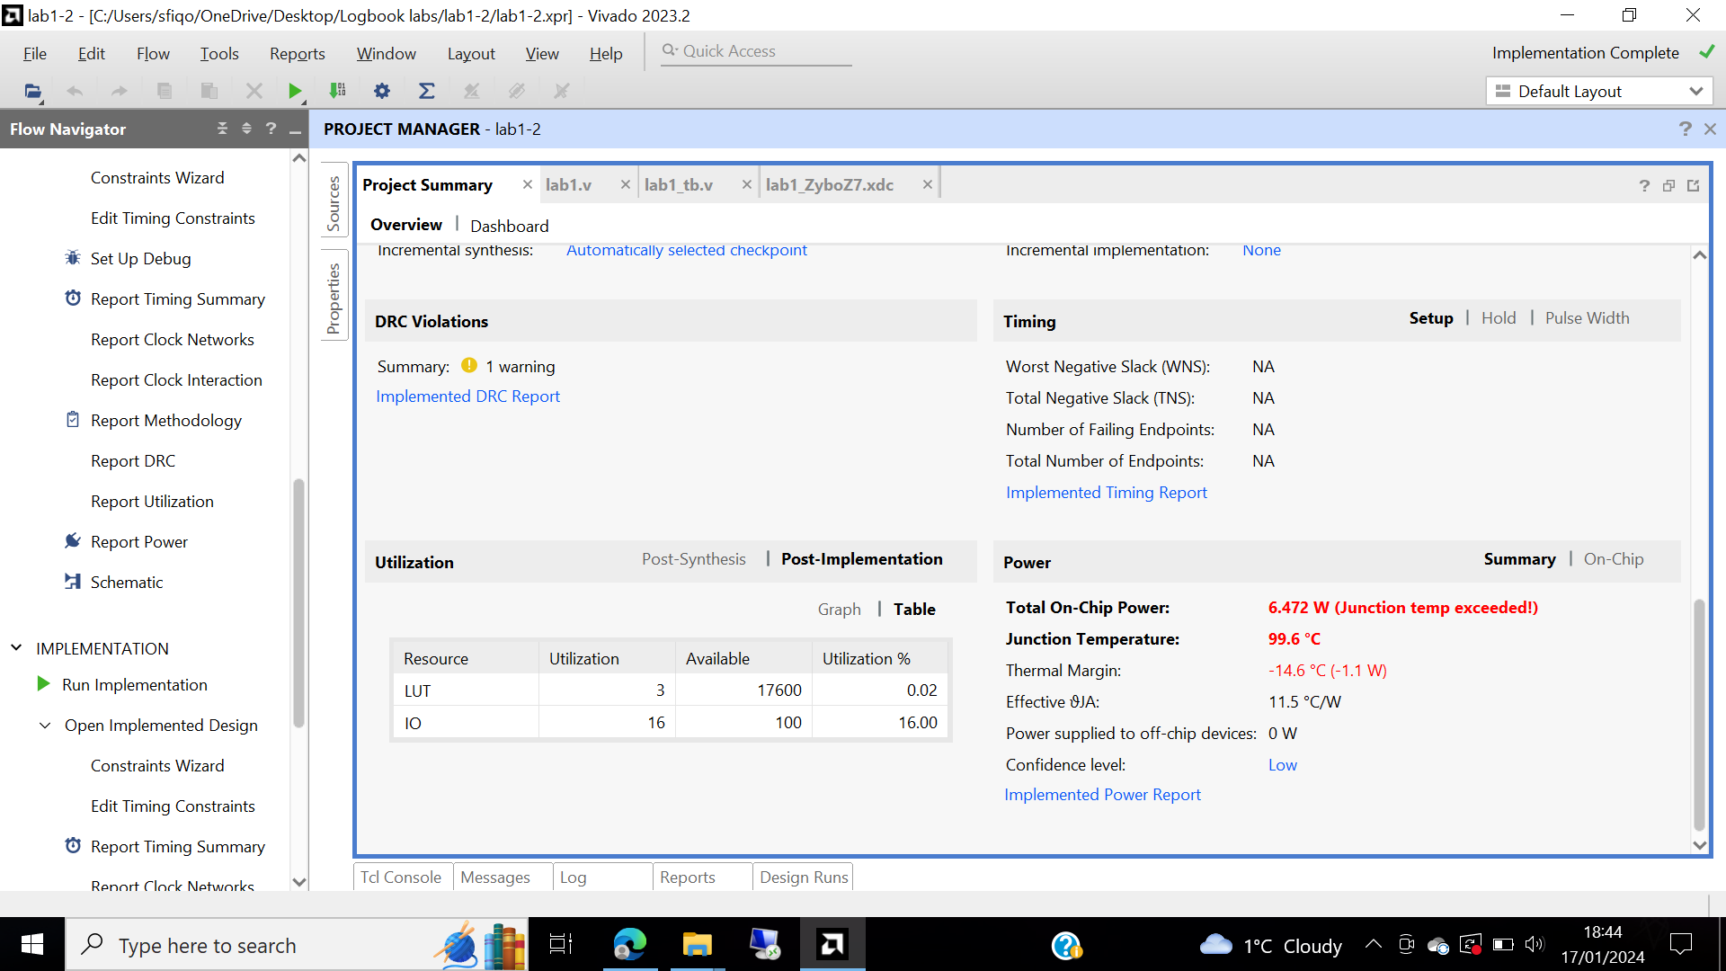

Figure 10: Project summary for implementation utilization,

Figure 11 utilization report

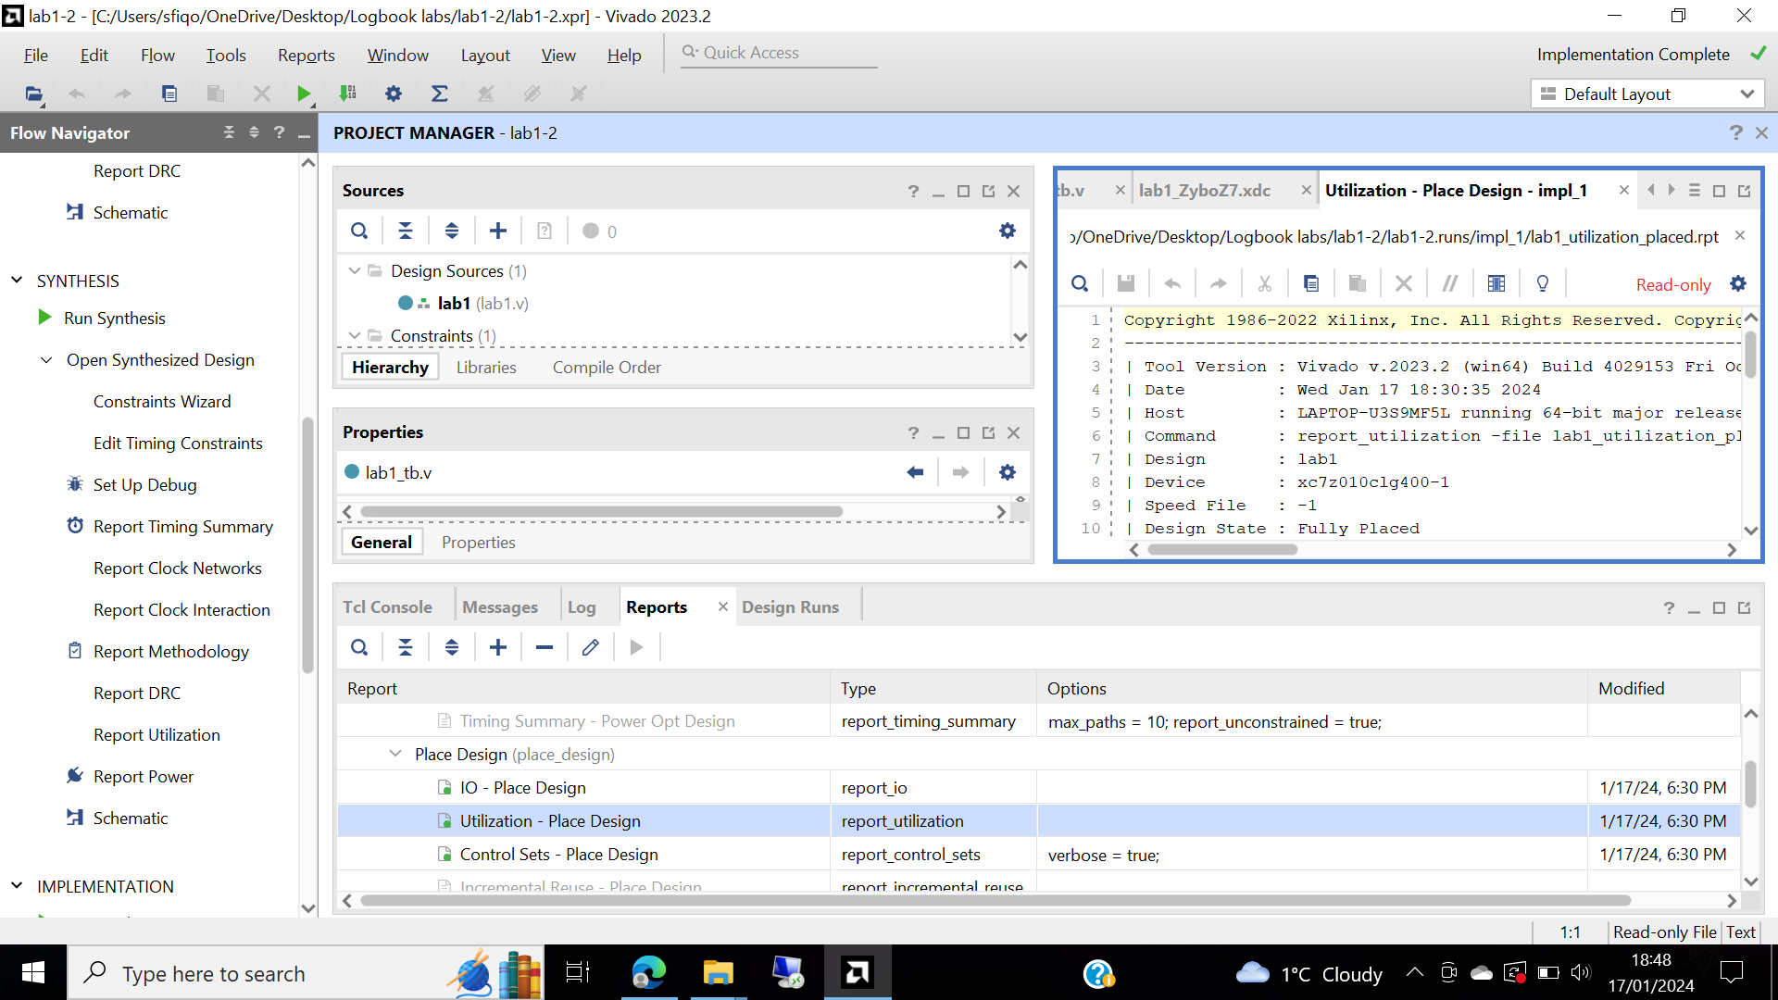

Figure 11: The utilization report.

Step 5:

Run post implementation timing simulation process under simulation task in figure 12 then right clicked at 50 ns.

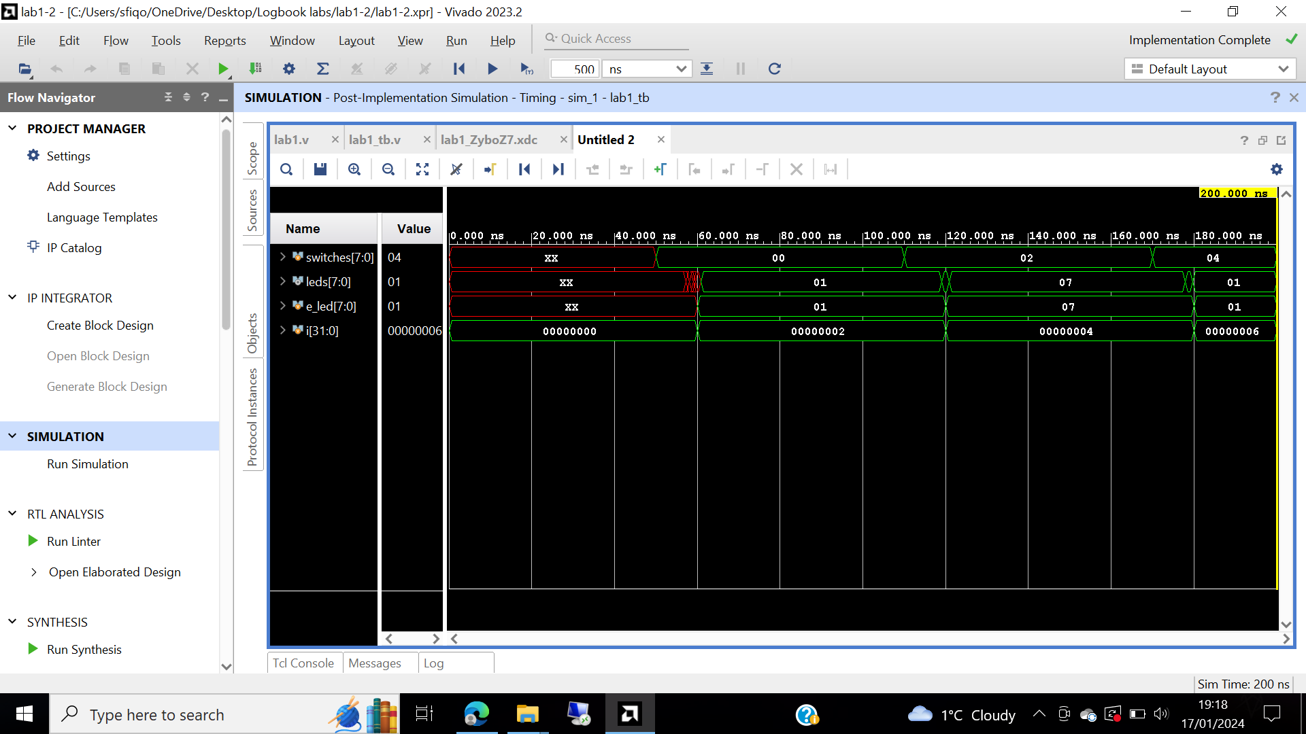

Figure 12: Figure 12: Zoomed in to see the waveform window from 0 to 200 ns.

Then right clicked at 58ns where the LED changes to mark an event, figure 13 illustrates this process around 58.00 ns.

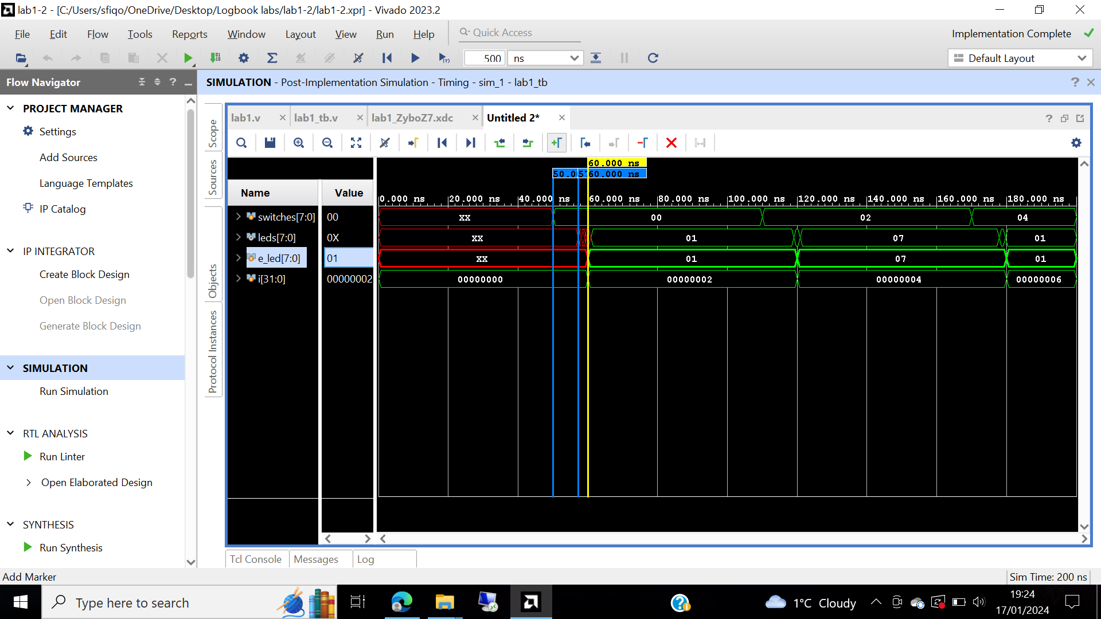

Figure 13: Markers added

where the led changes.

Step 6:

The FPGA board is connected to the laptop and start to generate the bitstream, FPGA is programmed by open a hardware session and Auto- connect the Zybo board demonstrated in figure 14.

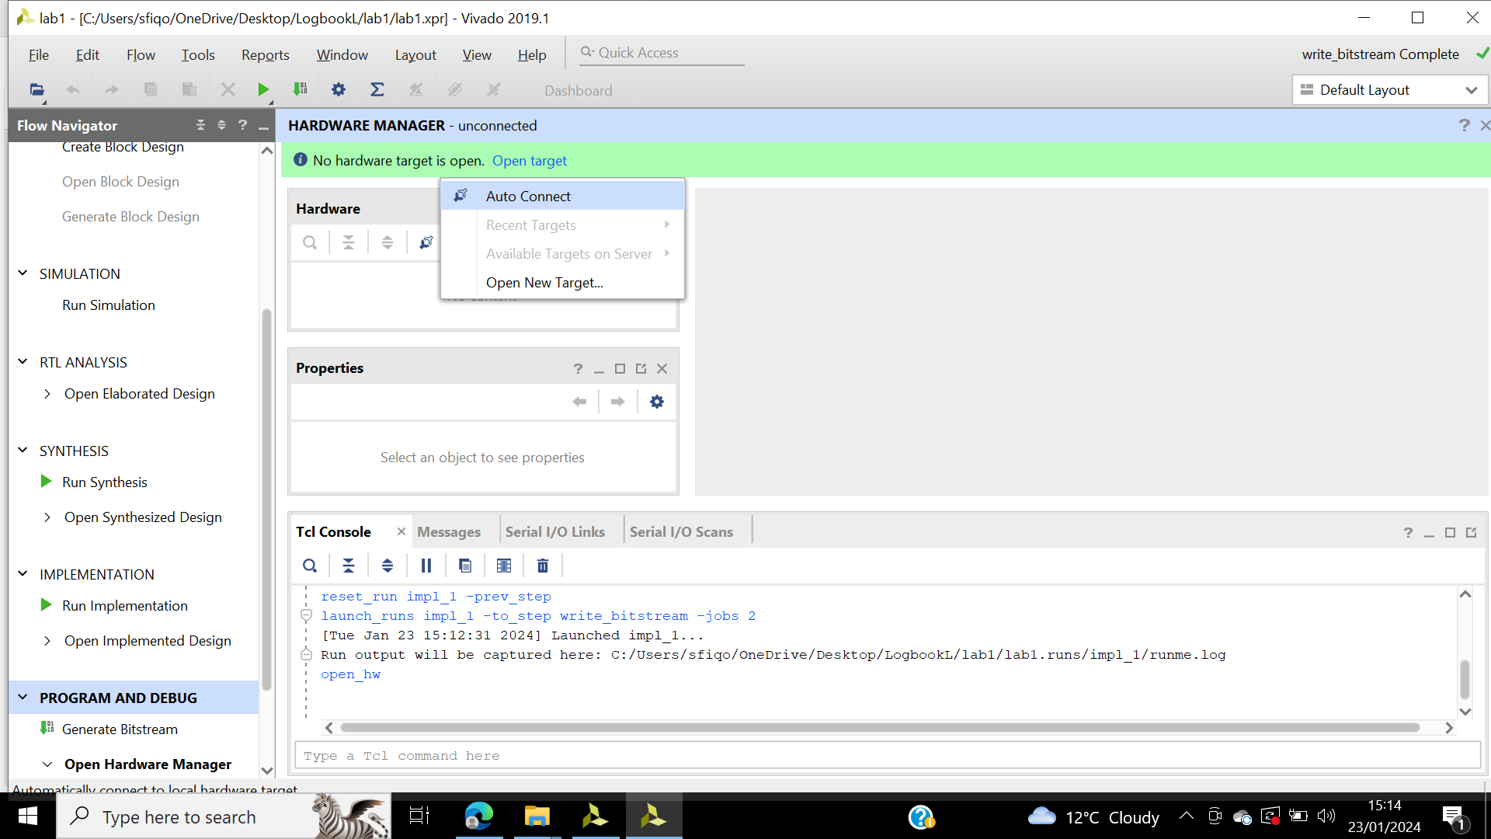

Figure 14: Hardware manager.

The Zybo Board is programmed as illustrated in figure 15. One connected, the Zybo Board is verified flipping the switches and analysing the outputs, shown in figure 16.

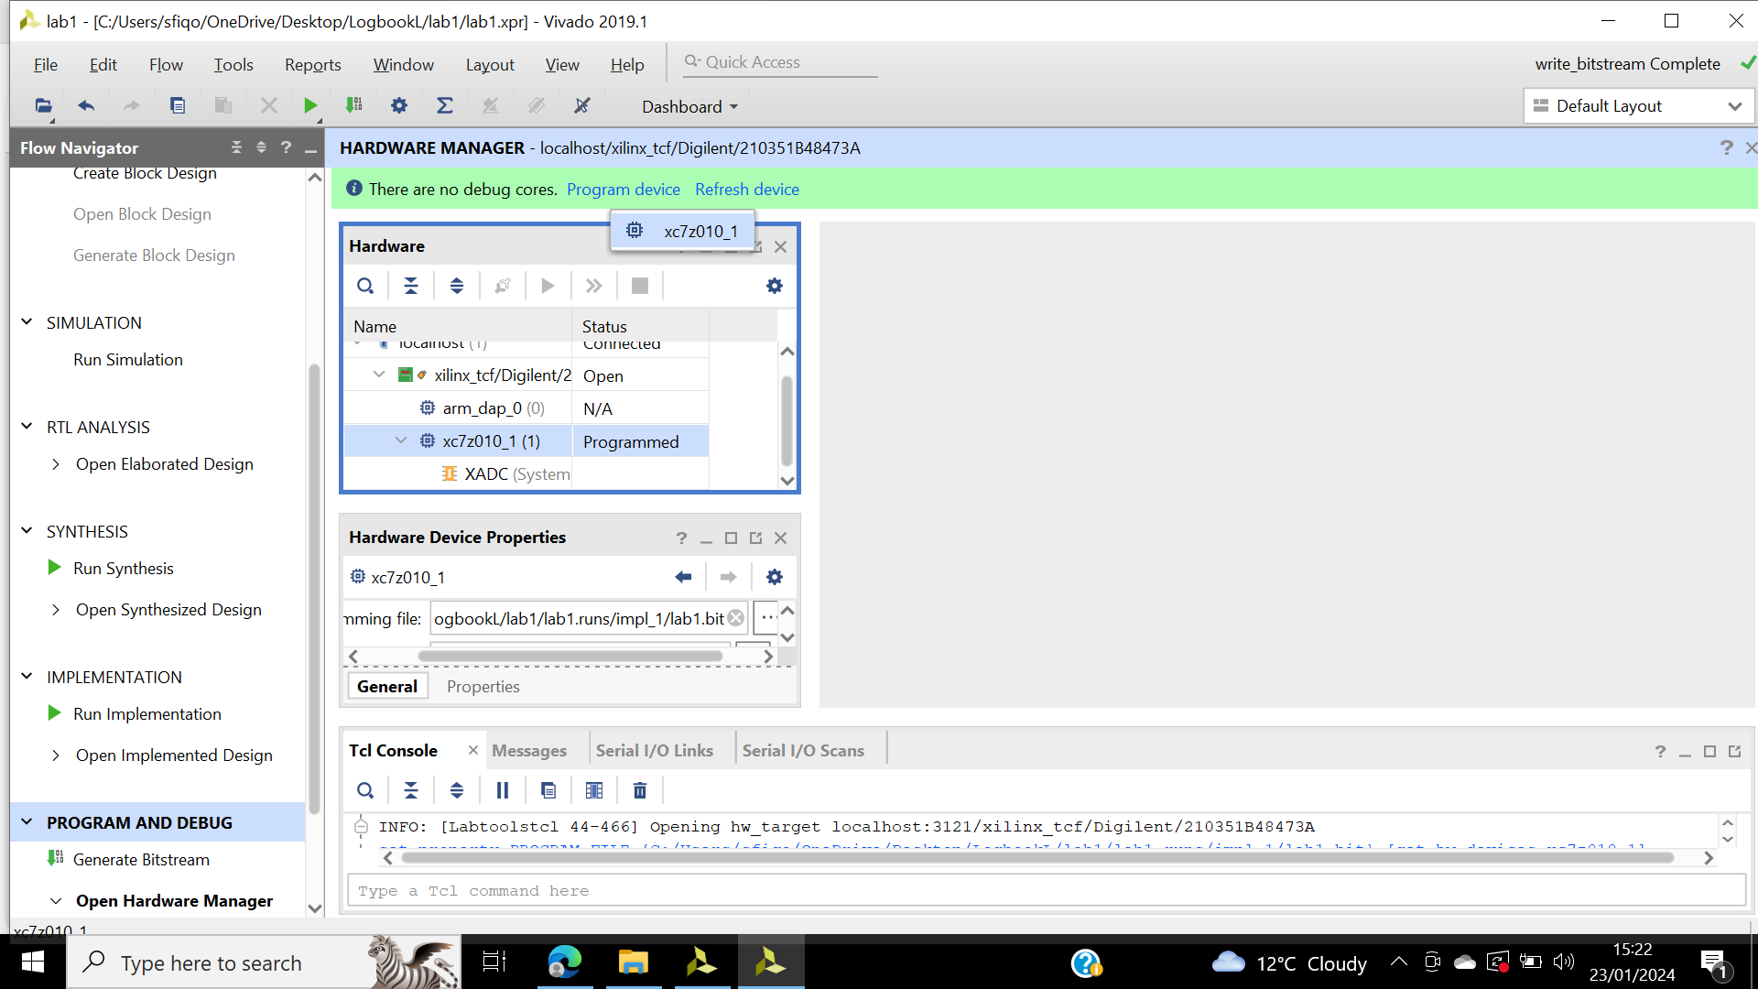

Figure 15 Zybo Board connected.

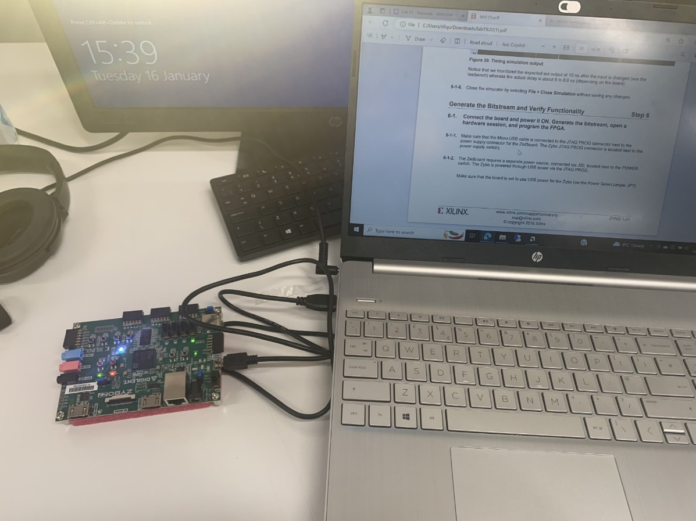

Figure 16: Analysing output of the Zybo Board.

## **Conclusion**

This lab used the Vivado IDE to perform an HDL design flow. Vivado is a software designed by Xilinx for synthesis of HDL (hardware description language) code for Xilinix FPGA (Field programmable gate array) and SoC (System on chip). The project was created by using the files provided. Then after the behavioural simulation was performed using the testbench to verify the functionality of the design. The design was then synthesized, implemented and a bitstream was generated. Using the testbench a timing simulation was run on the implemented design. Using the generated bitstream the functionality was verified in the hardware. Observing the performance of this lab, a lot of time has been consumed to connect the Zybo Board.

# **Lab 2**

## **Introduction**

This lab introduces the synthesis process and its effect on the design when changed. Numerous reports will be generated allowing to analyse the process after each stage, writing checkpoints to go back and analyse the generated report without re-synthesising.

## **Objectives and aims.**

To create a Vivado project with the provided files, the XDC constrain files, and the HDL files. The criteria is to elaborate the design and understanding the output, synthesize the design also viewing its schematic. Reports will be generated. Check points will be noted. After changing the synthesis settings, the design will be resynthesized design. The changes will be shown on the schematic, timing summary and power and utilization report.

## **Results**

Step 1:

Lab 2 is created. The project files are created in the tcl window show in figure 17. Figure 18 shows the changes made to the ps7_create.tcl file.

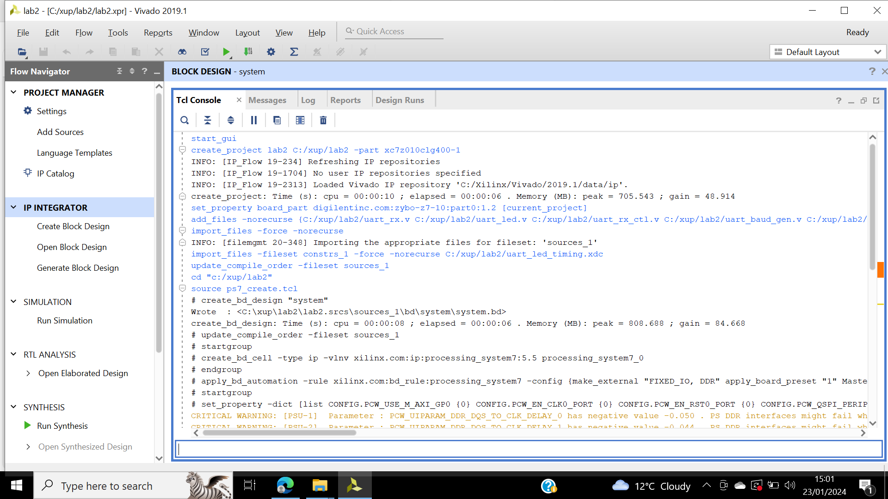

Figure 17: Tcl shell window opened, command script creates block design called system, this adds ZYNQ PS with one GPIO channel 49 and one EMIO channel. Creates a top-level wrapper file called system_wrapper.v. this includes system.bd.

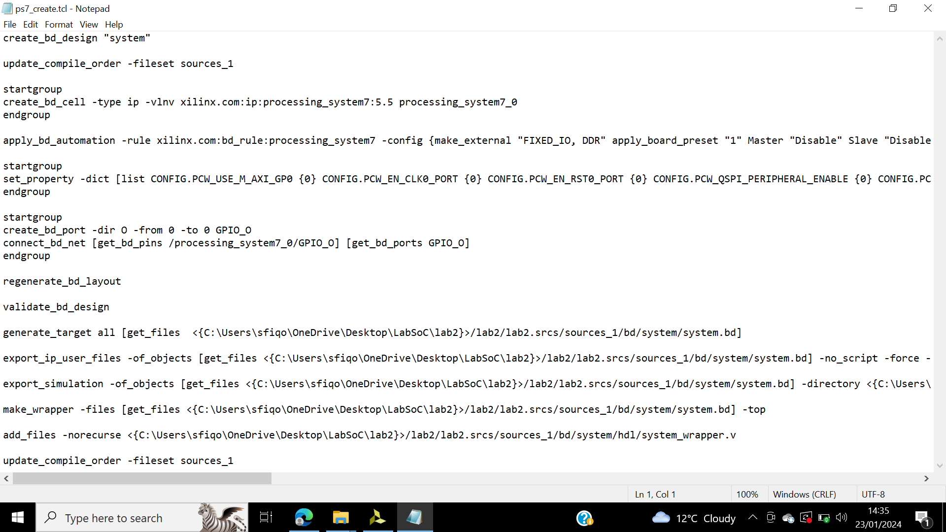

Figure 18: Ps7_create.tcl.

Uart_led is expanded in the design sources shown in figure 19, this shows the hierarchy of the lower-level modules. uart_led shows content illustrated in figure 20.

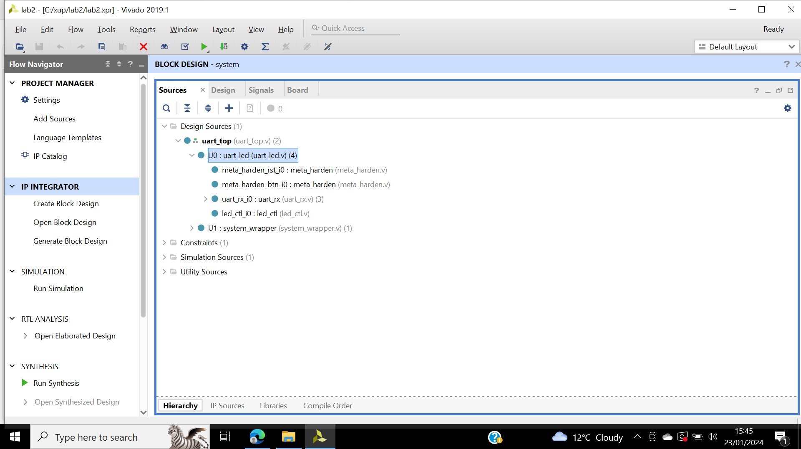

Figure 19: design source files.

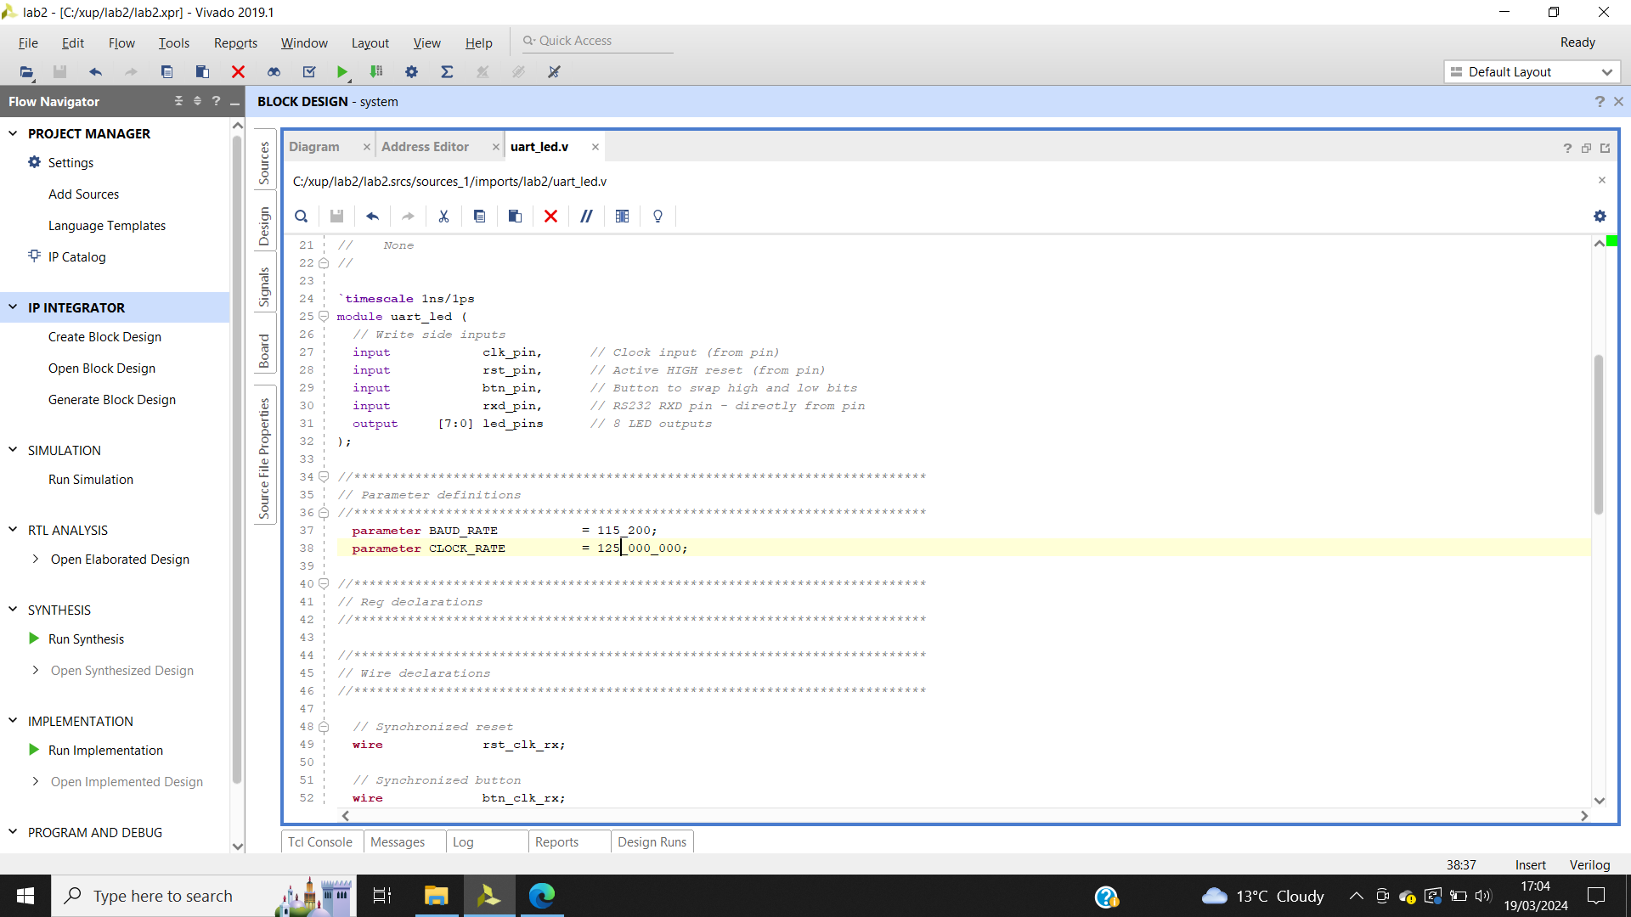

Figure 20: CLOCK_RATE parameter changed to 125 Mhz.

Figure 21 displays the U0 and uart_rx_i0 hierarchy design files.

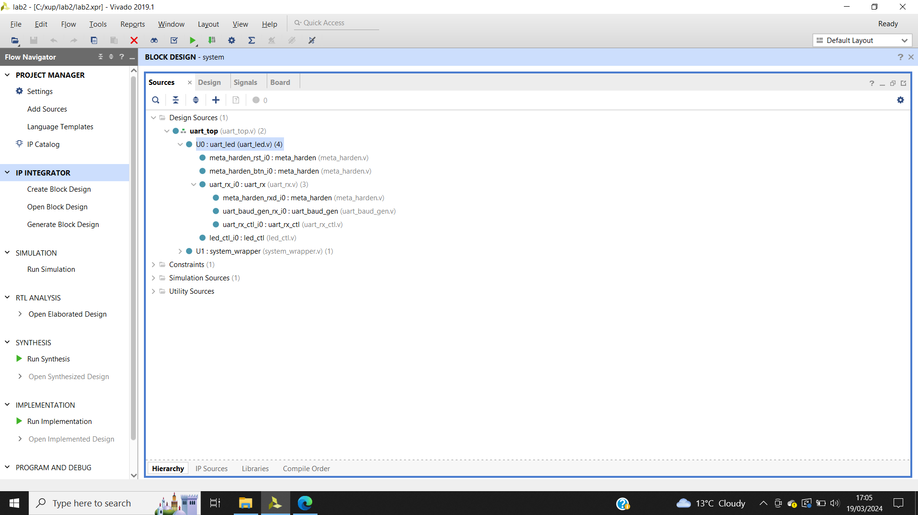

Figure 21: U0 and uart_rx_io instance hierarchy, the meta_harden modules are used to synchronize the asynchronous reset and pushbutton inputs.

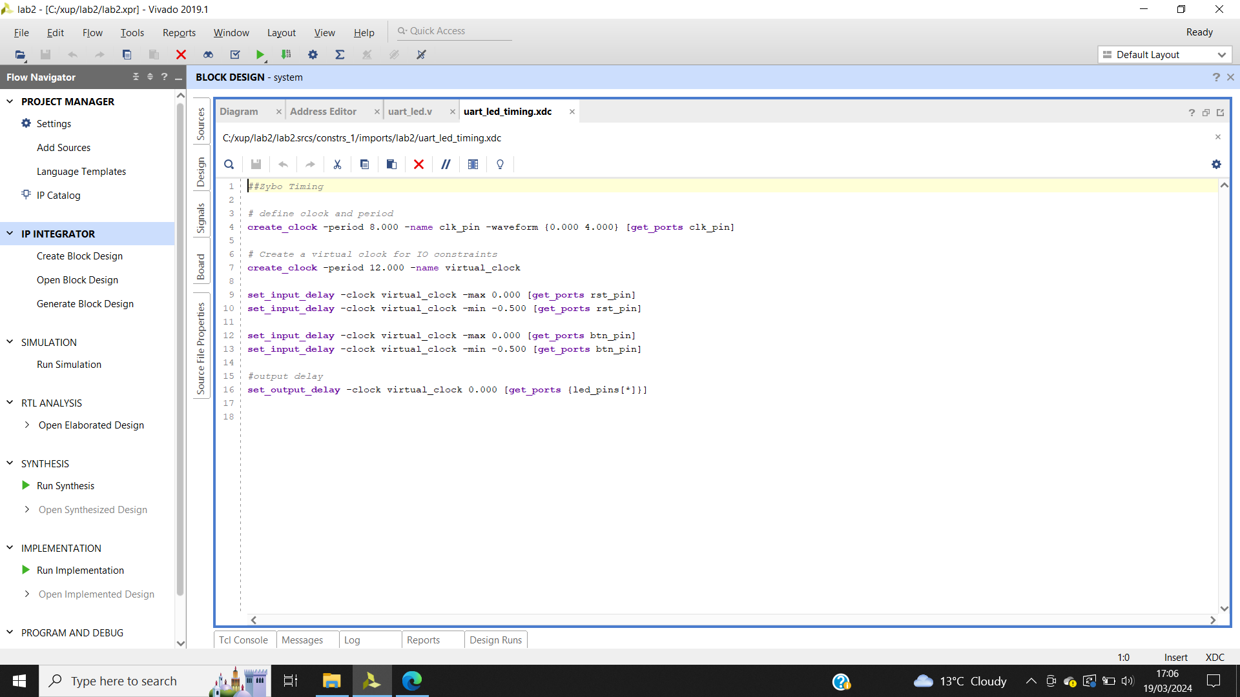

Figure 22: Timing constraint, has an on-board clock of 125 Mhz so Line 4 creates the period constraint of 8 ns with duty cycle of 50%.

Figure 22 shows the uart_led_timing.xdc source.

Step 2:

In figure 23 shows the schematic design.

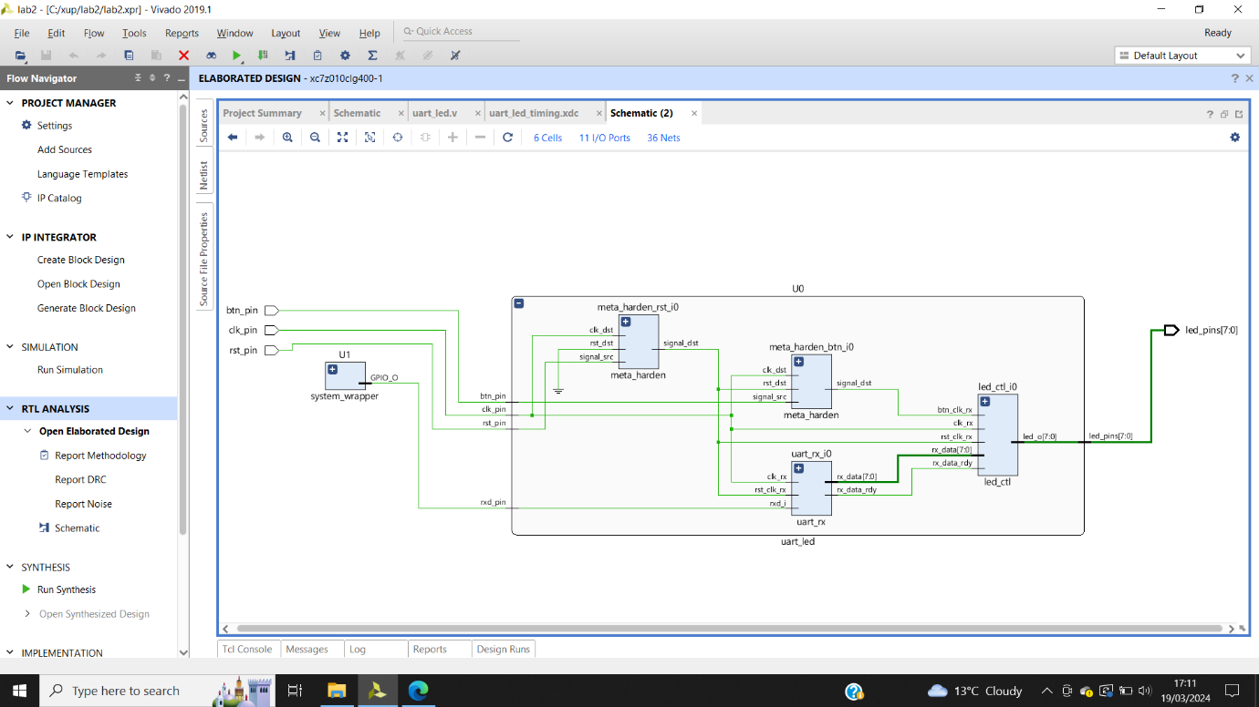

Figure 23: Schematic.

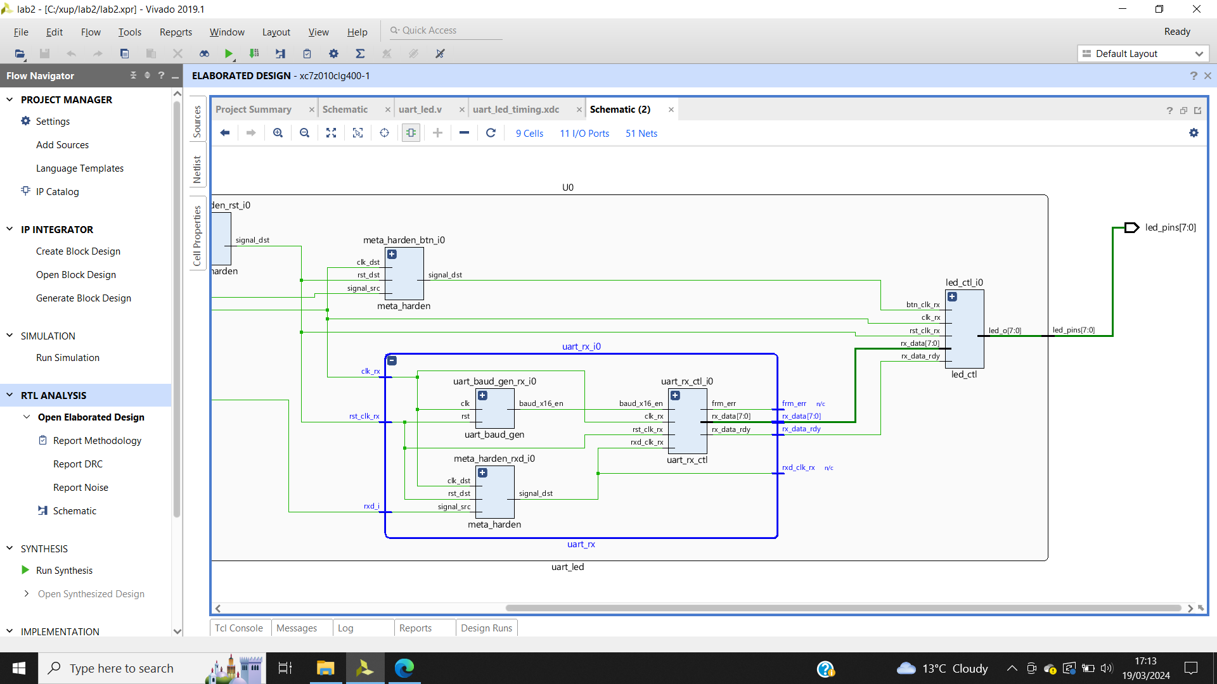

Figure 24: uart_rx_io underlying components.

Figure 24 shows the lower-level components of uart_rx_io.

Figure 25 shows the noise report ssn_1(simultaneous switching noise).

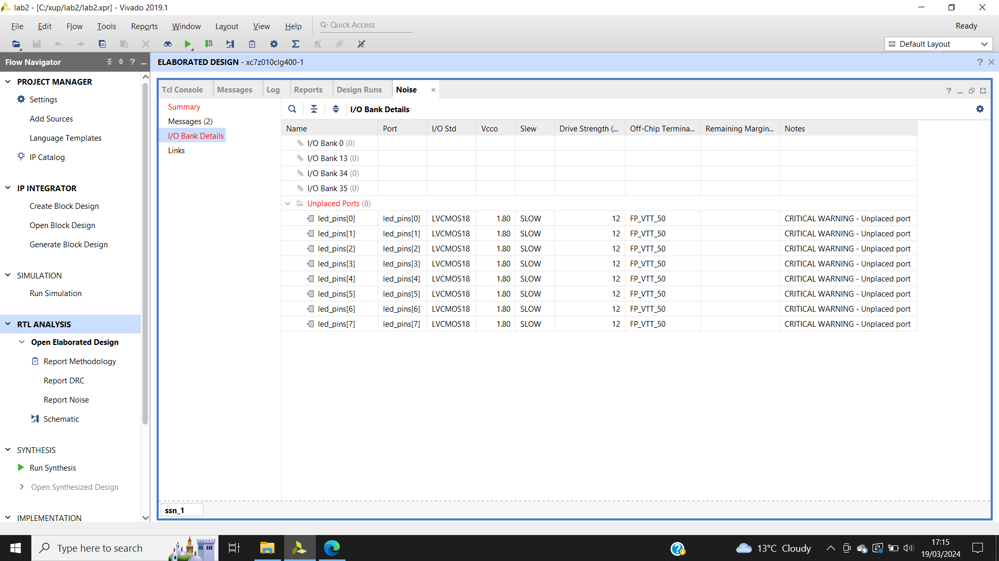

Figure 25: ssn_1 report. Details highlighted in red, as pin assignments aren’t done. Noise analysis is completed on the output pins.

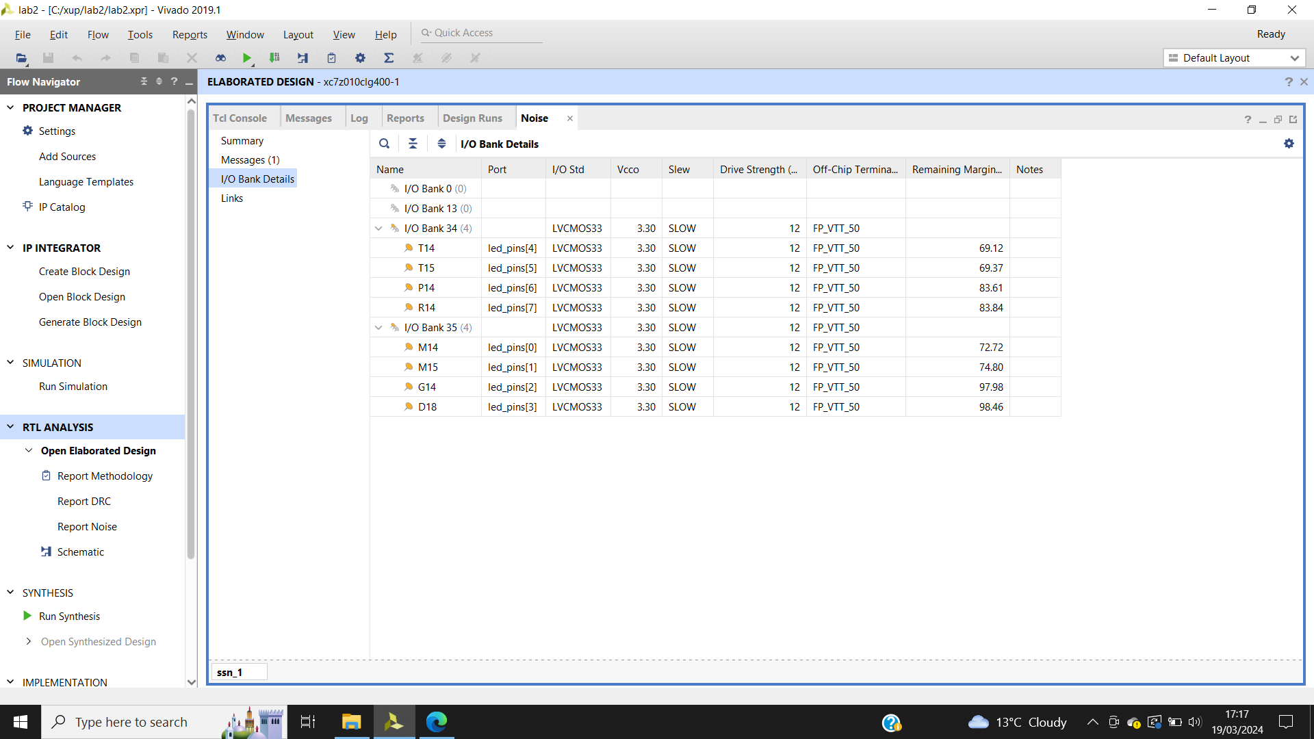

Figure 26: Report noise, no more errors.

Figure 26 shows the updated noise report.

Step 3:

Run synthesis

Project summary shown on figure 27.

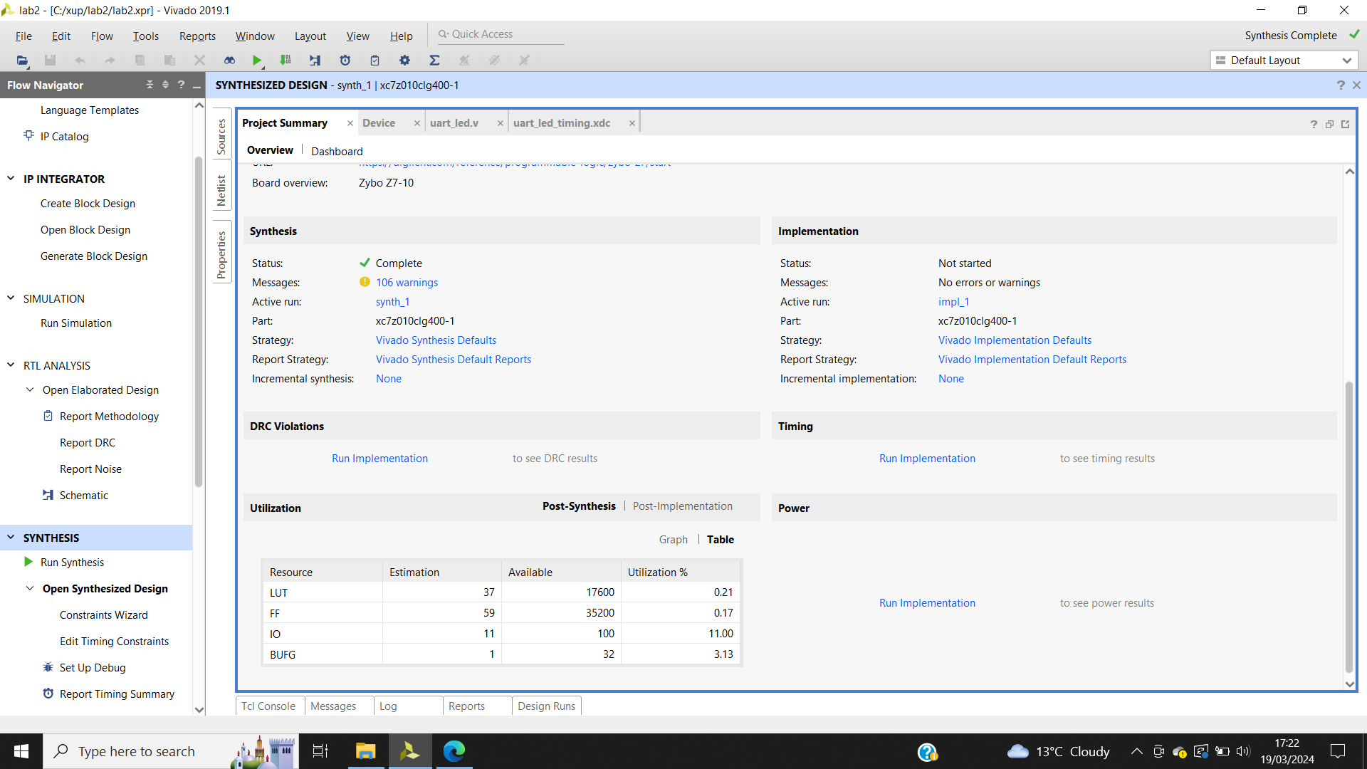

Figure 27: Project summary.

Schematic is opened as shown in figure 28.

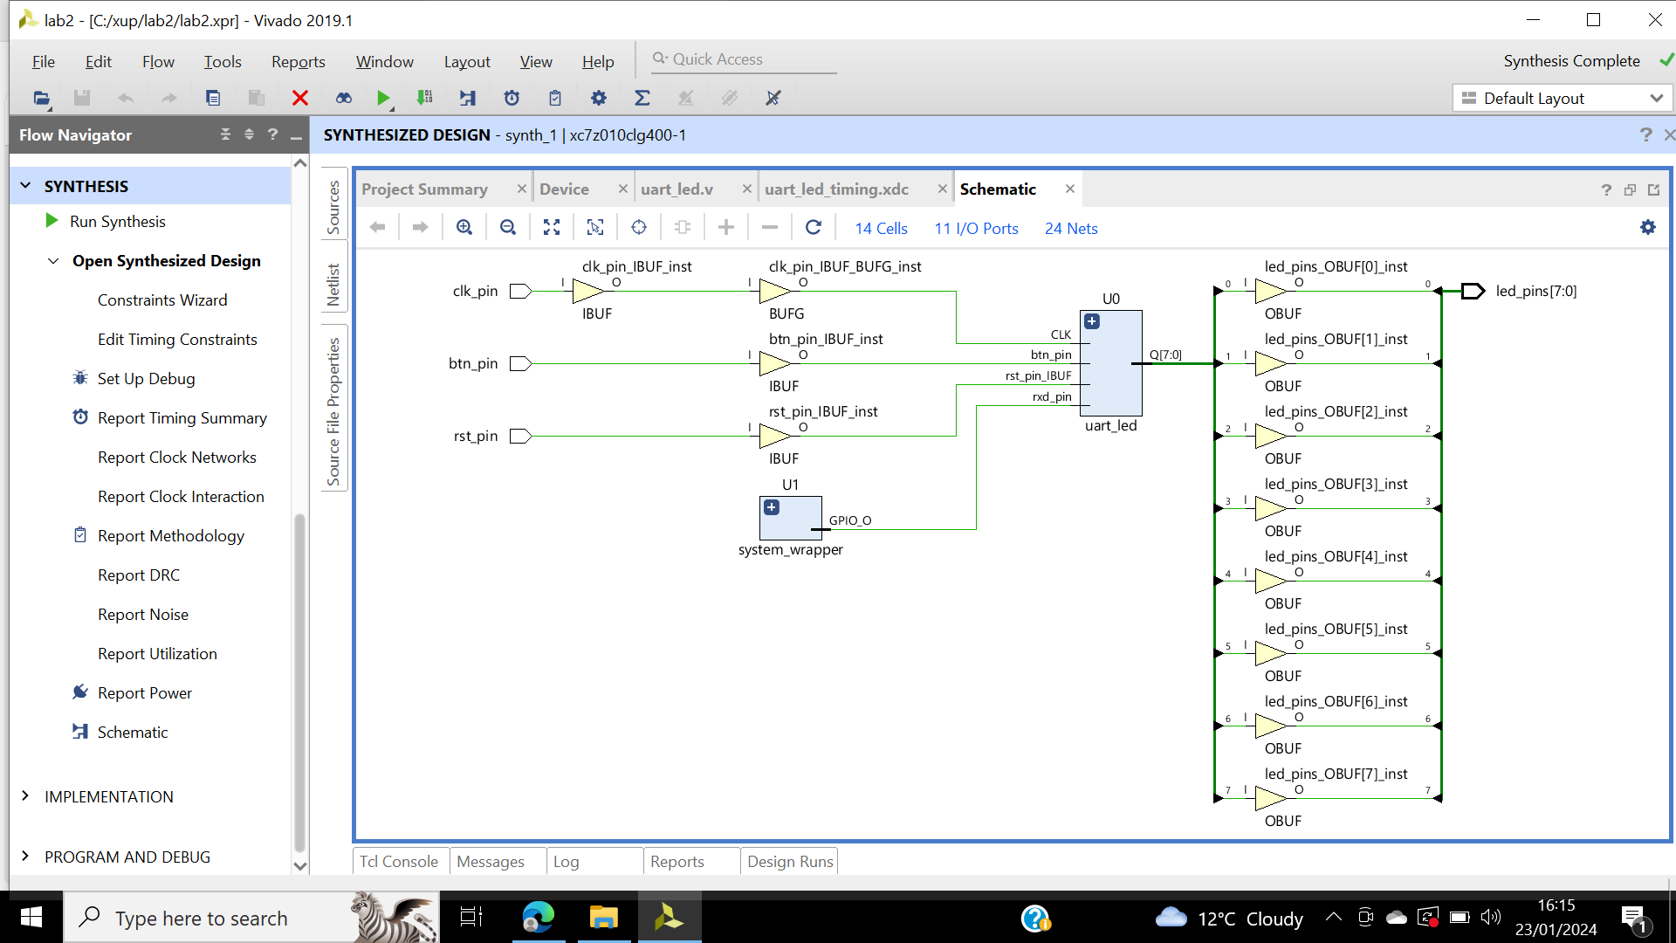

Figure 28: Schematics view shows IBUF and OBUF already added as the input and output are buffered.

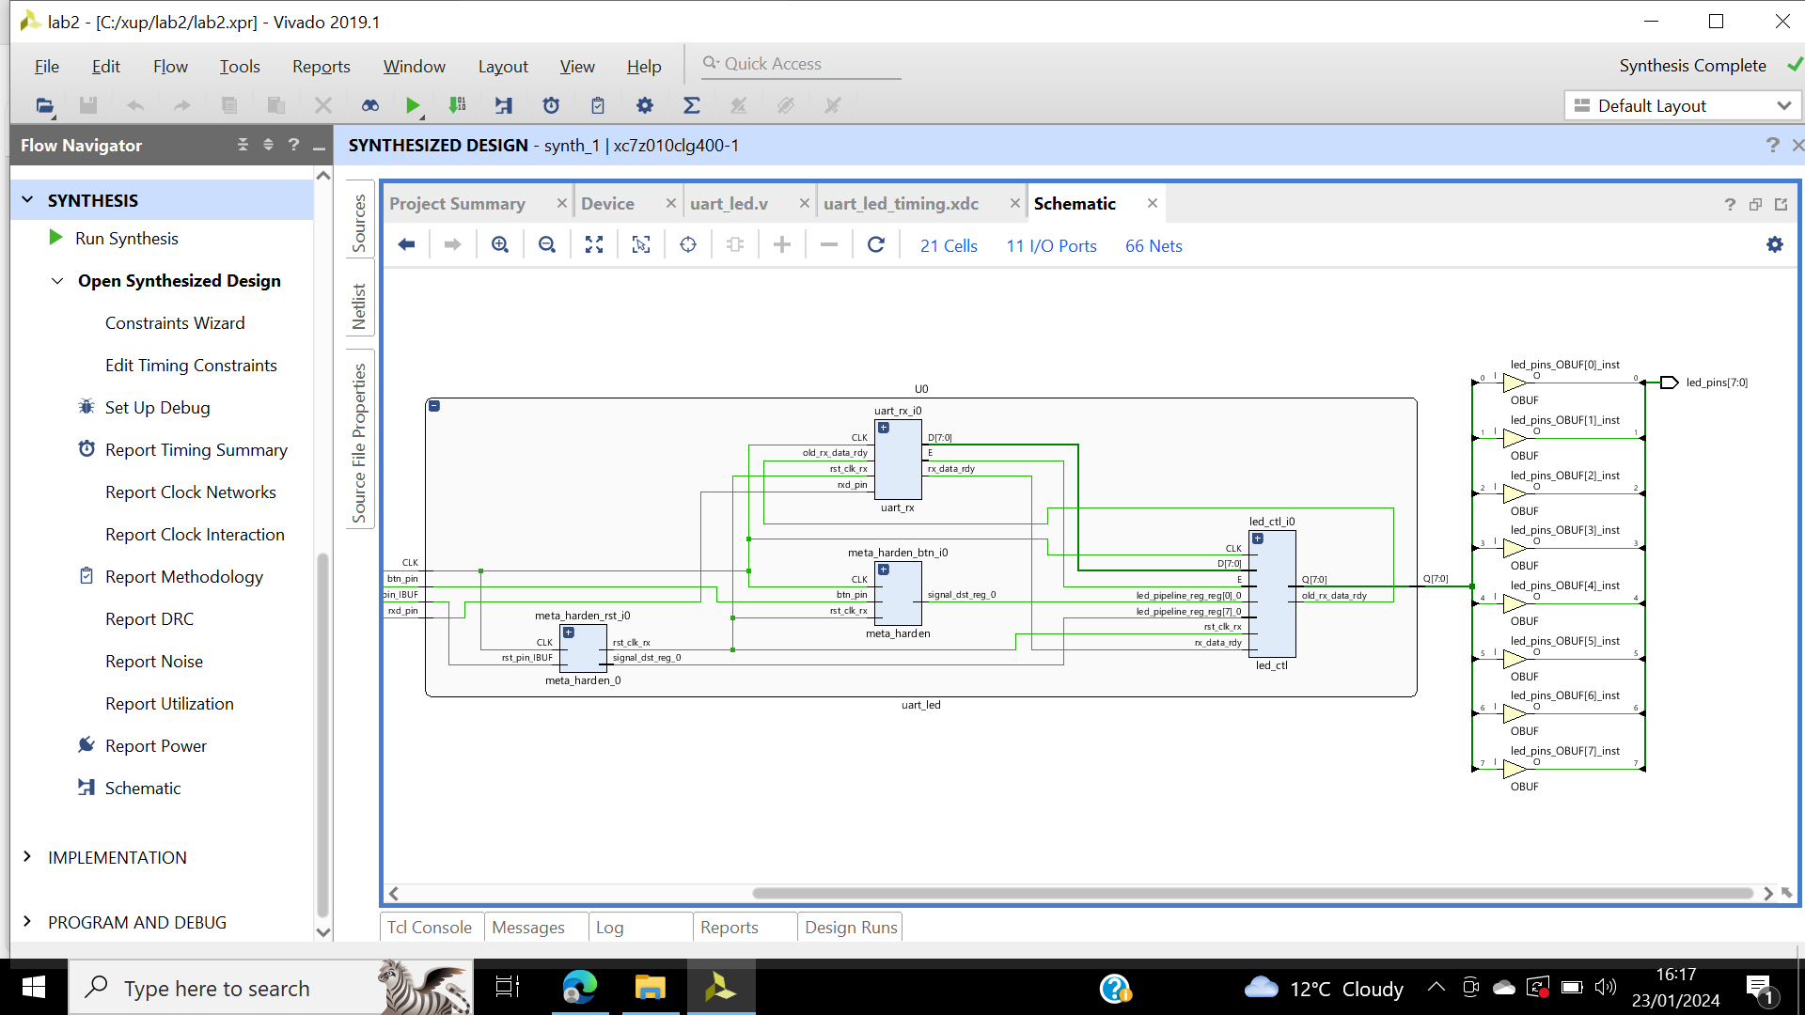

Figure 29: U0 instances, schematic view.

U0 and uart_rx_io instances shown in figure 29 and 30.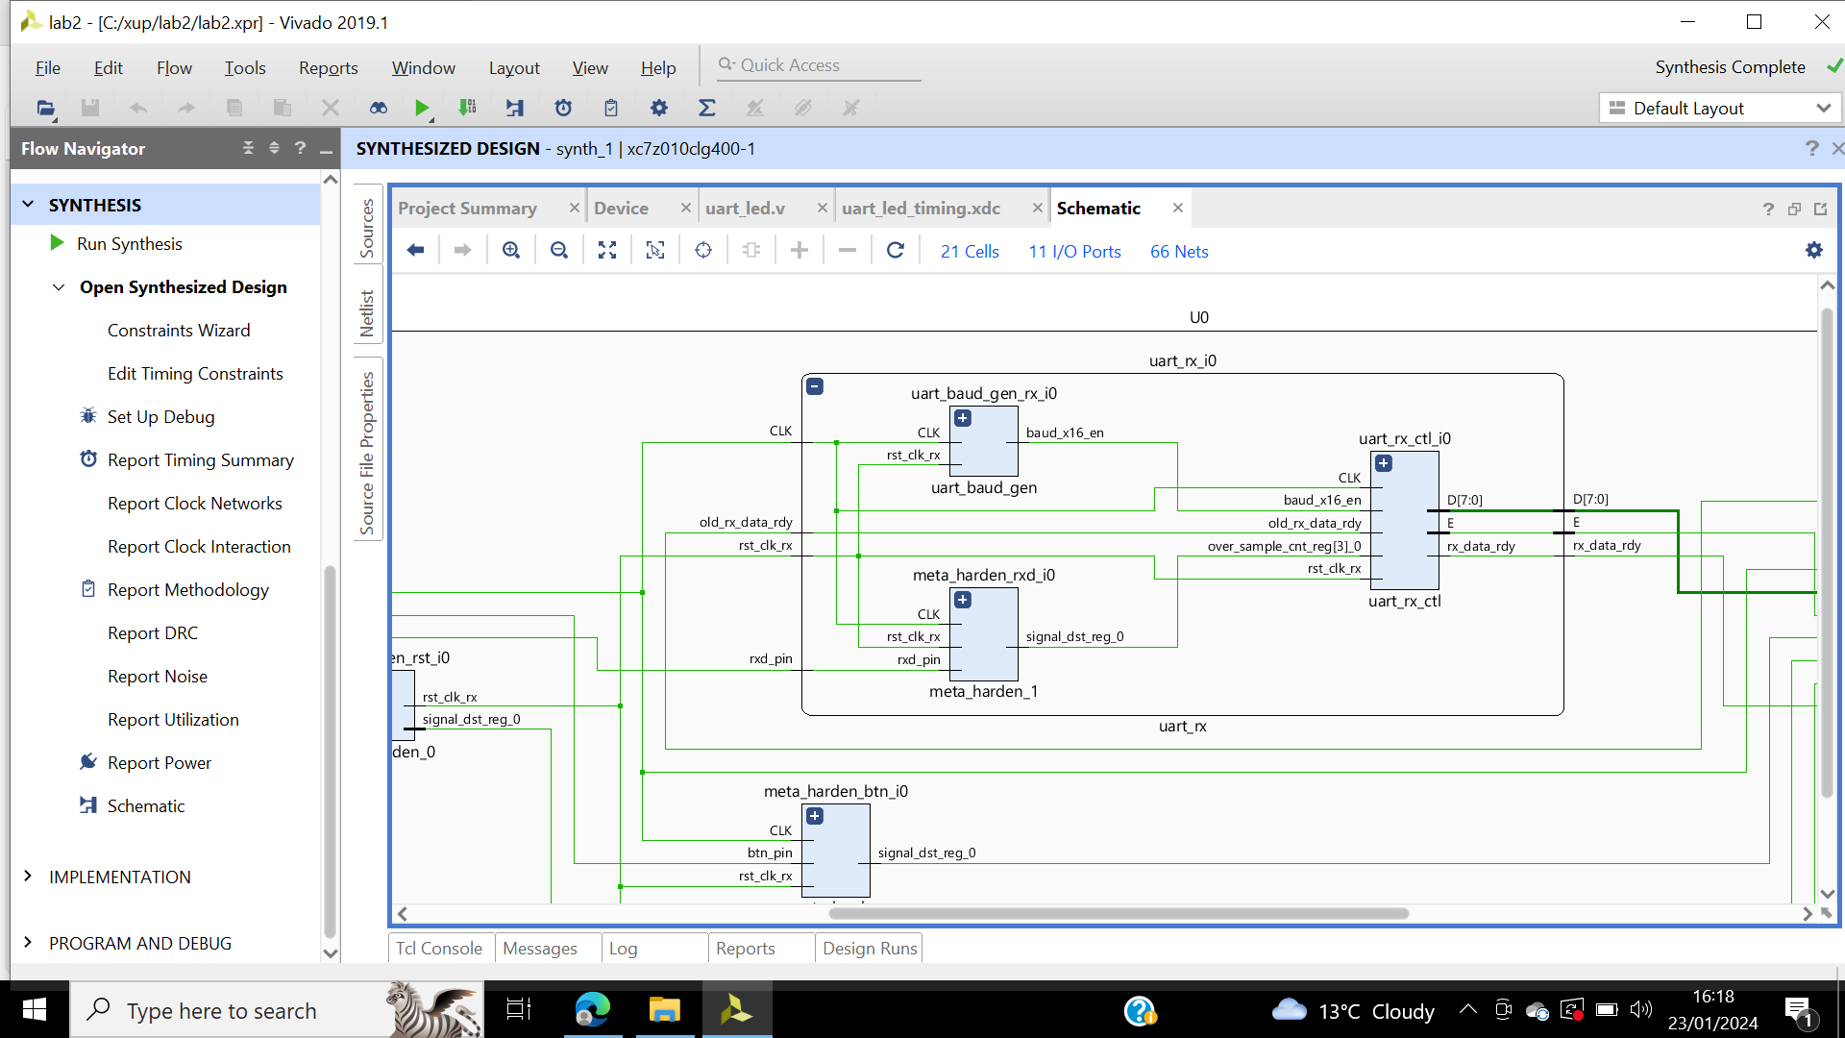

Figure 30: Uart_rx_i0 instances, schematic.

The instantiation of uart_baud_gen_rx_i0 is shown in Figure 31. The two flip-flop synchronisation circuit is implemented in Figure 32. There is less chance of metastability because of this synchronisation. In FPGAs, a phenomenon known as metastability may result in system failures when signals are exchanged across circuits in asynchronous clock domains (Intel, 2008). It happens when an input signal for a flip-flop comes in too close to the edge of the clock signal, which could make the flip-flop unstable and result in an unpredictable output.

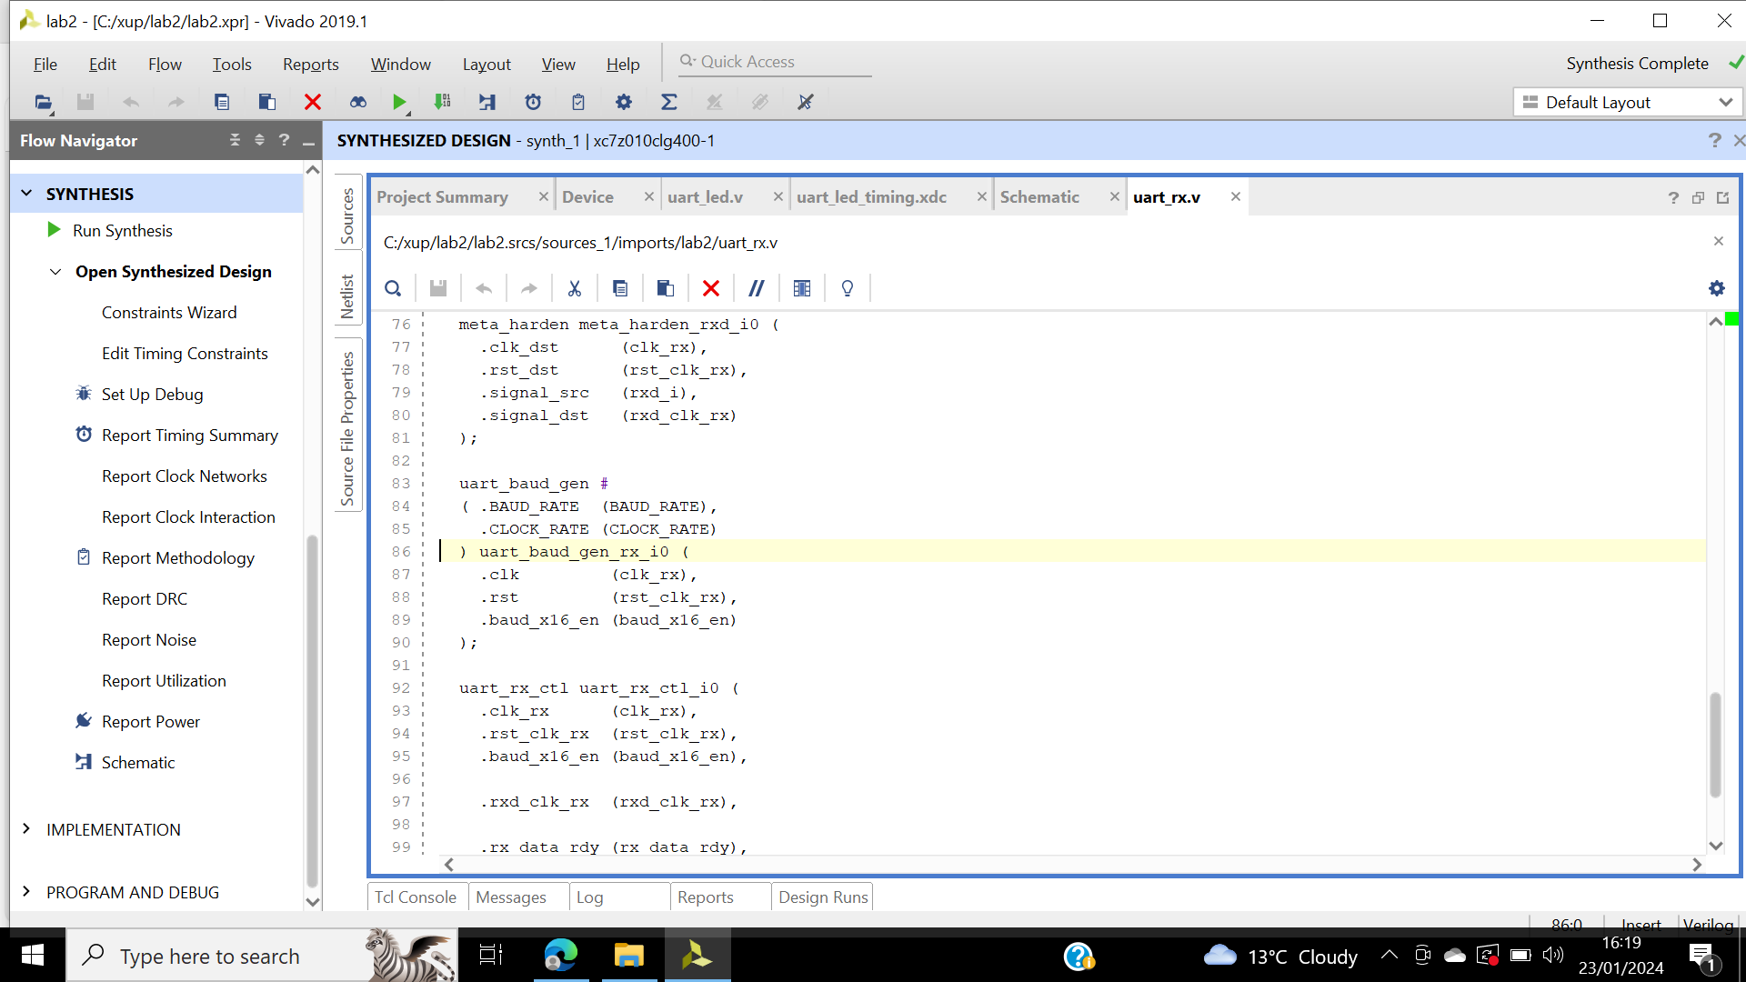

Figure 31: Uart_baud_gen_rx_i0 instance, CLOCK_RATE and BAUD_RATE parameters passed to module being called.

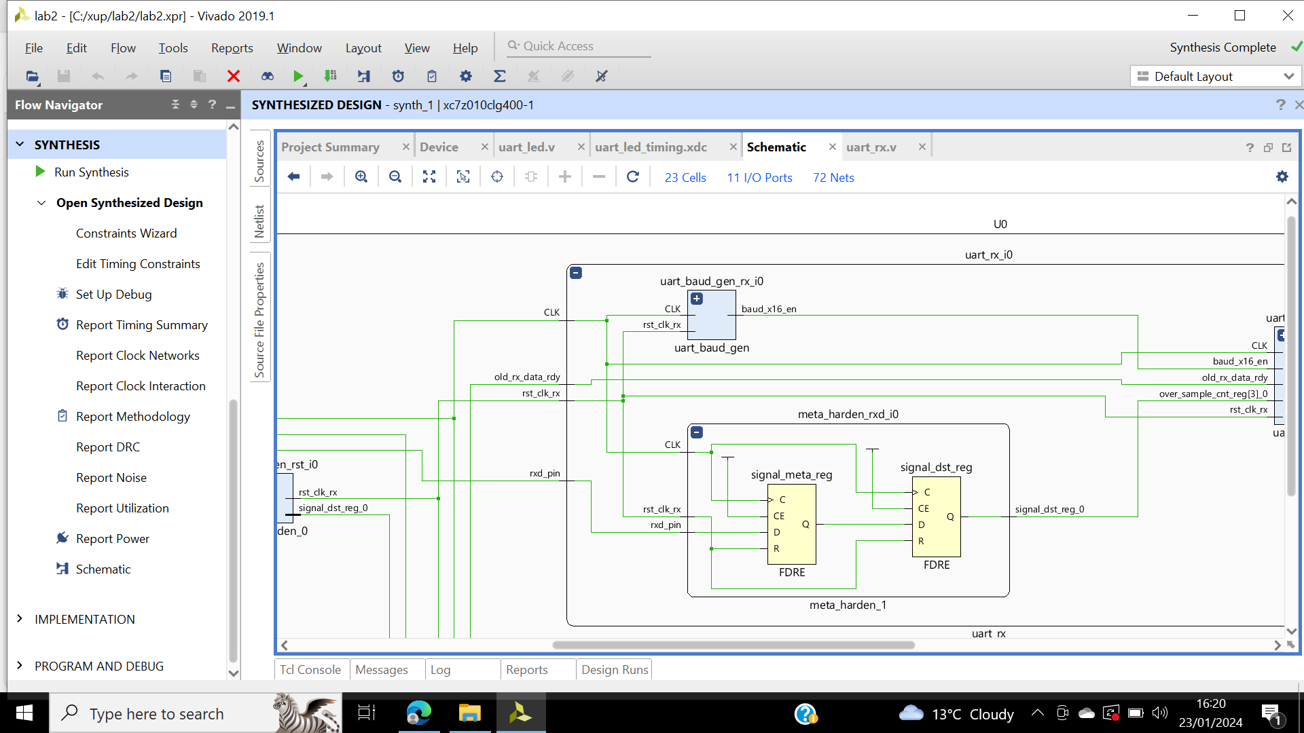

Figure 32: Meta_harden_rxd_io instance, synchronization circuit being implemented.

Timing report shown in figure 33. WNS shows the 8 failing points.

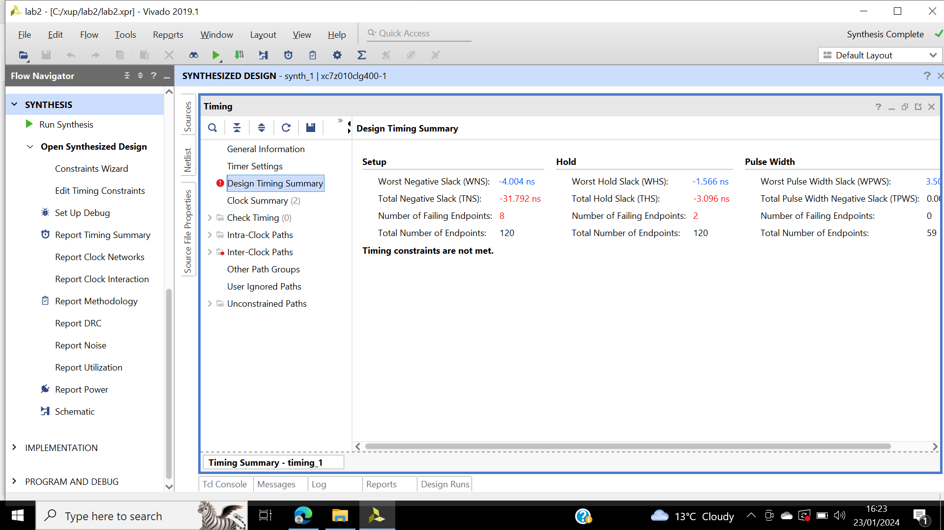

Figure 33: Timing report, Design Timing Summary, and Inter-Clock Paths entry, indicating timing violations.

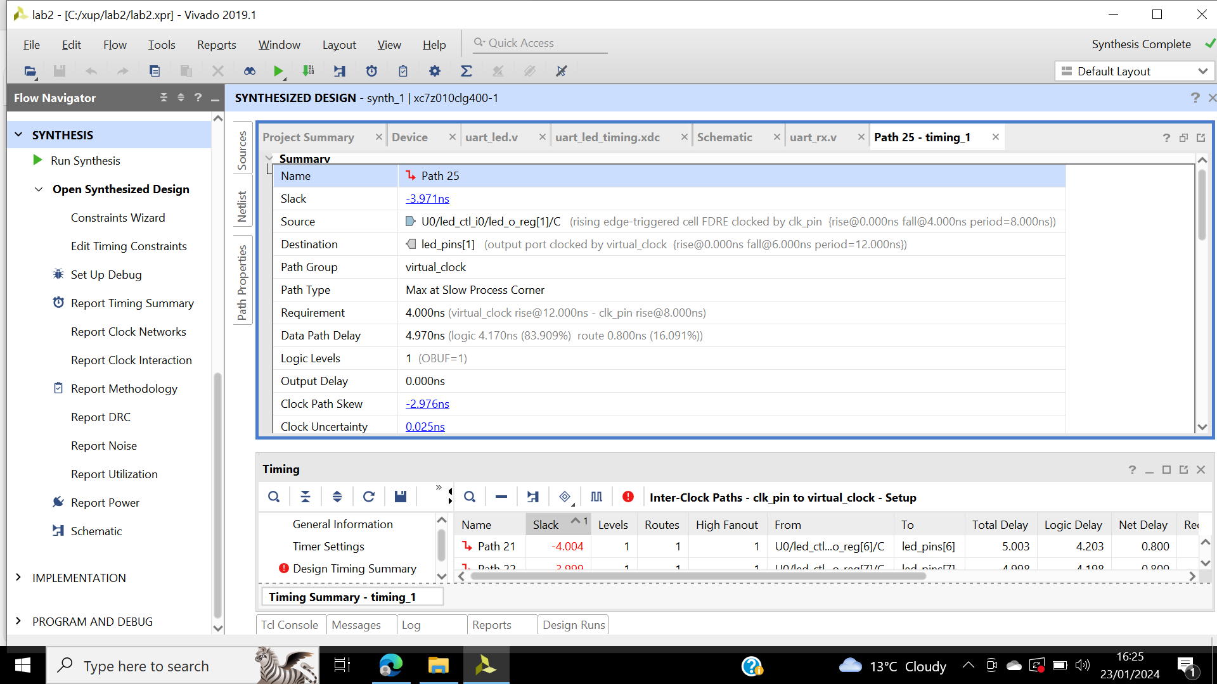

Figure 34: Worst failing path 25.

In figure 34 shows how path 25 is created.

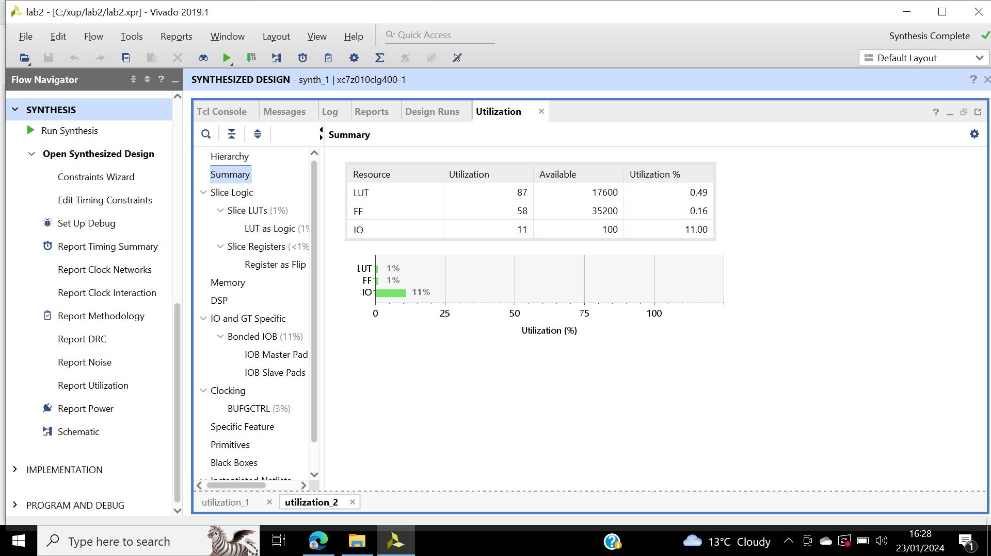

Figure 35: Report utilization summary.

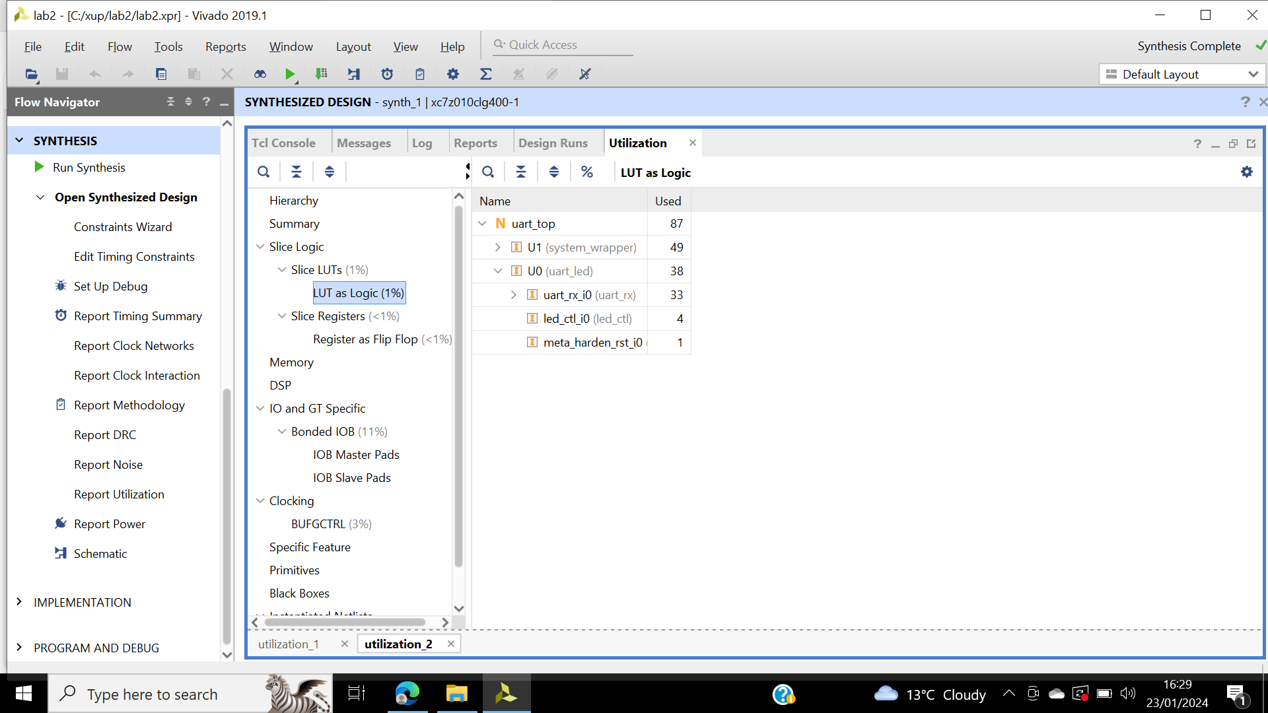

Figure 36: Utilization by lower-level modules, complete hierarchy.

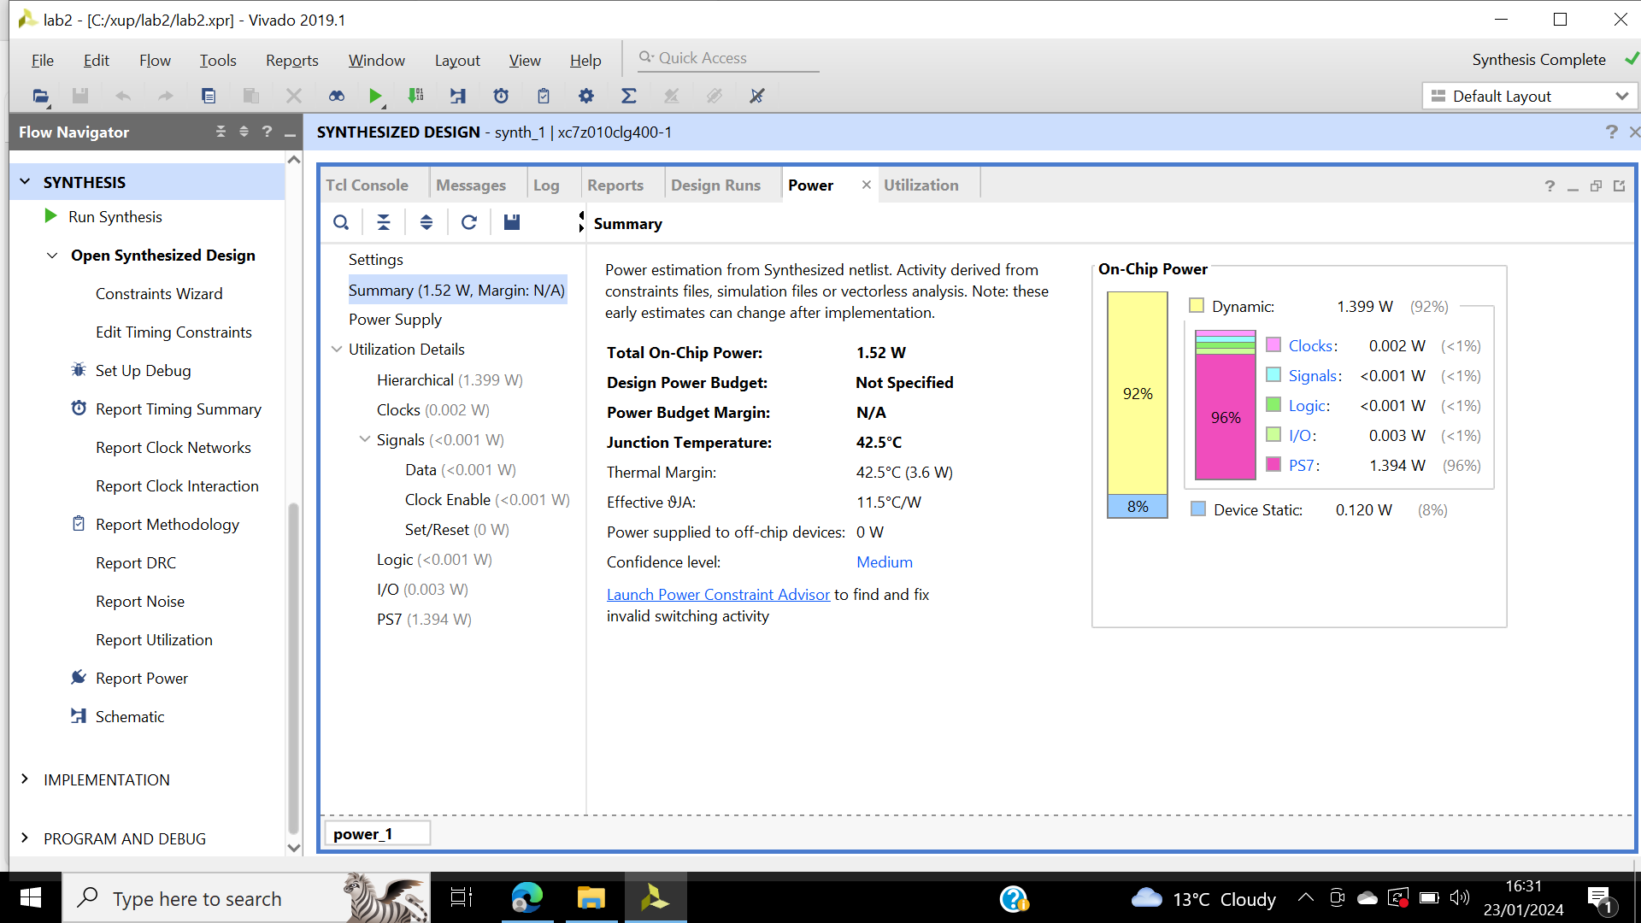

Figure 37: Estimated power consumption, no simulation run data.

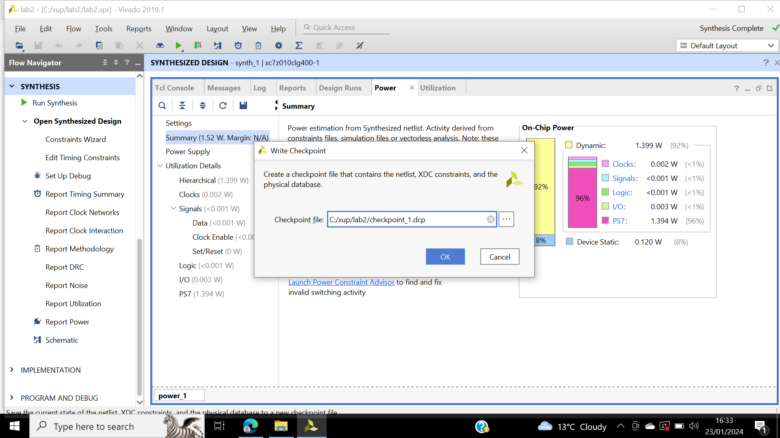

Figure 38: Writing checkpoint.

The flatten hierarchy is changed to ‘full’, the purpose of this is to flatten the design, this shrinks the design hierarchy slowing automation easier. In figure 39 shows the changes to the design.

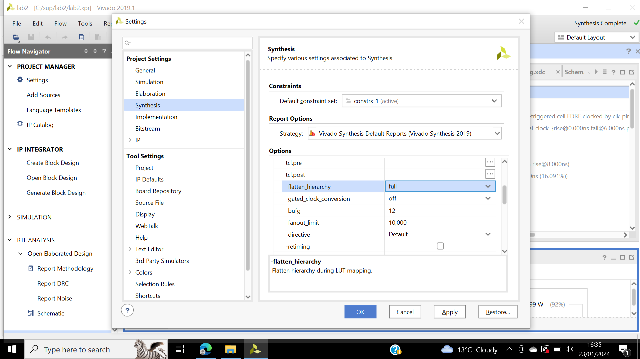

Figure 39: Changing the project settings.

Synthesized design in schematic shown on figure 40.

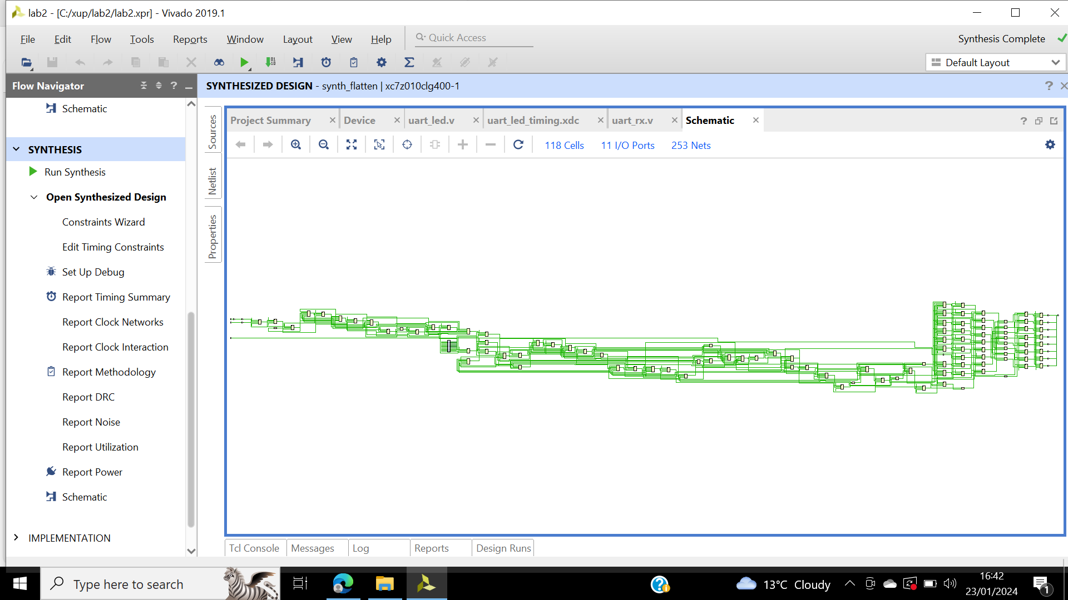

Figure 40: Flatten design schematic view.

Report utilization shows the number of slices, which is 57. Write another checkpoint in order for the processed design can be saved.

Step 4:

Checkpoint_1 is opened, a schematic of the previous design is displayed. From tools the report timing summary is selected and then report utilization.

Checkpoint_2 is opened, checkpoint_1 is closed so that a second Vivado GUI isn’t invoked. The schematic opens showing the difference that changing the synthesis settings has.

## **Conclusions**

In this lab timing constrains and synthesised design were utilised to view various post-synthesis reports. The use of checkpoints was demonstrated to analyse design flow. As well as the effects of changing synthesis setting. Checkpoints allows designer to isolate problems to see where they went wrong. One of the mistakes I made when starting this lab was not changing the clock frequency from 100Mhz to 125Mhz as Zybo has an on-clock rate of 125Mhz.

# **Lab 3**

## **Introduction**

This lab is a carry on from lab2, performing static timing analysis on a simple uart-led, it takes an input and displays the equivalent ASCII characters. Then open the hardware session and program the FPGA. The design will be validated by programming in the hardware in SDK.

## **Objectives and aim**

The objective of this lab is to set the synthesis back its default values, implement the design. Generate and analyse the reports. Run the static timing analysis and generate the bitstream to verify the hardware.

## **Results**

Step1:

Lab 2 is opened and saved as lab 3. Flatten_hierachy is set to rebuilt in synthesis setting. Which allows the design hierarchy to stay during synthesis and rebuilt maintaining logic reference.

Synthesis is completed. Default timing report is created timing_1, illustrated in figure 41.

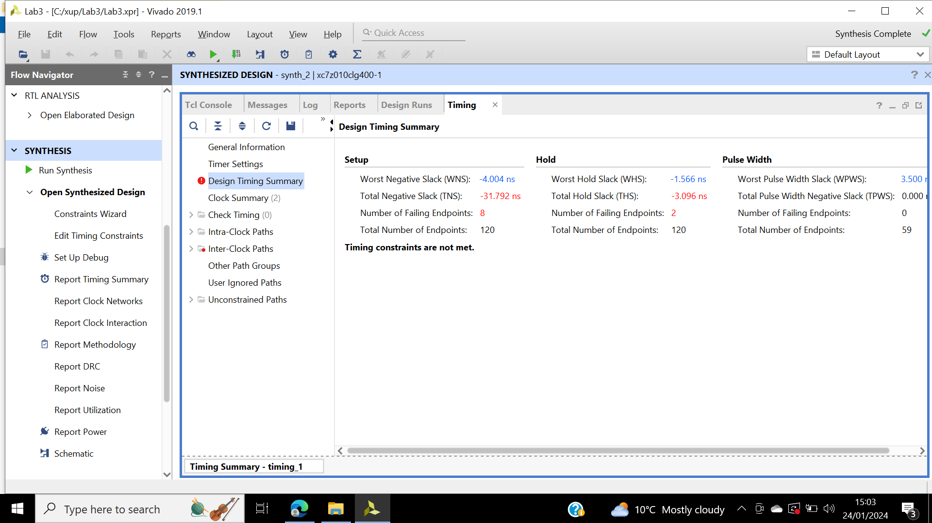

Figure 41: Timing report.

WNS shows the 8 failing points. Path 25 is selected and viewed in schematic illustrated in figure 42.

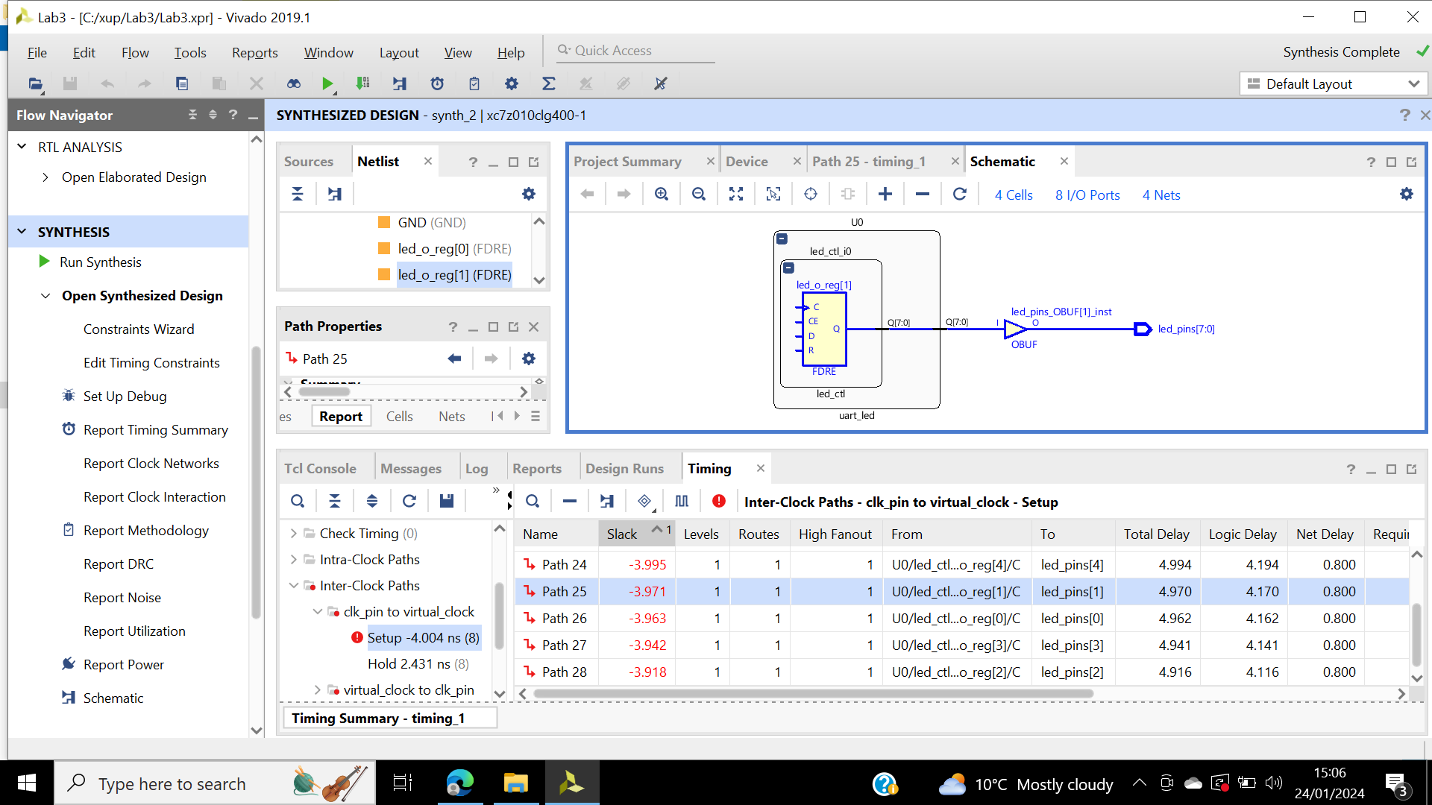

Figure 42: Output data path schematic.

Figure 43 illustrates the full source clock. The data path delay is included in the clock period of the clk_pin clock source. As virtual clock is slower than clk_pin period.

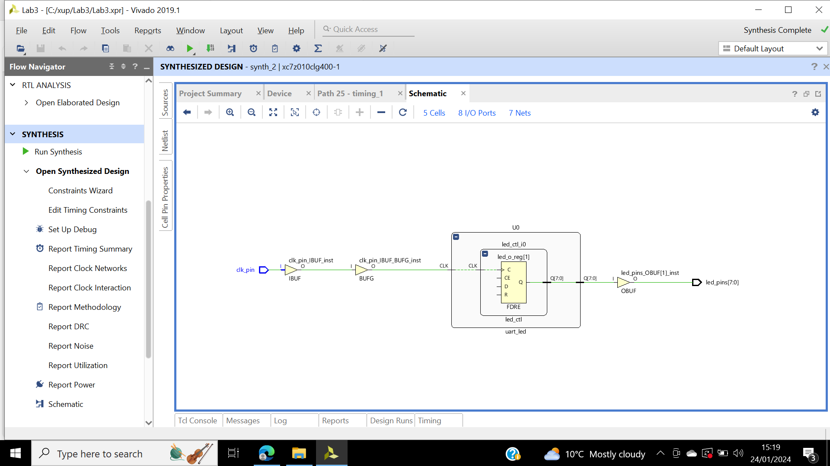

Figure 43: Full schematic of U0.

Design constraint is changed via timing GUI. Change the virtual clock period to 8 ns shown in figure 44 and apply the change. Rerun the report, figure 45 shows timing summary, still 2 failing paths for the hold.

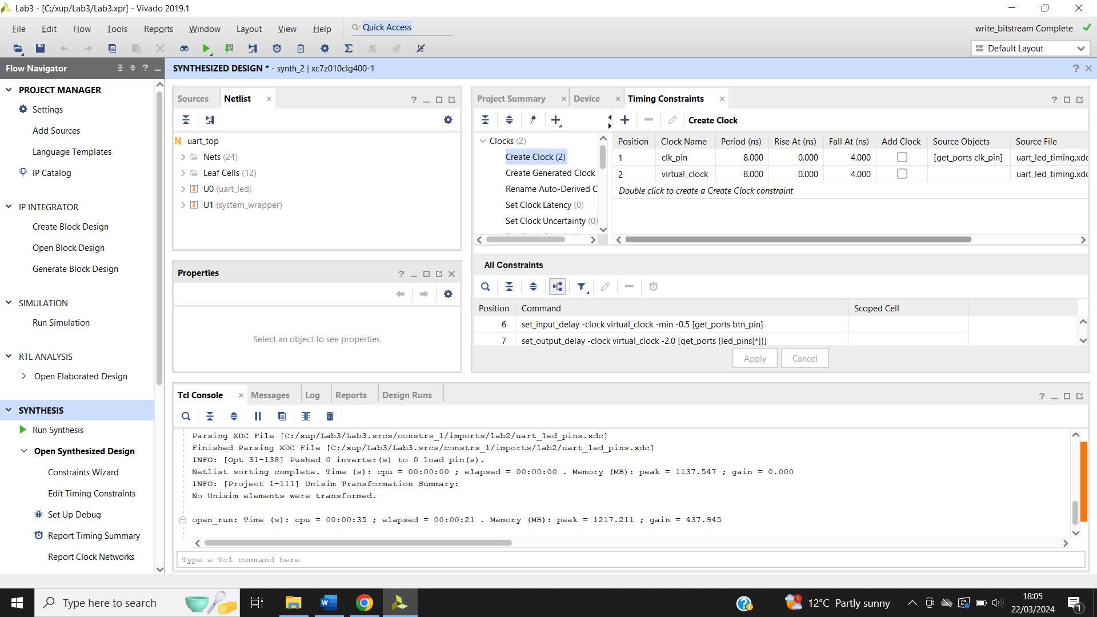

Figure 44: Updated timing Constraints showing.

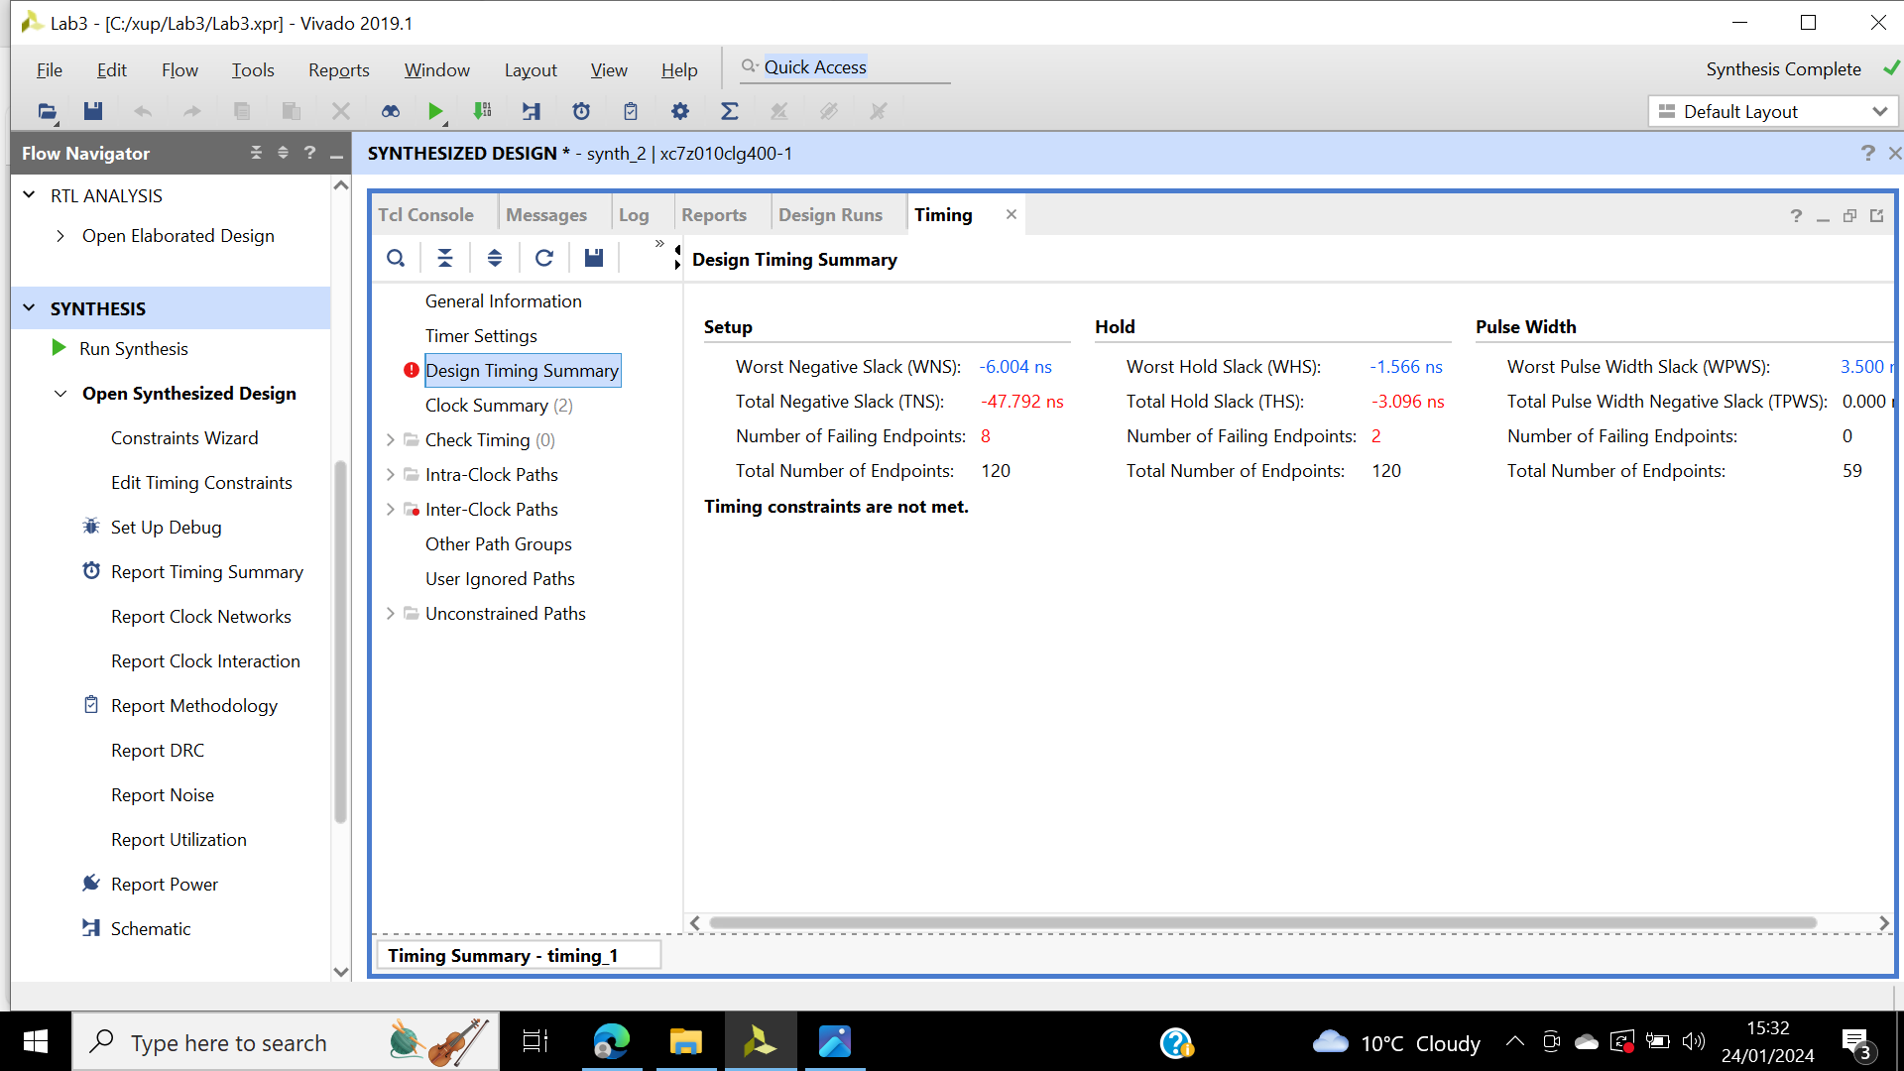

Figure 45: Design timing summary, Setup timing violations removed.

WHS first path timing compositions illustrated in figure 46. The constrain file is saved and updated.

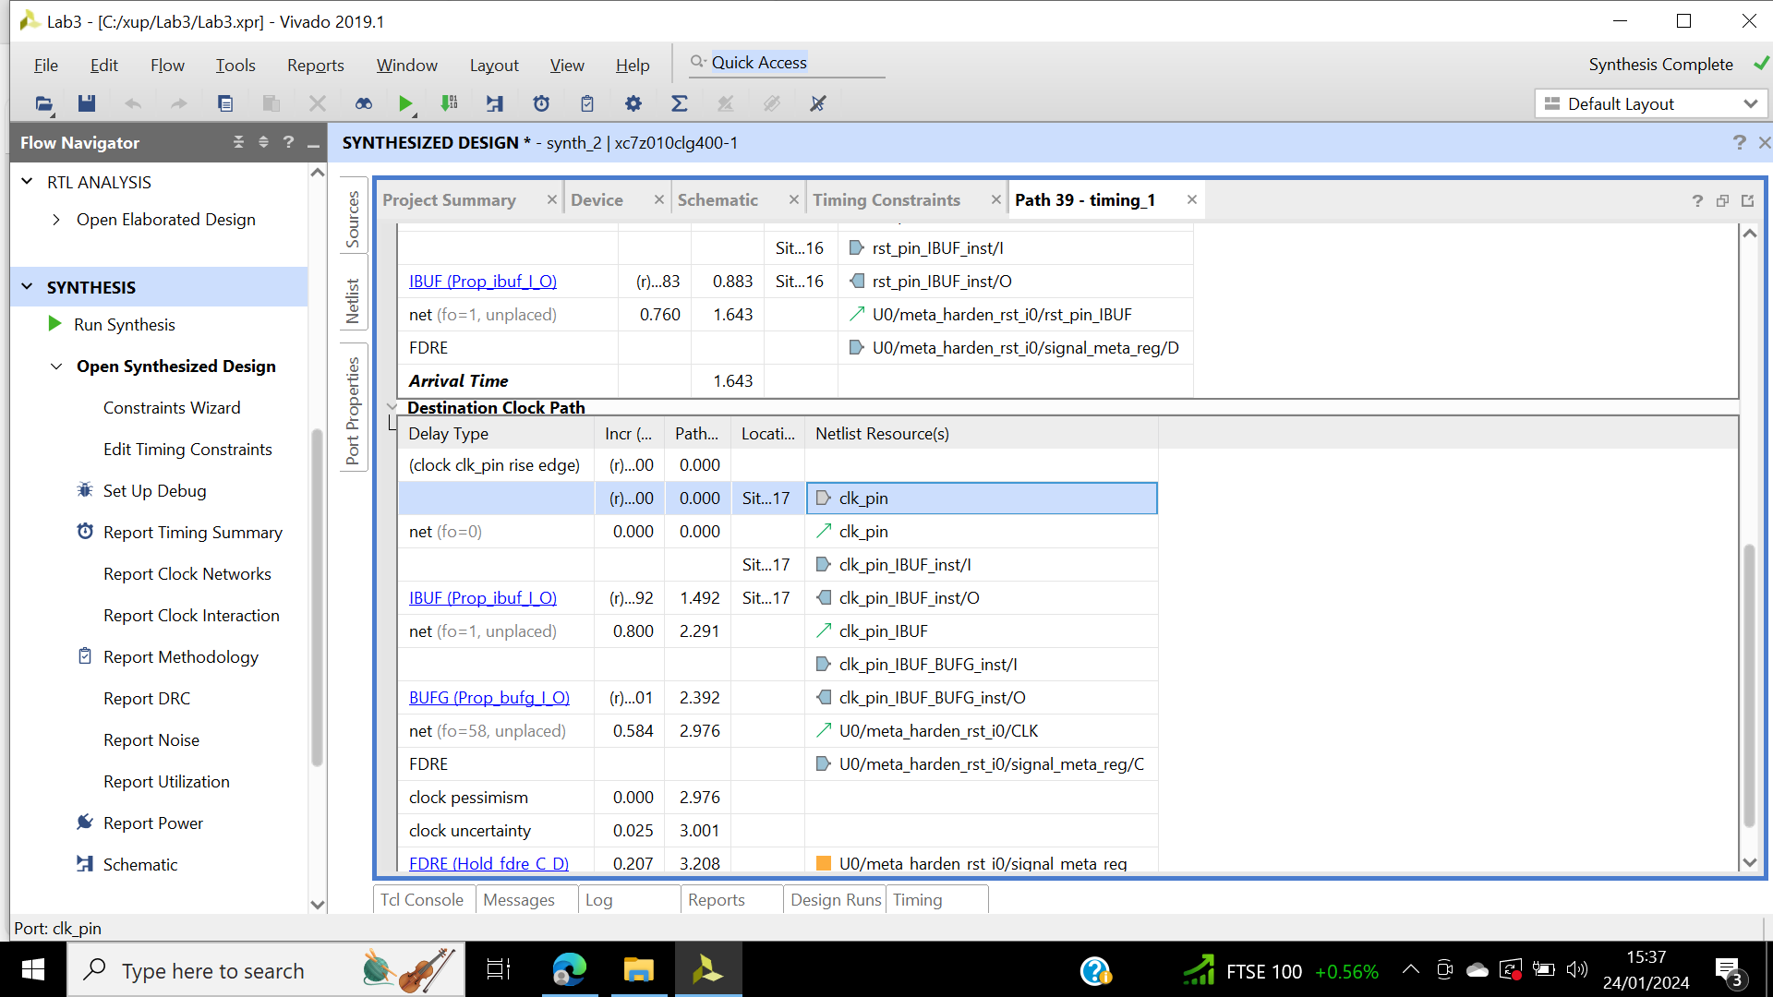

Figure 46: Path timing composition. Not including entire clock period.

Step 2:

Report utilisation is opened, figure 47 shows the slice LUTs.

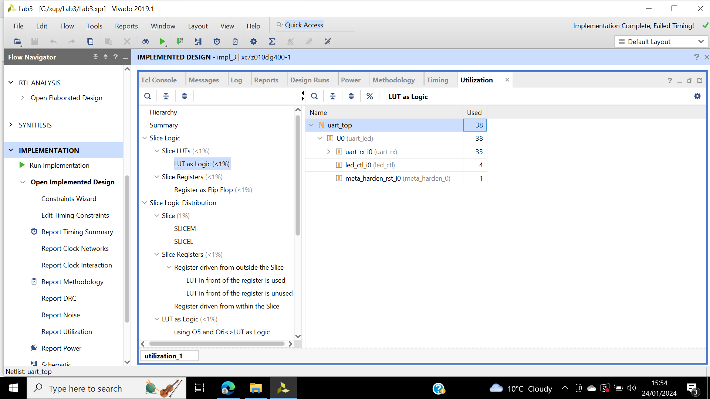

Figure 47: Utilization, slice LUTs.

Report timing summary is selected. Figure 48 shows the timing summary report generated. Compared to delays from the synthesis report (estimated figures), net delays are real delays. The data path delay is longer than the destination clock path delay introducing negative slack violation.

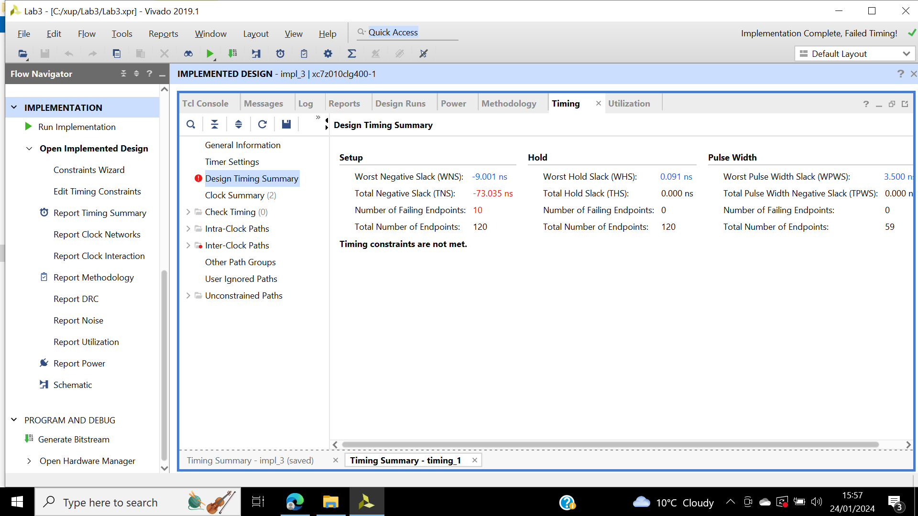

Figure 48: Timing summary report, timing violations.

Edit timing is selected, output delay value is changed to -2ns illustrated in figure 49, no more timing violation.

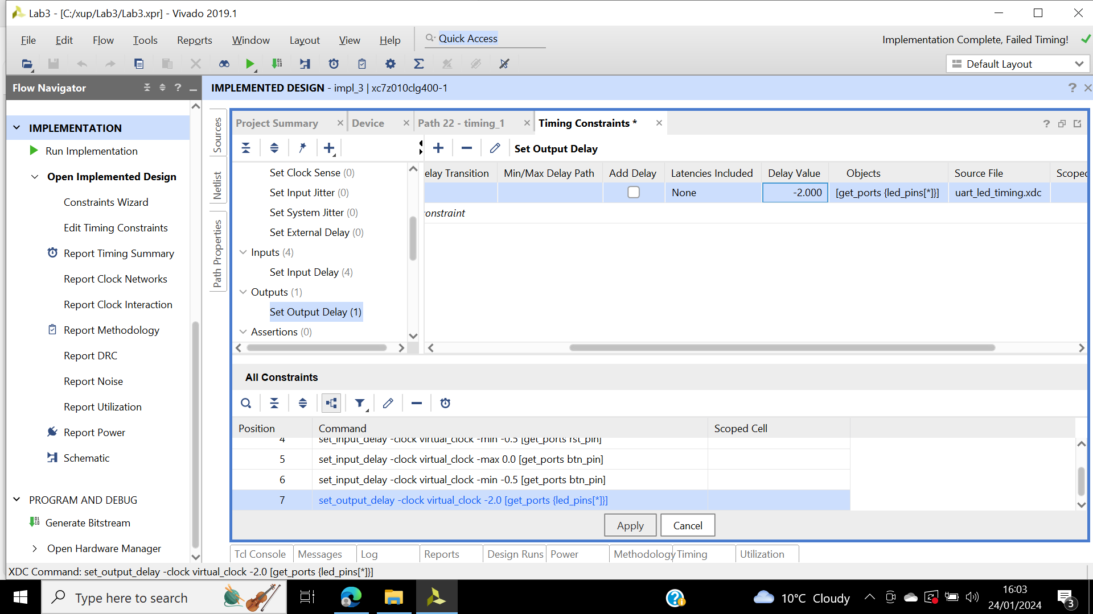

Figure 49: Editing timing constraint, set output delay entry.

Device view clk_pin entry shown in figure 90.

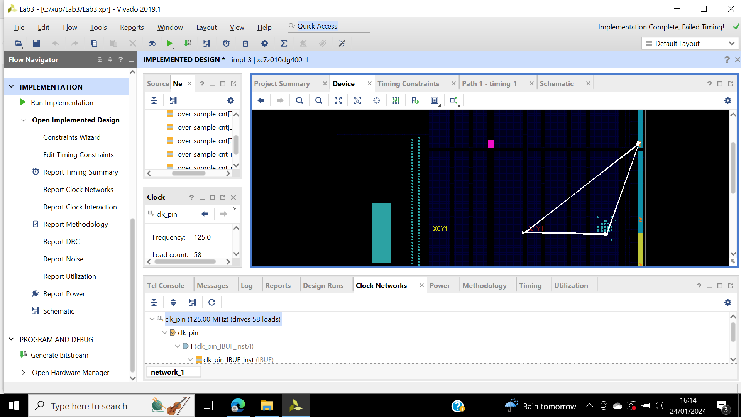

Figure 50: Clock nets, spread across multiple clock regions.

Step 3:

Generate the bitstream. Then reset the runs and re-run all the processes.

Step 4:

Connect the boards and program the FPGA. Once the programming bit file is downloaded the done light turns on. Start the terminal emulator tera term, figure 51 shows the COM settings.

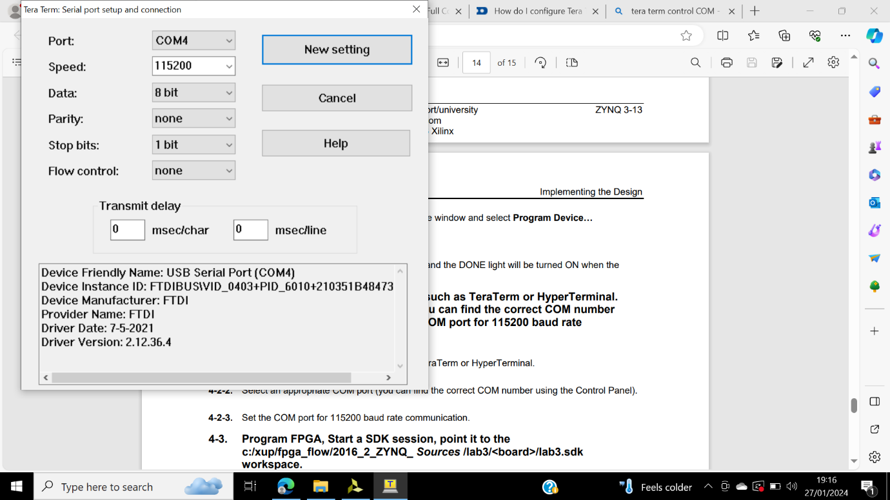

Figure 51: COM setting.

SDK is started, uart_led_zynq is launched on hardware. The program is downloaded.

Characters are written in the serial terminal and corresponding ASCII characters bit equivalent appear on the LED. BTNU swaps the upper four bits and the lower four bits, figure 52 and figure 53.

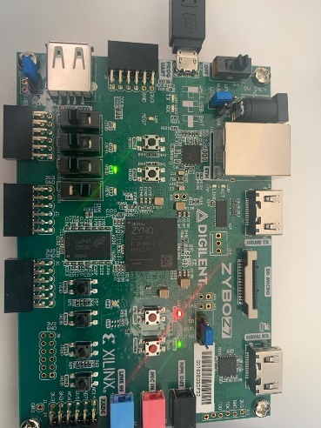

Figure 52: B.

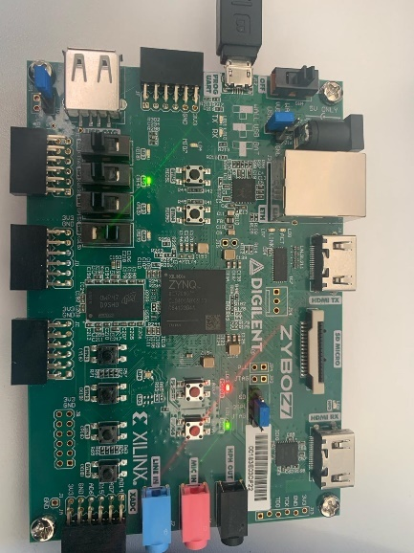

Figure 53: BTNU, B.

## **Conclusion**

This lab explored basic design analysis and further report analysation. As well as using various tools such as the tools connected to the display timing-critical paths including schematic viewers, delay path properties and reports, device view and selecting primitive parents. It has helped developed my understanding of reports and how each one can be utilised to further optimise the design. One of the difficulties of this the design was the ability to interpret the clock net, further analysis of the design was able to help me as well as introduce me to further opportunities, such as the ability to hide clock nets.

# **Lab 4**

## **Introduction**

This lab will be using IP catalogue to generate a clock resource, then instantiate the generated clock core in the waveform generator design. The IP integrator is used to generate the FIFO core which is used in the HDL design.

## **Objectives and aims.**

The objective of this design is to include an IP while making the project. Use the IP catalogue to produce a clocking core, then instantiate it. Using the IP integrator to create a block design, then instantiate it. Finally generate a bitstream and verify the functionality in the hardware.

## **Results**

Step 1:

New Vivado project is created, illustrated in figure 54. Syntax error appear on the source pane due to missing files. clogb2.txt is added fixing the error.

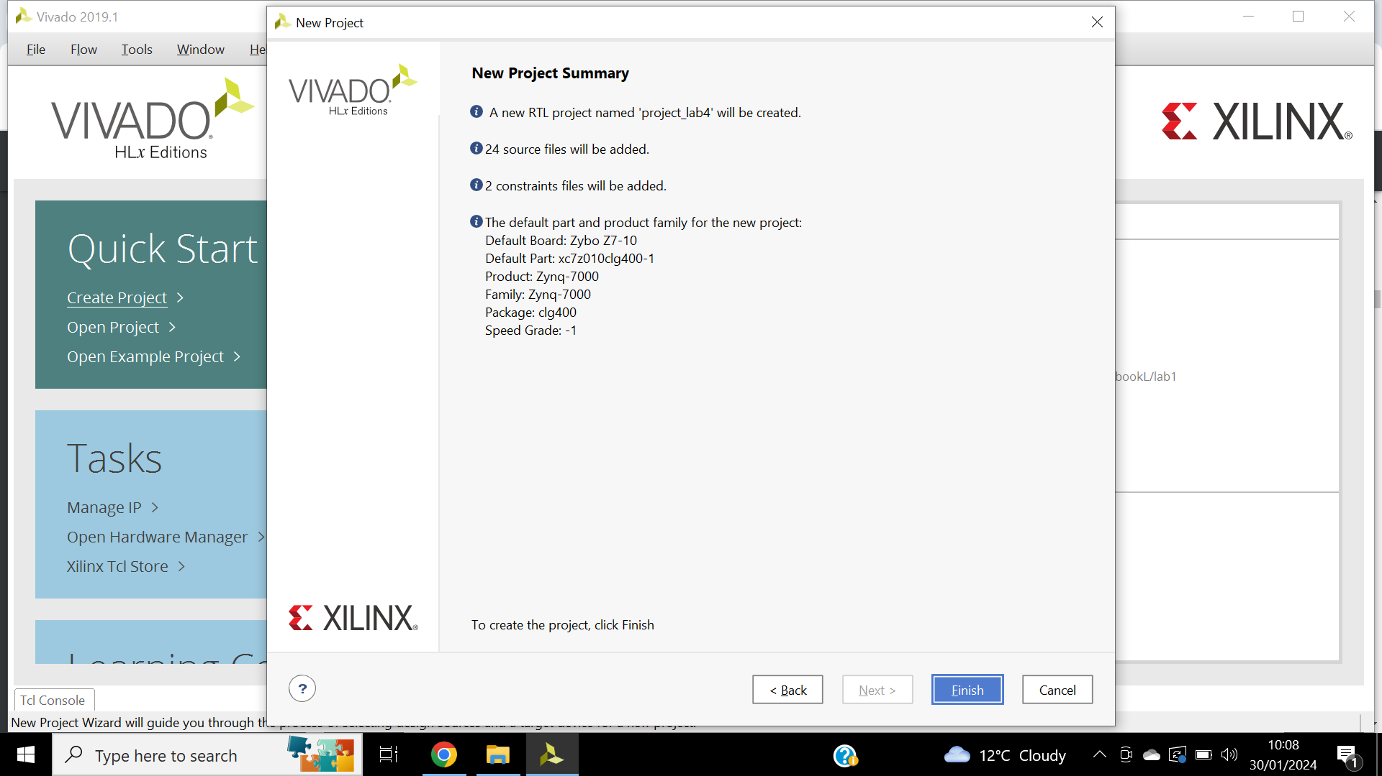

Figure 54: Summary page- clock core being generated.

Step 2:

On the clock wizard, core name is changed to clk_core primary input clock frequency to 125MHz and the primitive used to MMCM illustrated in figure 55.

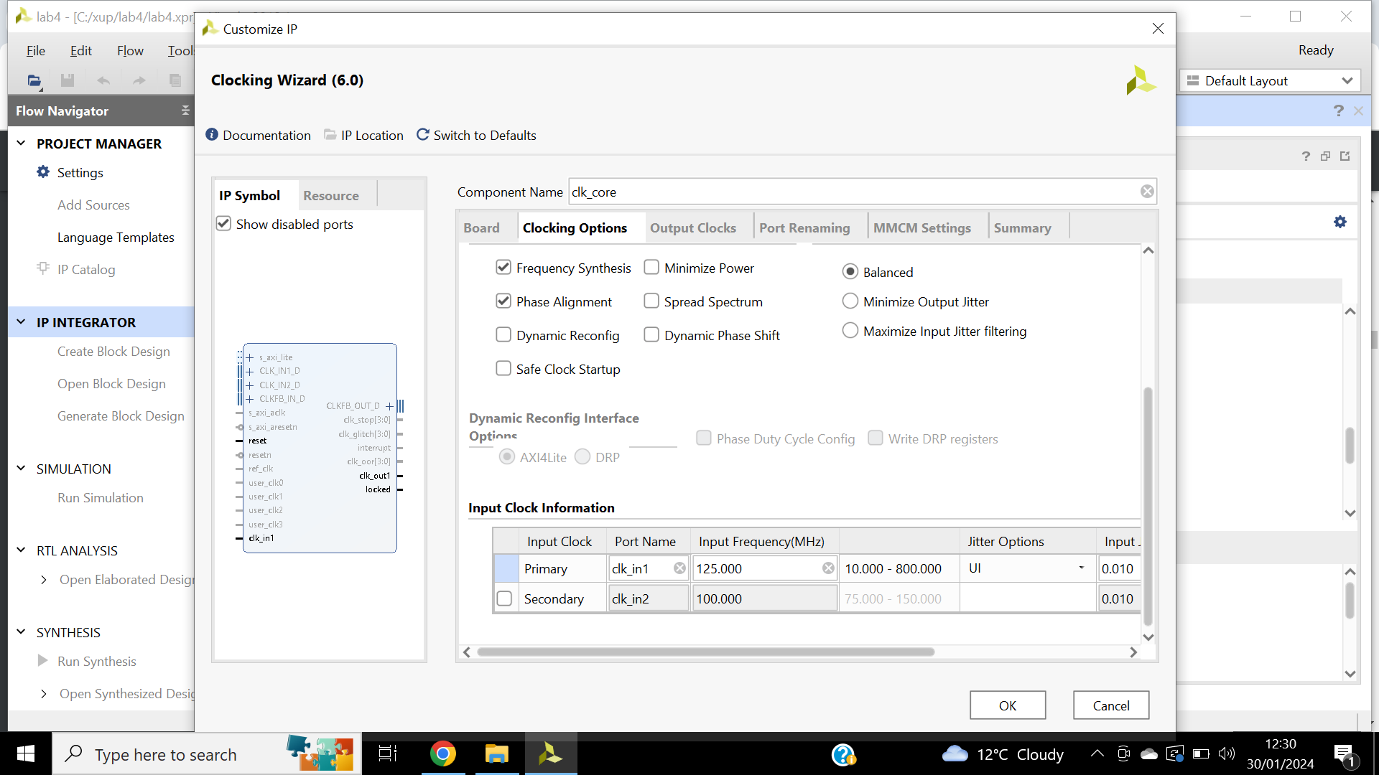

Figure 55: Updated clocking option, clocking wizard.

The second clock output is enabled via output clocks tab. The requested output frequency should be 50MHz illustrated in figure 56. Figure 57 shows the summary page.

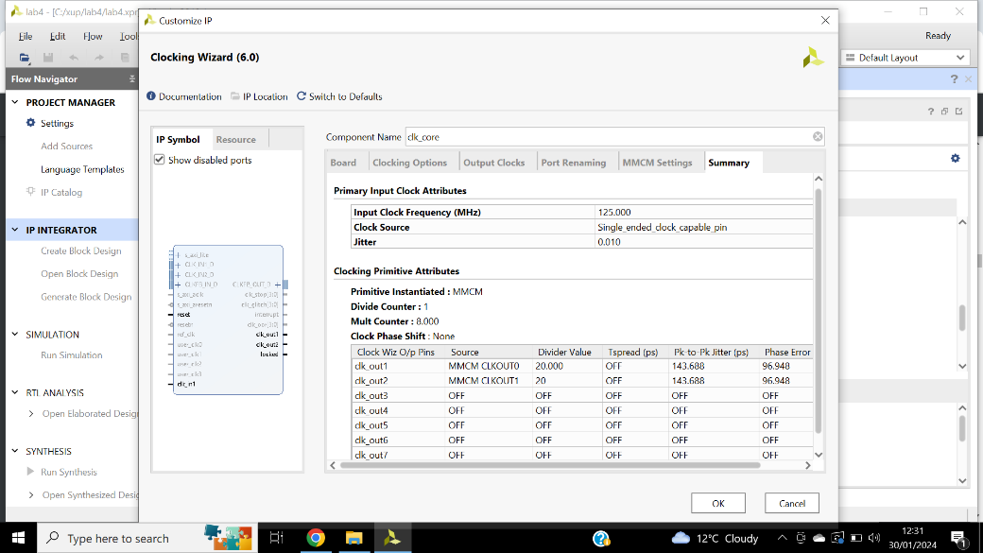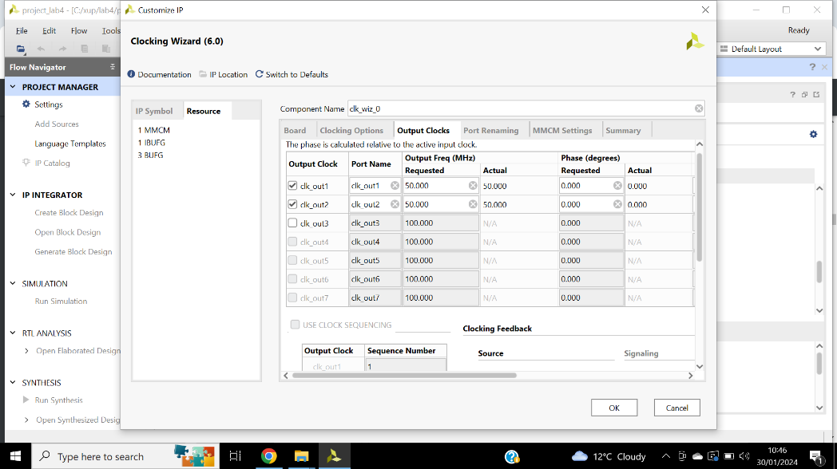

Figure 56: Updates output clocks, clocking wizard.

Figure 57: Summary page, clock core being generated.

Code from clk_core.veo are pasted into clk_gen.v file. Figure 58 shows the updated clk_gen.v file which instantiates the clk_core. Save the file. Figure 59 shows clk_core instantiated in the hierarchy.

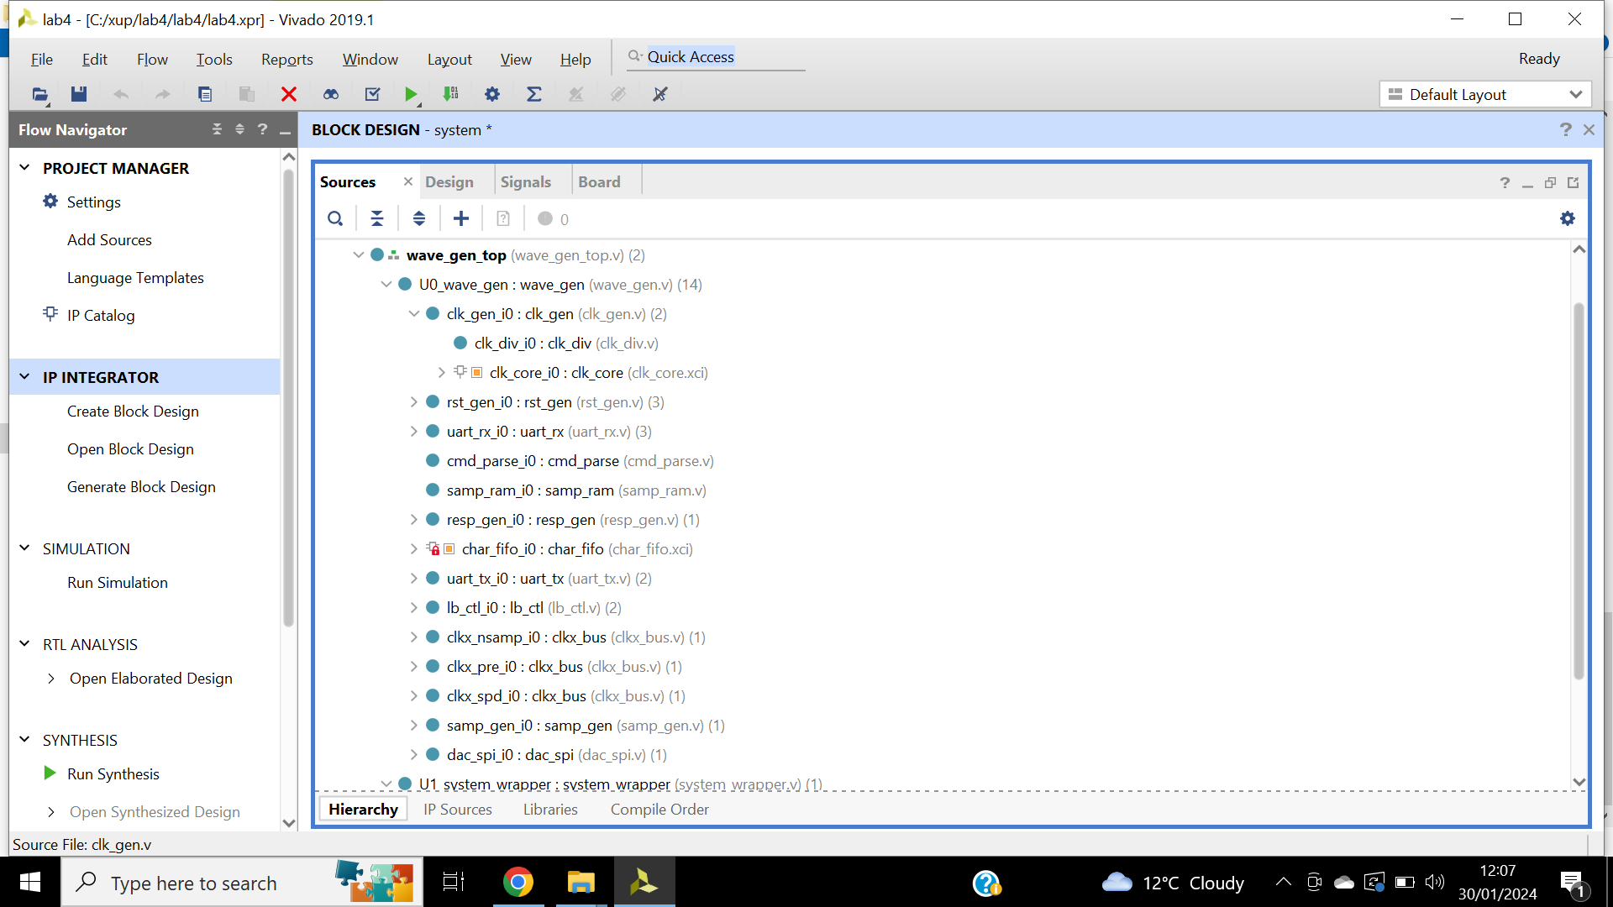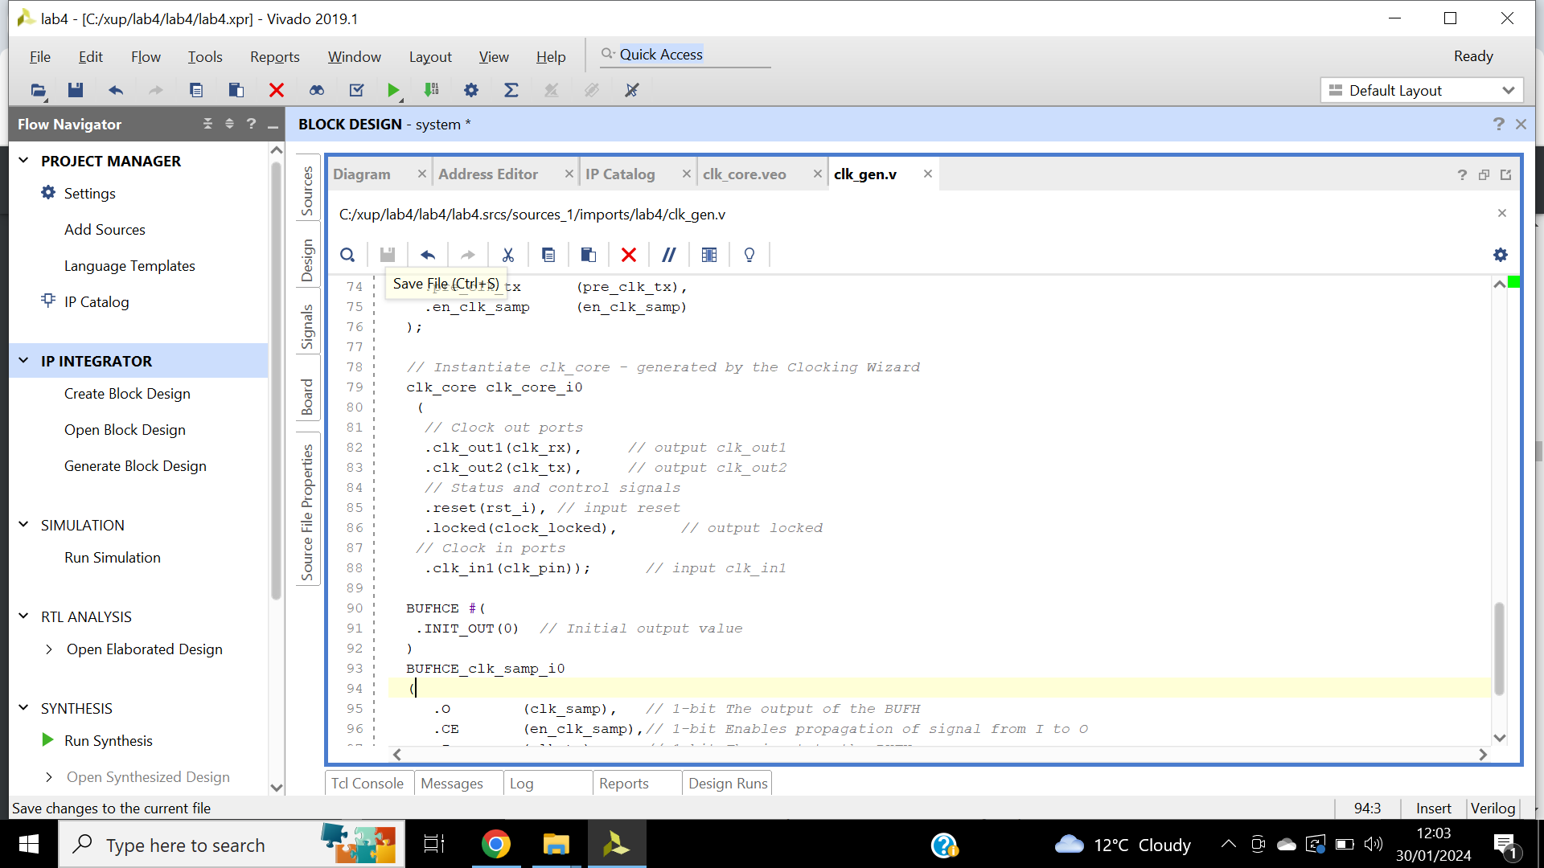

Figure 58: clk_gen.v file, changed instance name and net names

Figure 59: Design source hierarchy, clk_core.xci.

Step 3:

Implementation is completed. Figure 60 shows clock resource utilisation.

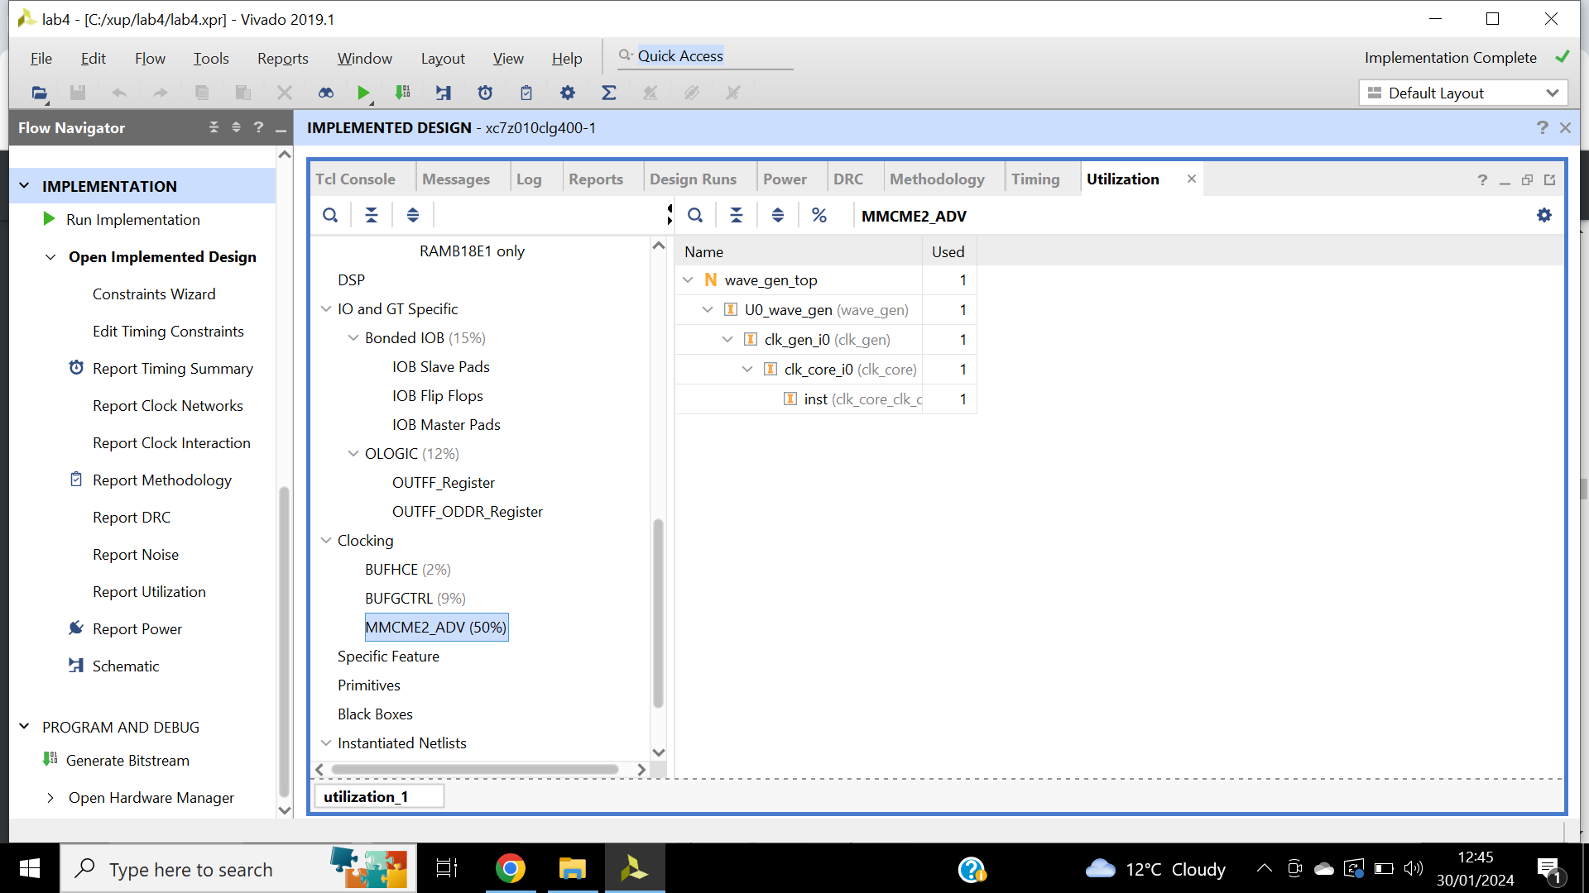

Figure 60: clock resource utilisation, -design using clock resources.

Step 4:

Bitstream is generated, the board is connected, and power is turned on.

Tera term is started, then the device is programmed. SDK is launched, wave_gen_uart is launched on hardware.

Testpattern.txt content is sent to the design. The design understands various commands all in hexadecimals depicted in figure 61.

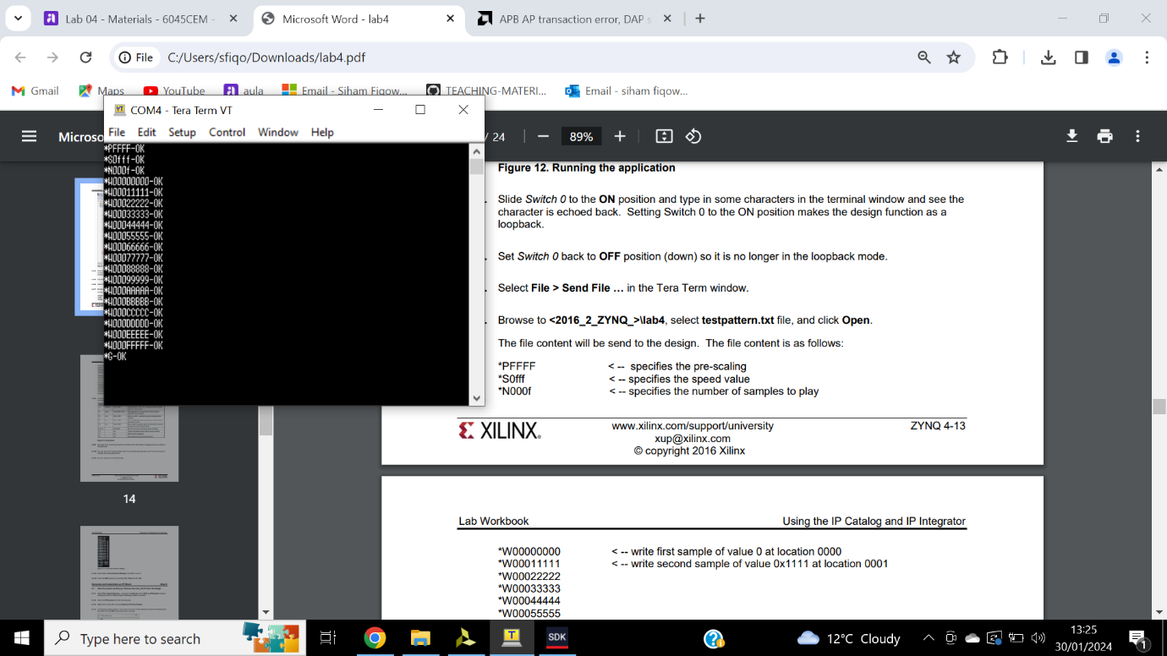

Figure 61: Terminal display window.

Step 5:

Project is saved as lab4.ipi, char_fifo is removed from IP sources as well as its instantiation in wave_gen.v file.

New block designed named char_fifo is created. Fifo generator is instantiated via IP catalogue, figure 62.

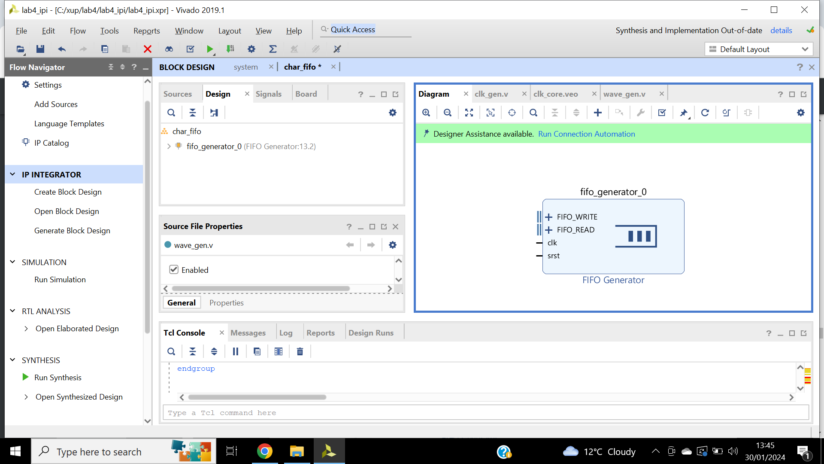

Figure 62: Fifo generator instantiated in design canvas.

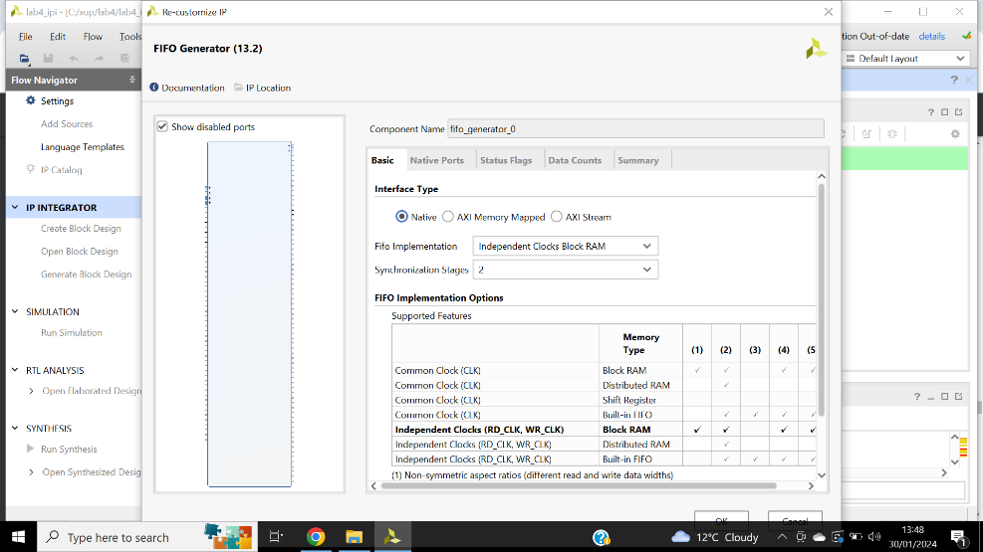Figure 63 illustrates the Interface type and FIFO implementation. On the natives’ tab figure 64 illustrates the read mode, write and read width. Figure 65 displays the summary tab.

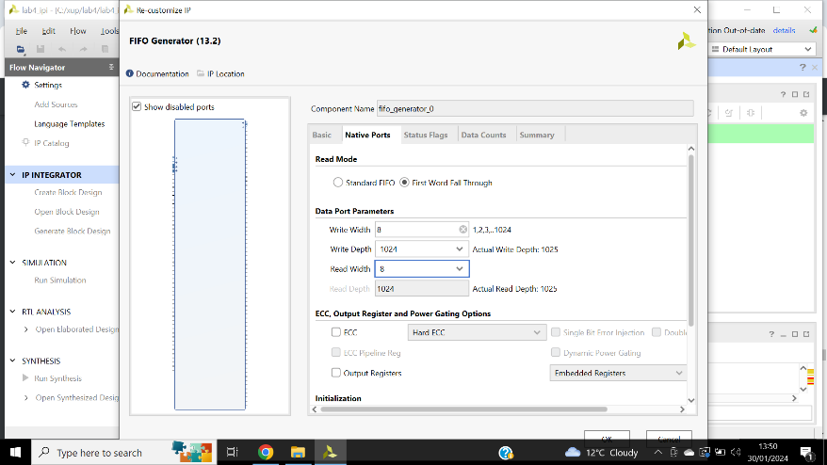

Figure 63: Configuring BRAM for separate read and write clocks.

Figure 64: Configuring port width and read mode.

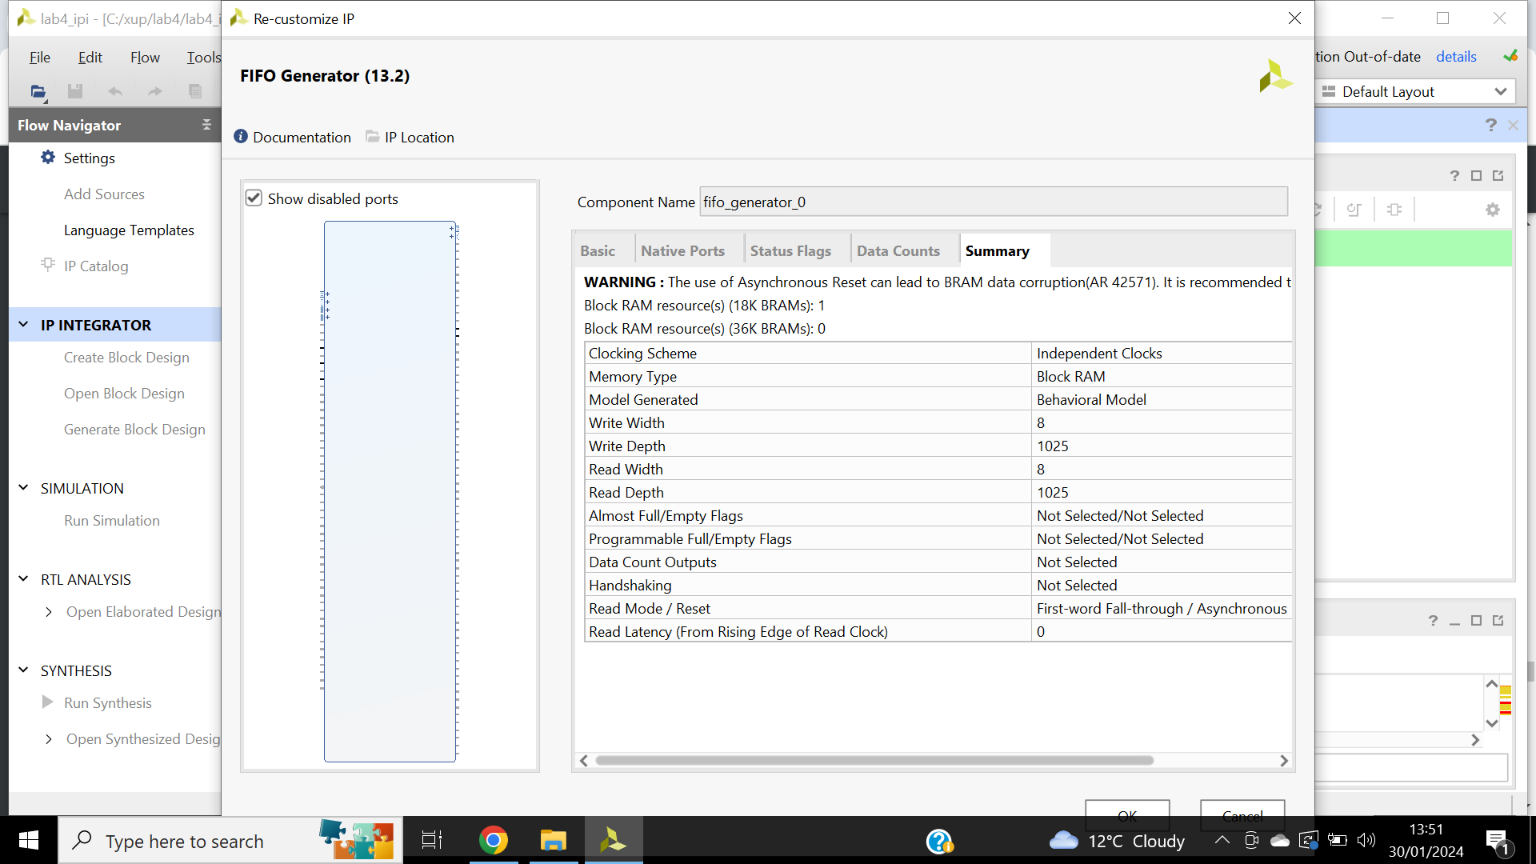

Figure 65: Summary tab of selected options and listing resources for configuration.

External wr_clk name is changed to clk_rx. External rd_clk name to clk_tx. Expanded FIFO_write and FIFO_read shows signal names, input and output ports are made external. In the external port properties, their names are changed shown in figure 66, select refresh to update the diagram. Figure 67 illustrates the design validation.

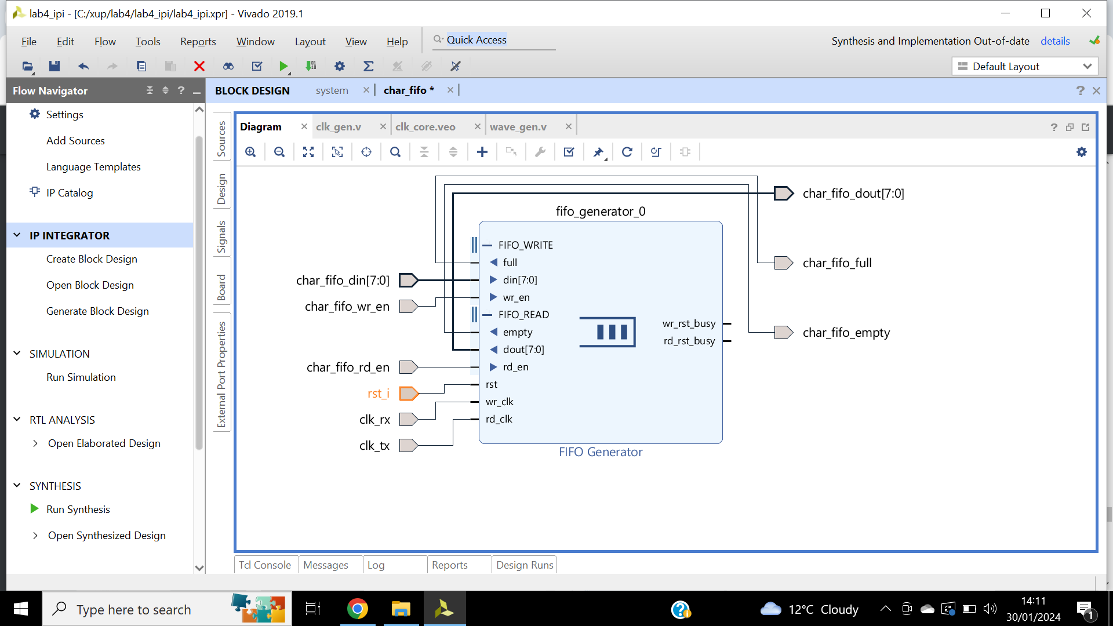

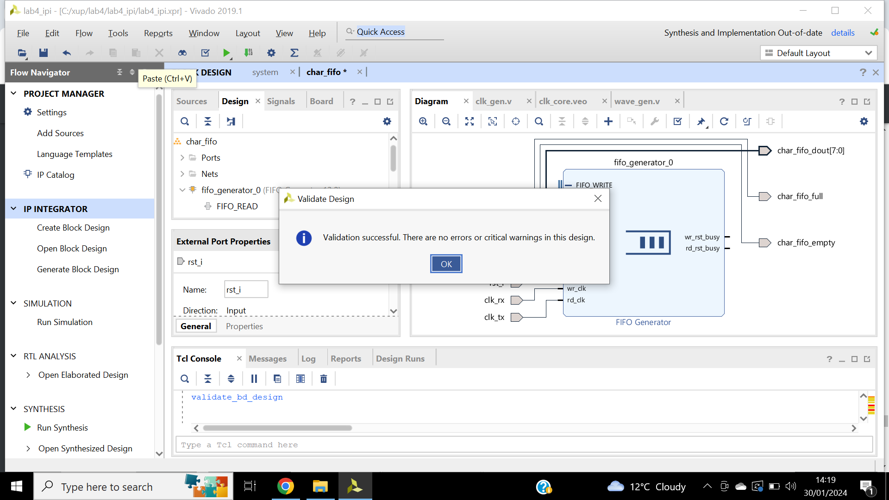

Figure 66: FIFO generator renamed ports.

Figure 67: Validation successful.

Generate output product for char_fifo so the IP can be instantiated in the design. Figure 68 shows the generated IP products.

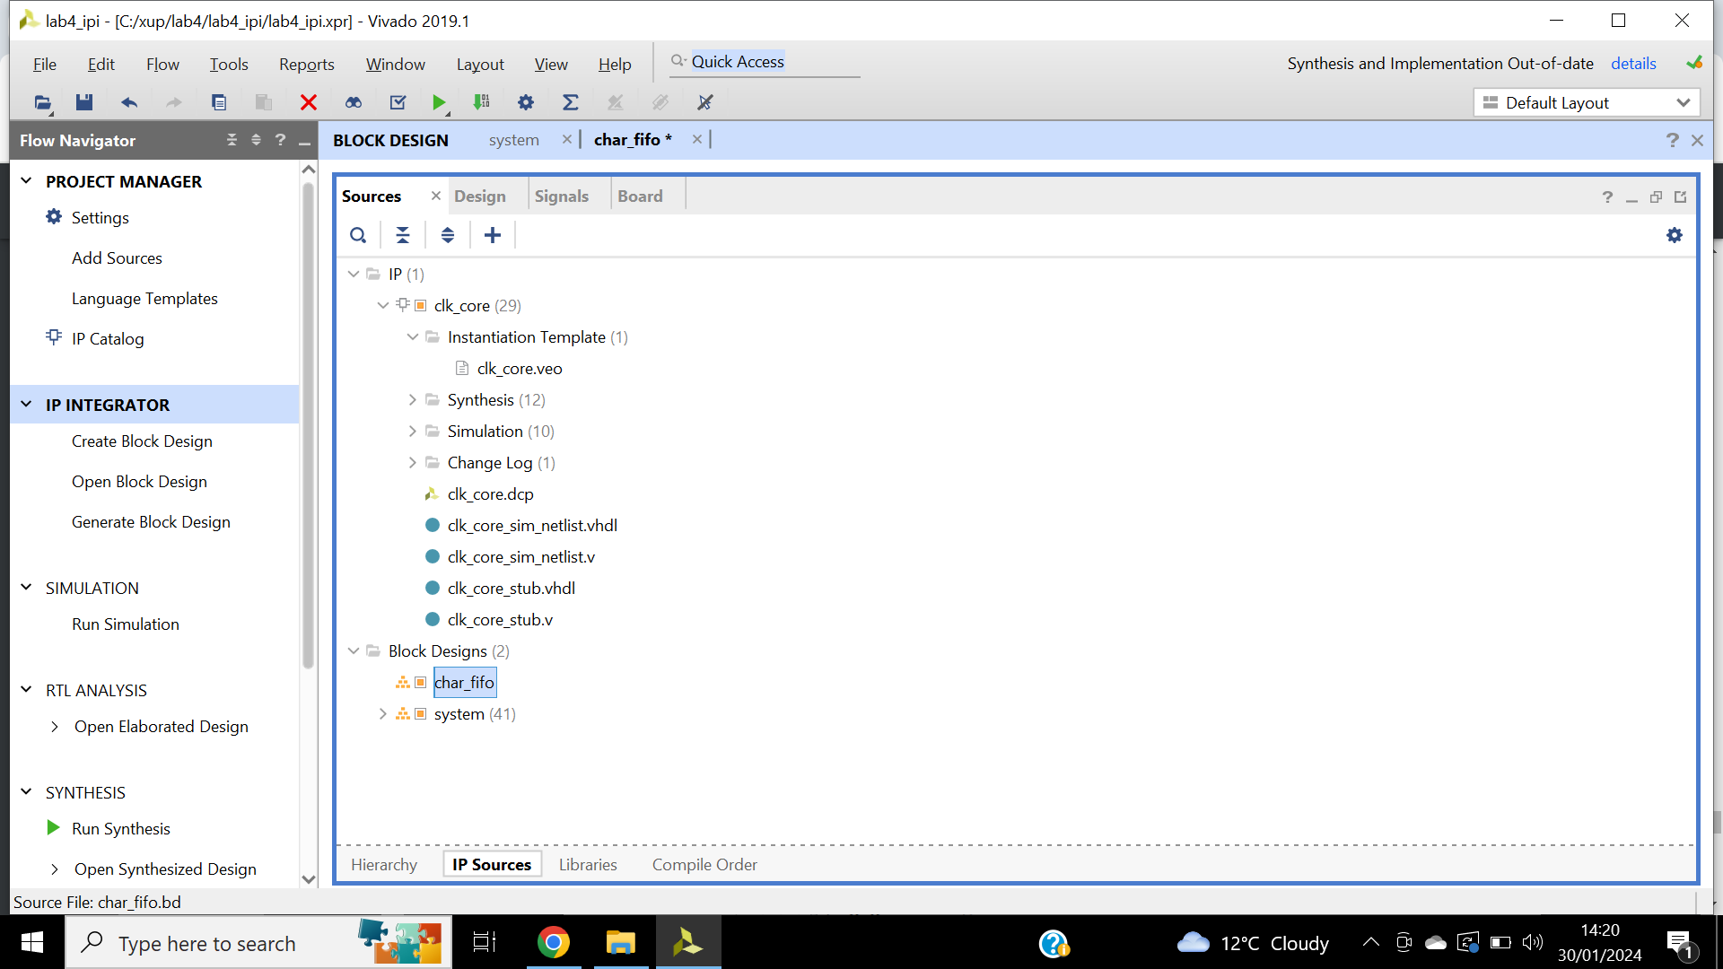

Figure 68: various IP output products displayed in the IP Sources tab.

Code from char_fifo_wrapper.v instantiation template is copied into wave_gen.v depicted in figure 69.

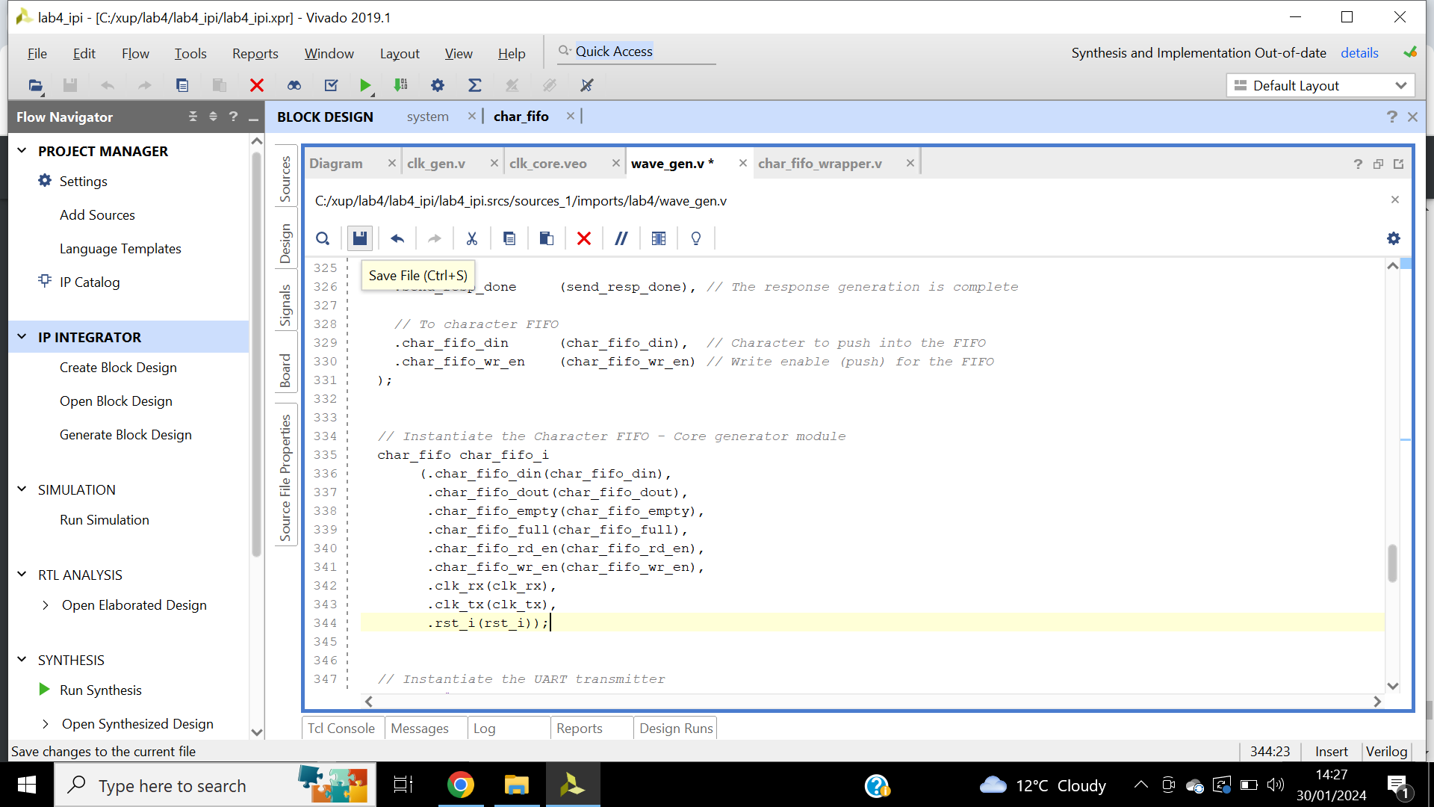

Figure 69: Wave_gen.v, instantiating char_fifo into the project.

Implementation is completed, the design is resynthesized, figure 70 illustrated the resource utilization report.

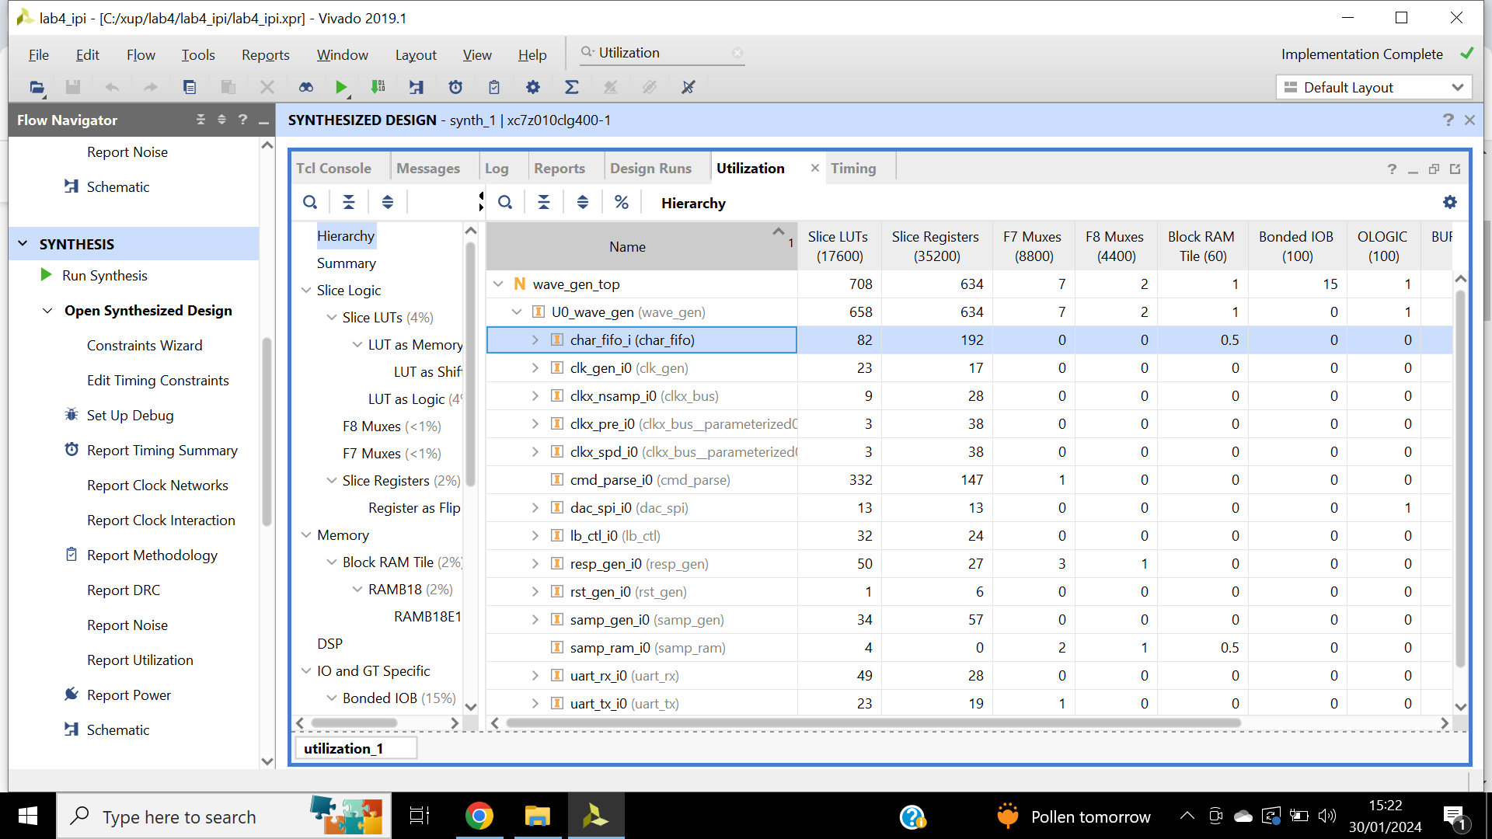

Figure 70: Resource utilization report, only one FIFO being used.

Bitstream is generated, FPGA is programmed. SDK is launched. Launch on hardware depicted in figure 71. Functionality is verified demonstrated in figure 72.

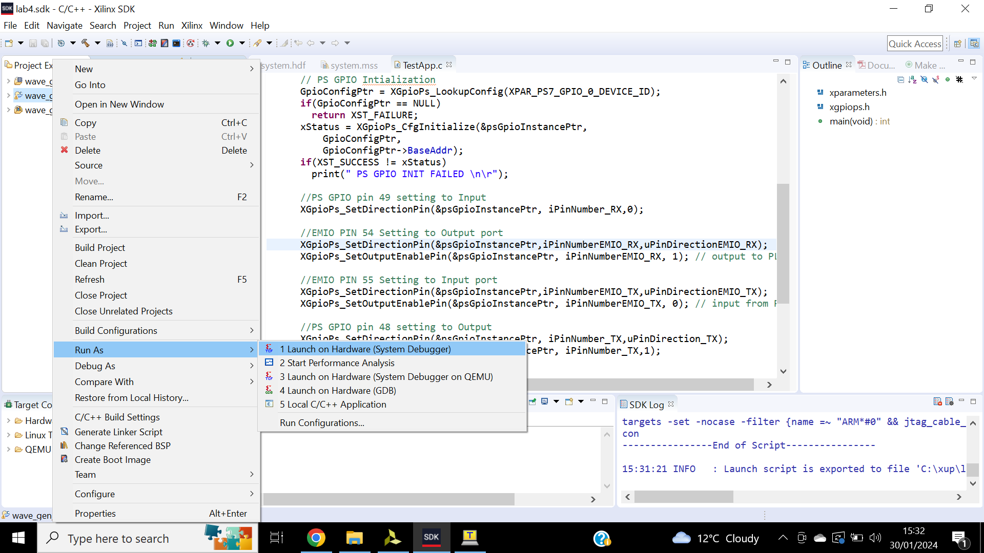

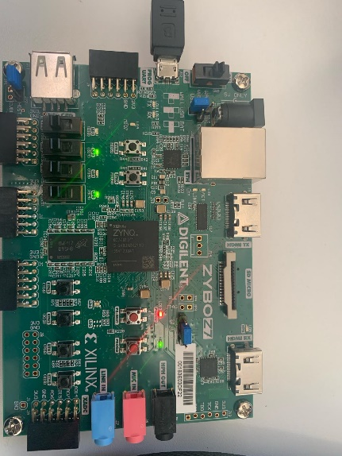

Figure 71: Verifying on hardware, character R.

Figure 72: Launch on hardware.

## **Conclusions**

This lab allowed us to insert existing IP while creating a project. The use of IP catalogues to generate a core. A FIFO was generated using the IP integrator which was used in the HDL. The generated core and block design were instantiated, then verified in the hardware. The IP integrator delivers a framework making IP integrations easier, faster and less error prone with aid from AXI bus interface. It allows for Ips to be shared and reused between projects and third parties.

# **Lab 5**

## **Introduction**

Lab 5 will be using uart_led of previous design to use I/O planning type, enter pin locations and export this to the RTL. Timing constraints are created, and timing analysis is performed.

## **Objectives and aims.**

The aim of this lab is to create a Vivado I/O planning project assigning various pins. The design will be synthesised, and timing constrains will be entered, the design will then be implemented perform timing analysis again and generate bitstream to verify functionality.

## **Results**

Step 1:

created Vivado I/O planning project.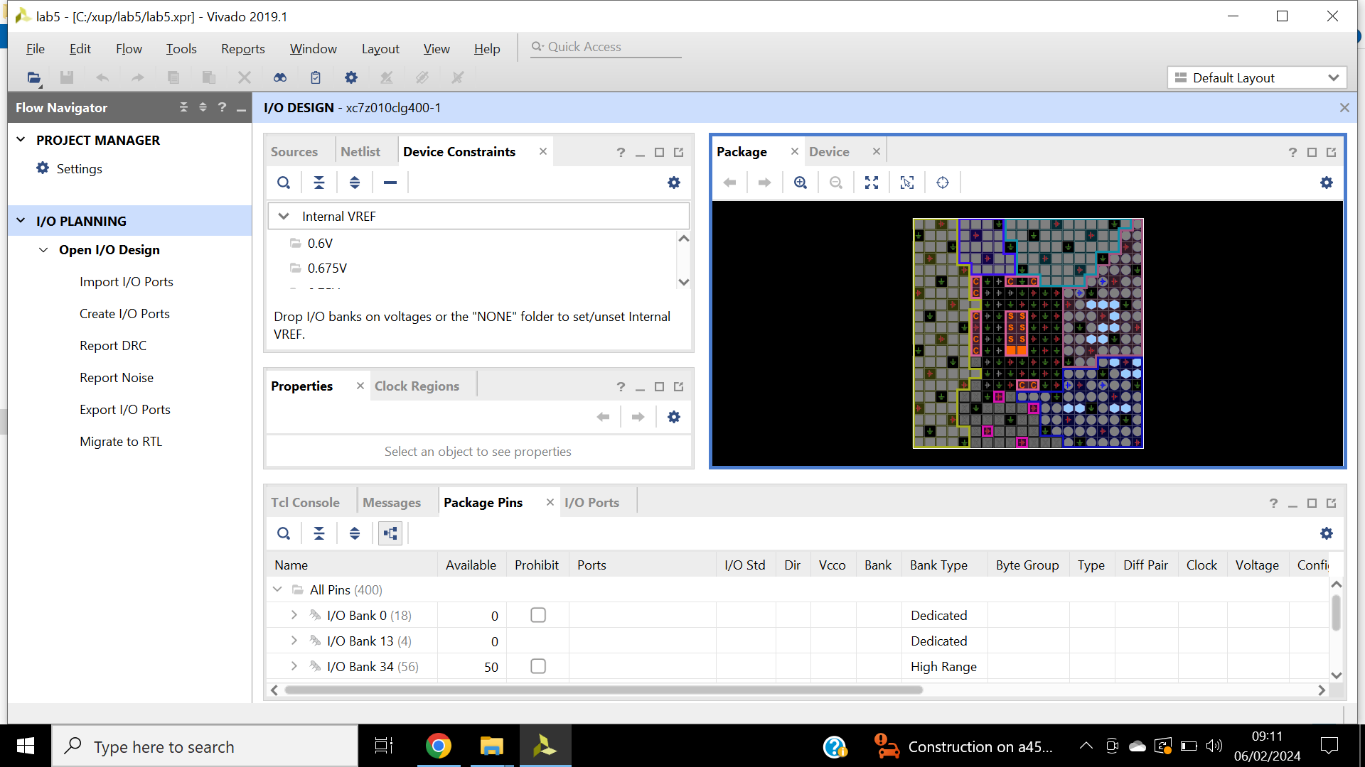 A new Vivado I/O project called lab 73 is created.

Figure 73: Device view window and package pins tab.

Step 2:

The clk_pin input port is created in figure 74, likewise, btn_pin and rst_pin input ports. Inputs pins K17, K18 and P16 location are assigned using the device view and package pins illustrated in figures 75 and 76.

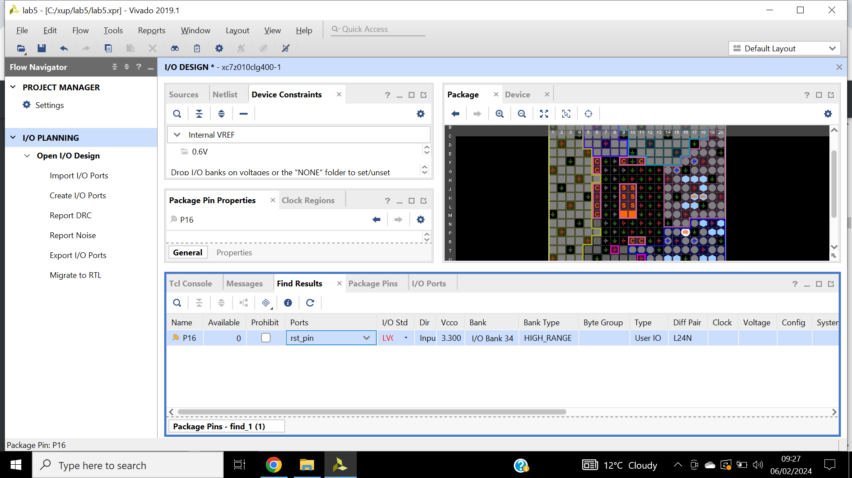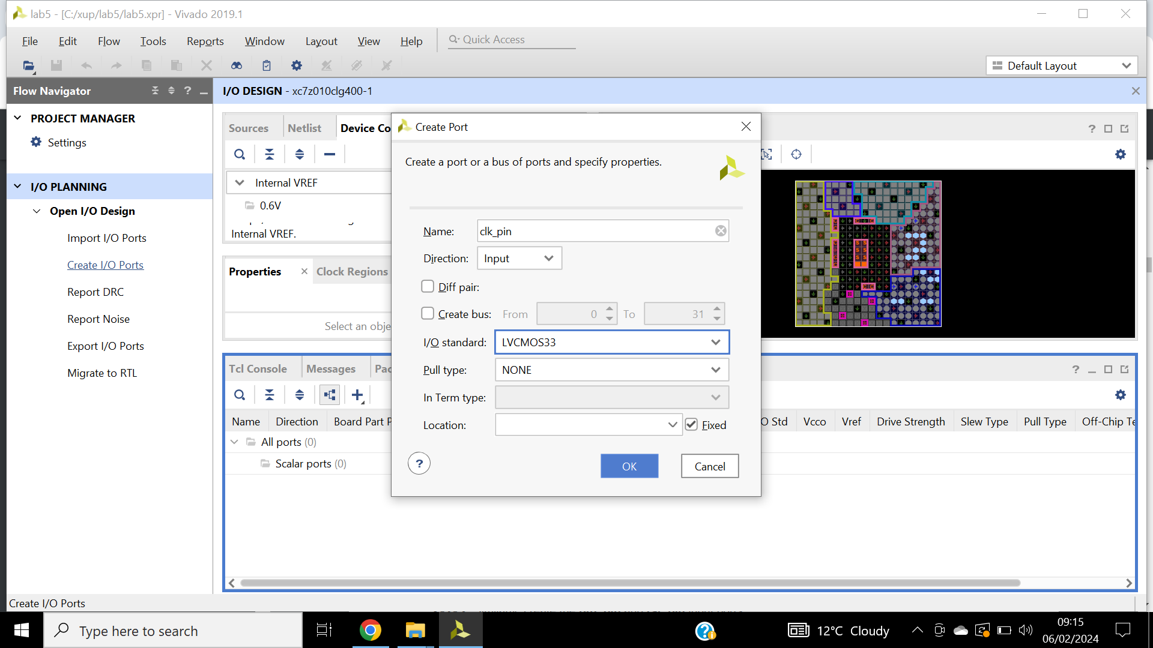

Figure 74: Find form, Package Pins, typed *P16 in match criteria and name rst_pin.

Figure 75: Creating I/O Port for clk_pin input. Changing the name field, I/O standard.

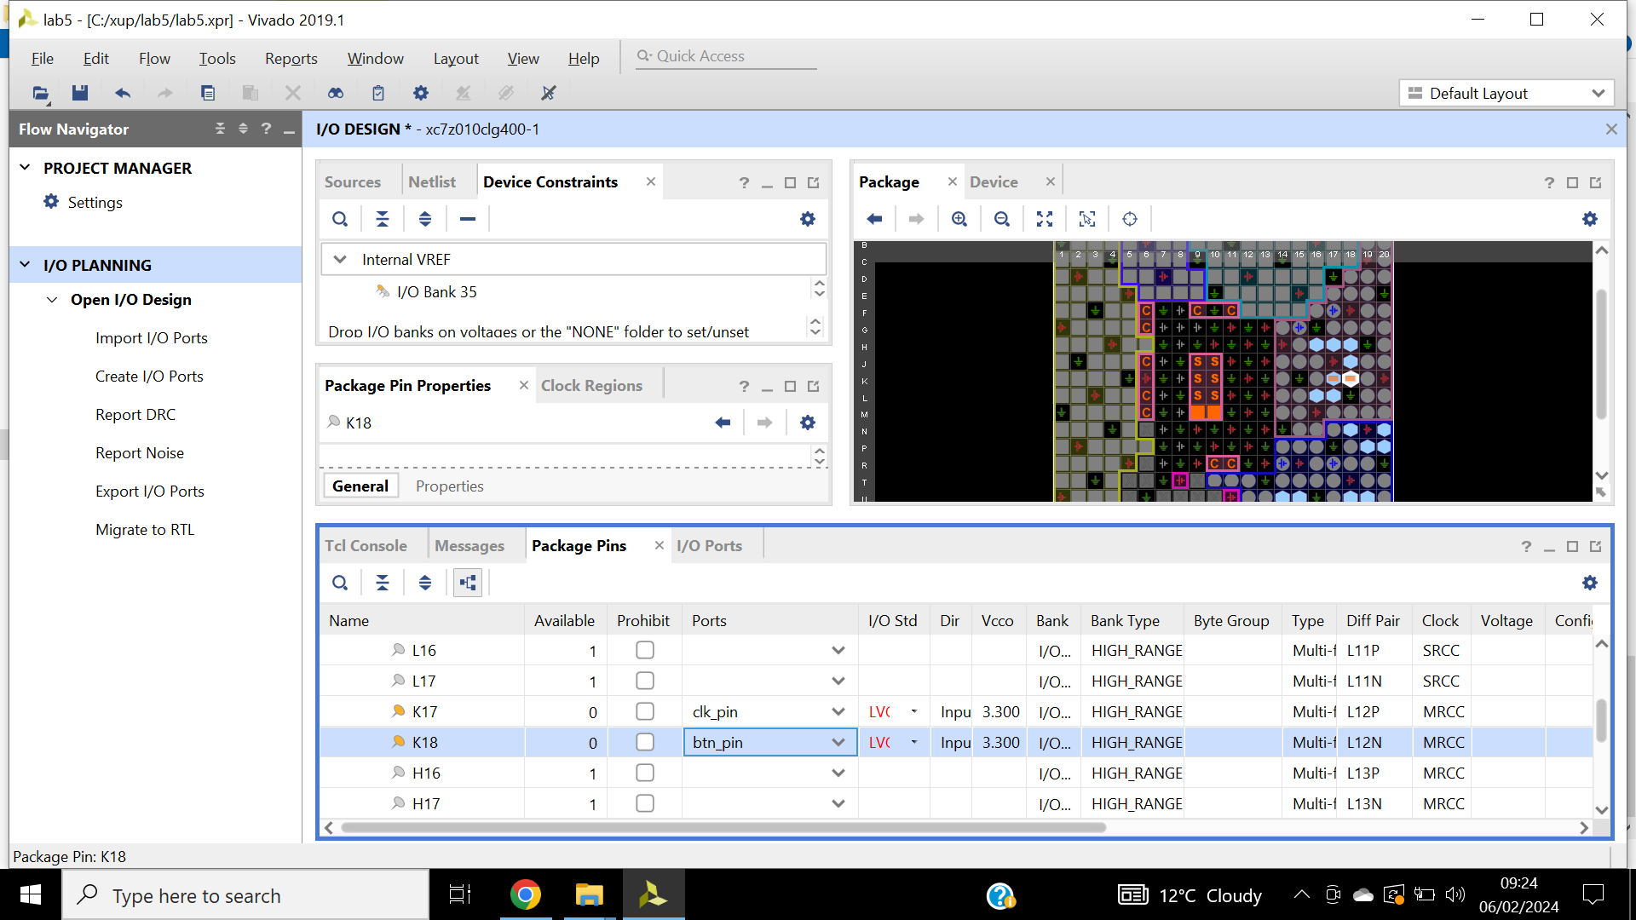

Figure 76: Pin entries shown in the Package Pins tab select clk_pin same for btn_pin.

Ports are created shown in figure 77. Outputs are assigned, depicted in figure 78. Constrain form is saved shown in figure 79. Figure 80 shows the updated source tab. Led_pins[3:0] are assigned to LEDs and led_pins[7:4] are assigned to PMOD JD.

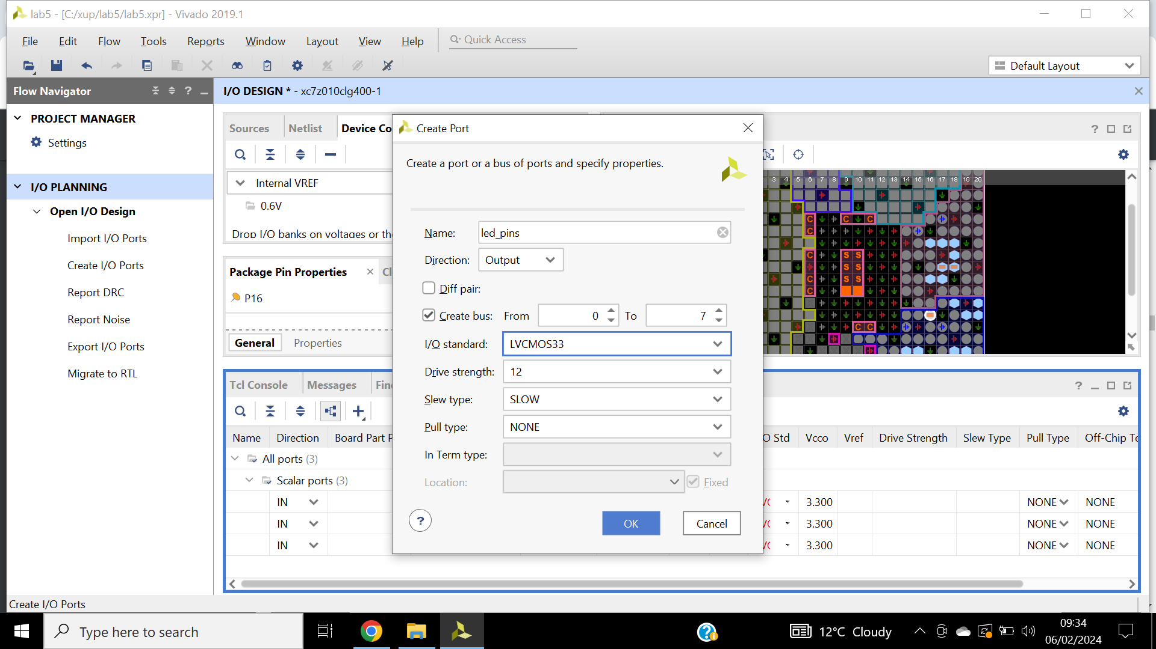

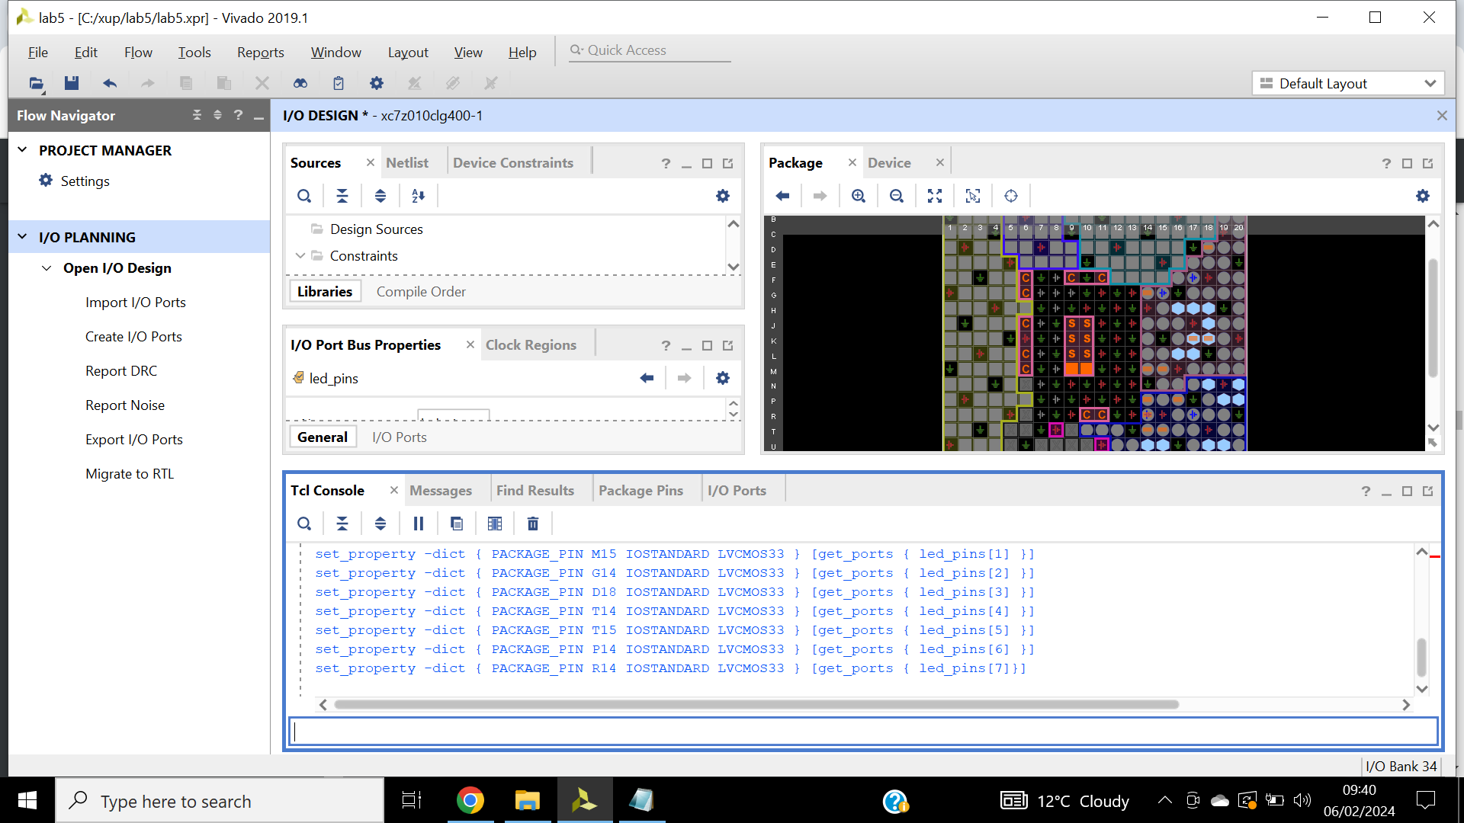

Figure 77: Assigning pin locations.

Figure 78: Create I/O ports form, led_pin will be displayed in the I/O tab.

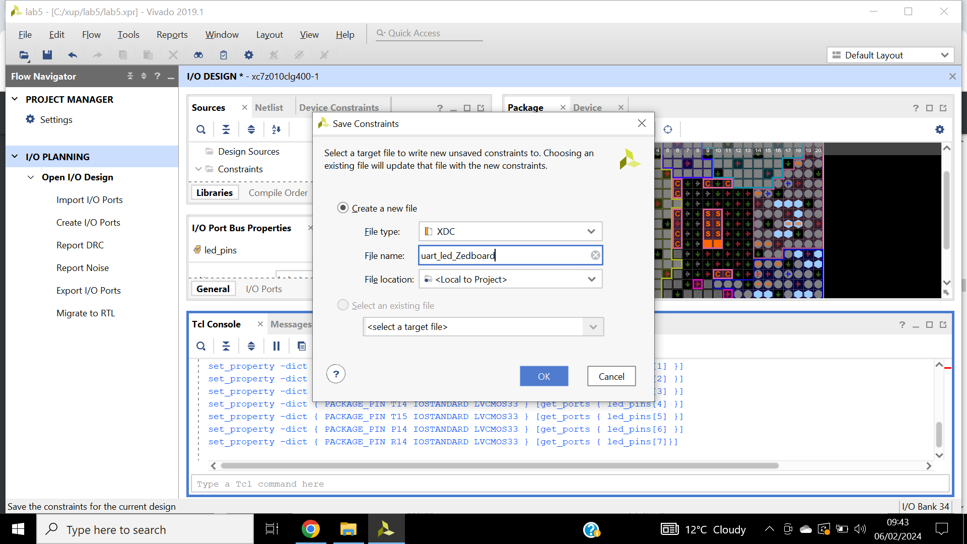

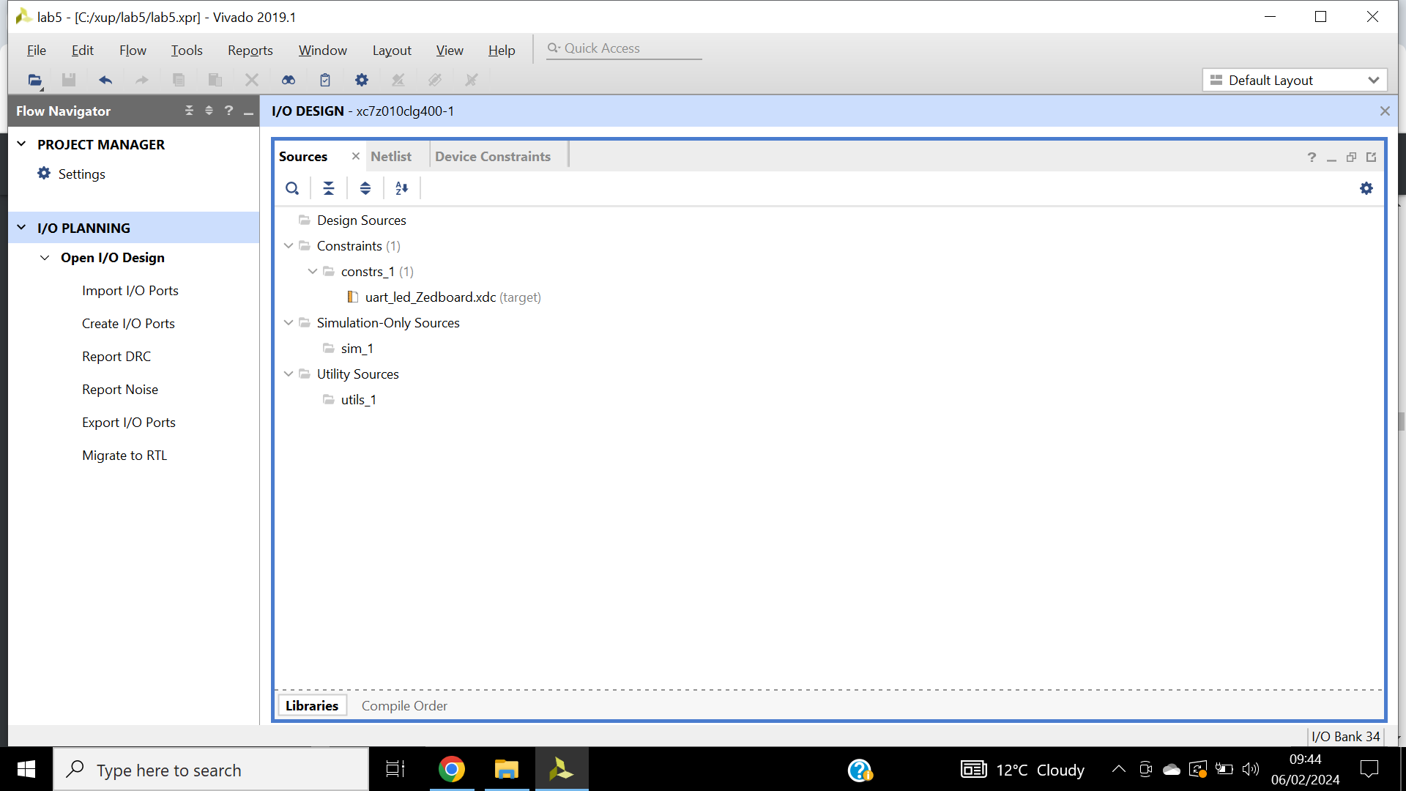

Figure 79: Save constraints form as uart_led_.

Figure 80: uart_led_.xdc file is created and added to the Sources tab.

Report DRC reports common issues and output illustrated in figure 81 and 82. Report noise output shown on figure 83. Pin locations are migrated to the RTL shown in figure 84.

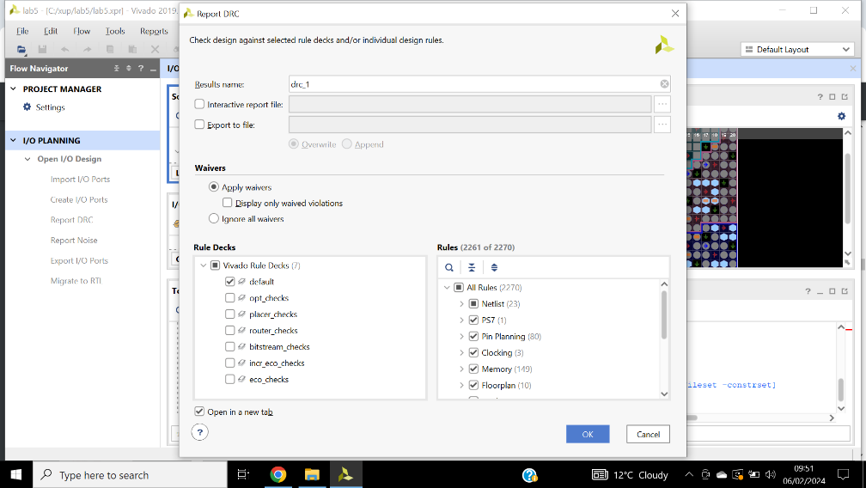

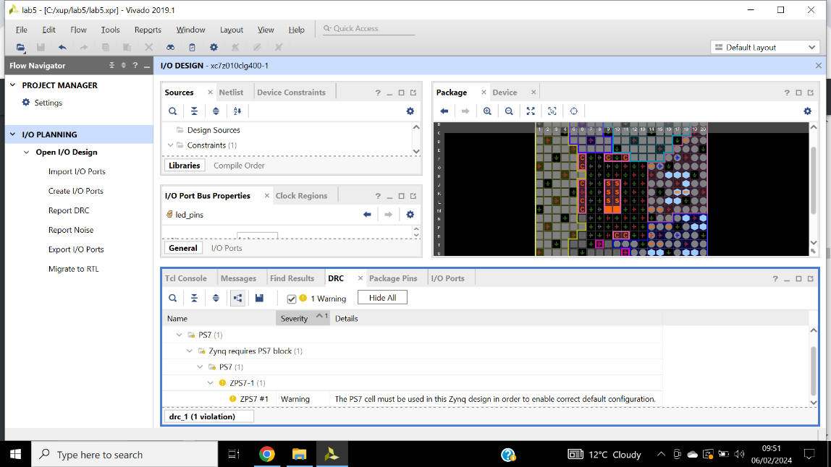

Figure 81: the design rules checker.

Figure 82: Report DRC, from the flow navigator pane under I/O planning. Ignore the warnings.

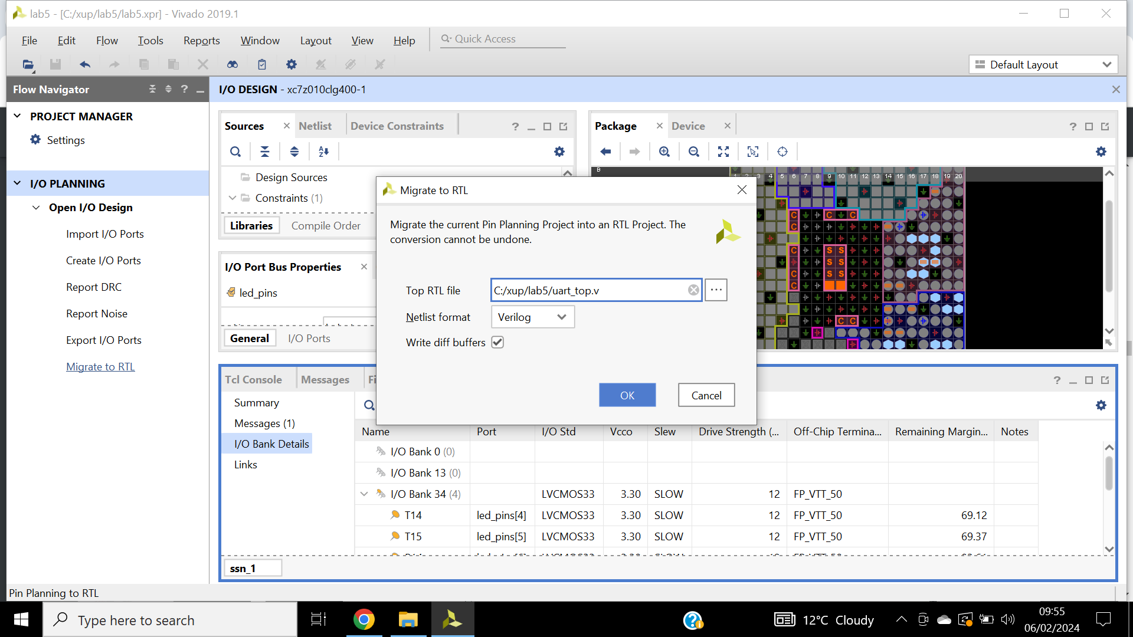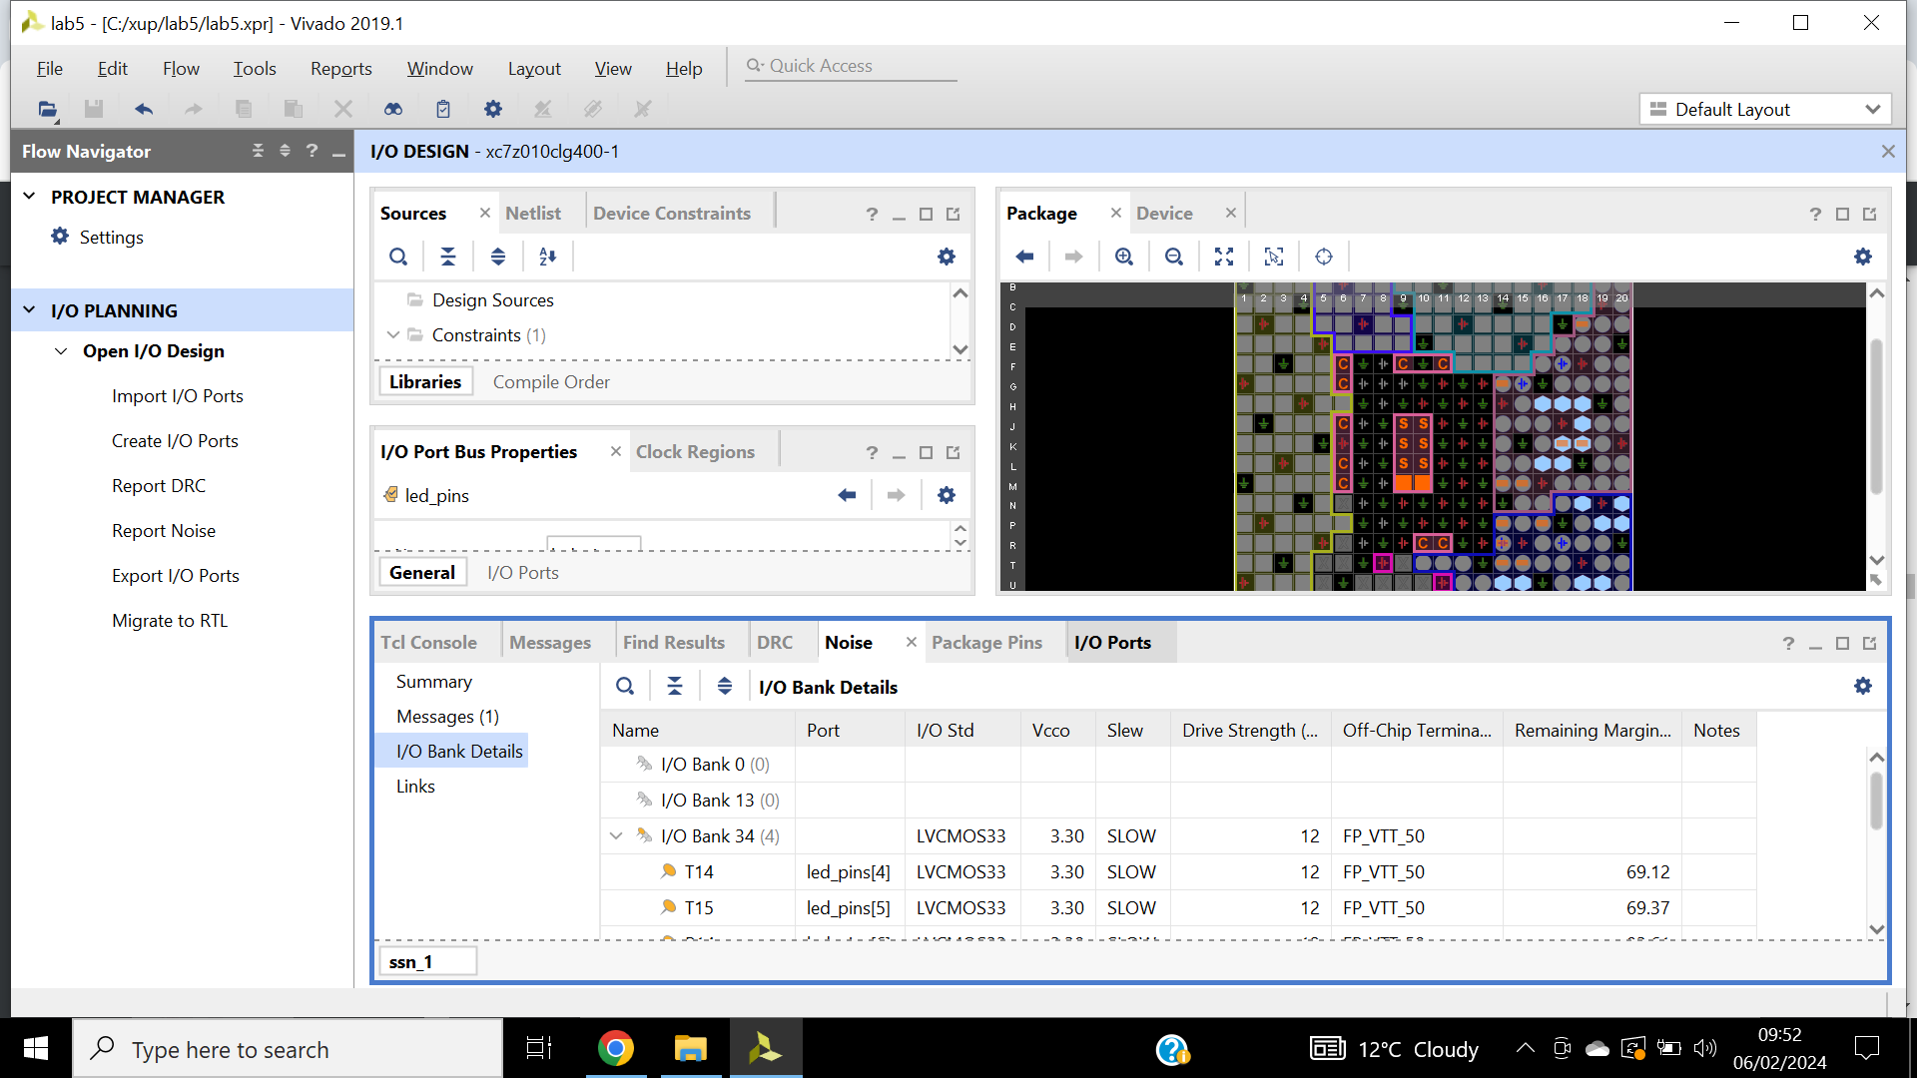

Figure 83: Report noise output, analysis is done on the output pins only (led_pins).

Figure 84: Migrating to RTL, changing top RTL file.

Uart_top.v and .v source files are added into the project illustrated in figure 85 and 86. Copy code from

uart_top.txt file into uart_top.v demonstrated in figure 87. 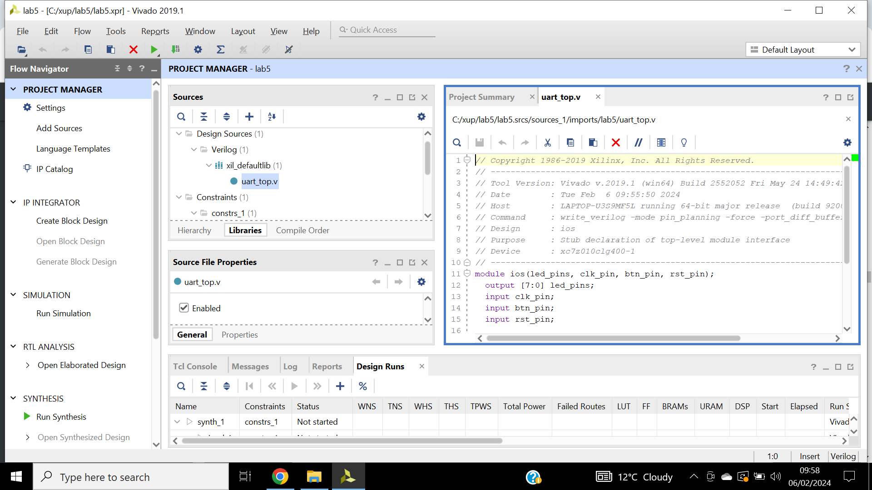

Figure 85: Uart_top.v file, module name with the ports listing.

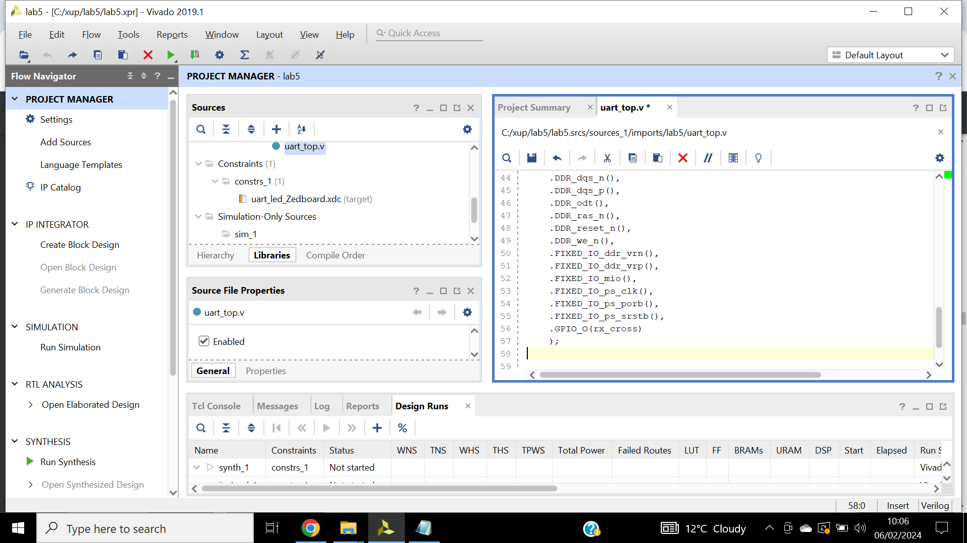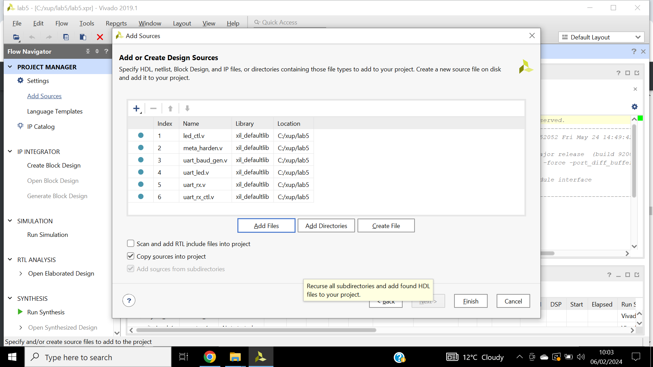

Figure 86: Changing uart_top.v file.

Figure 87: Adding source files.

Instantiating PS design depicted in figure 88. Uart_led file content is illustrated in figure 89.

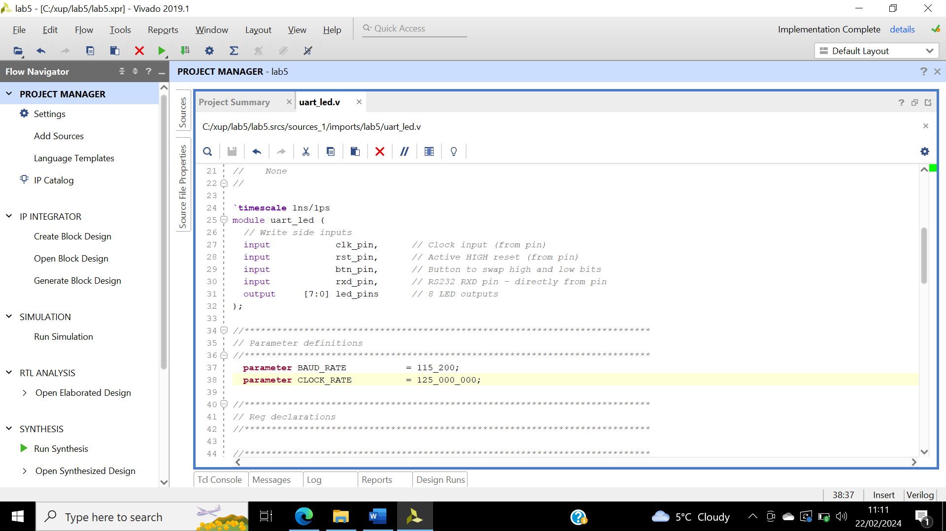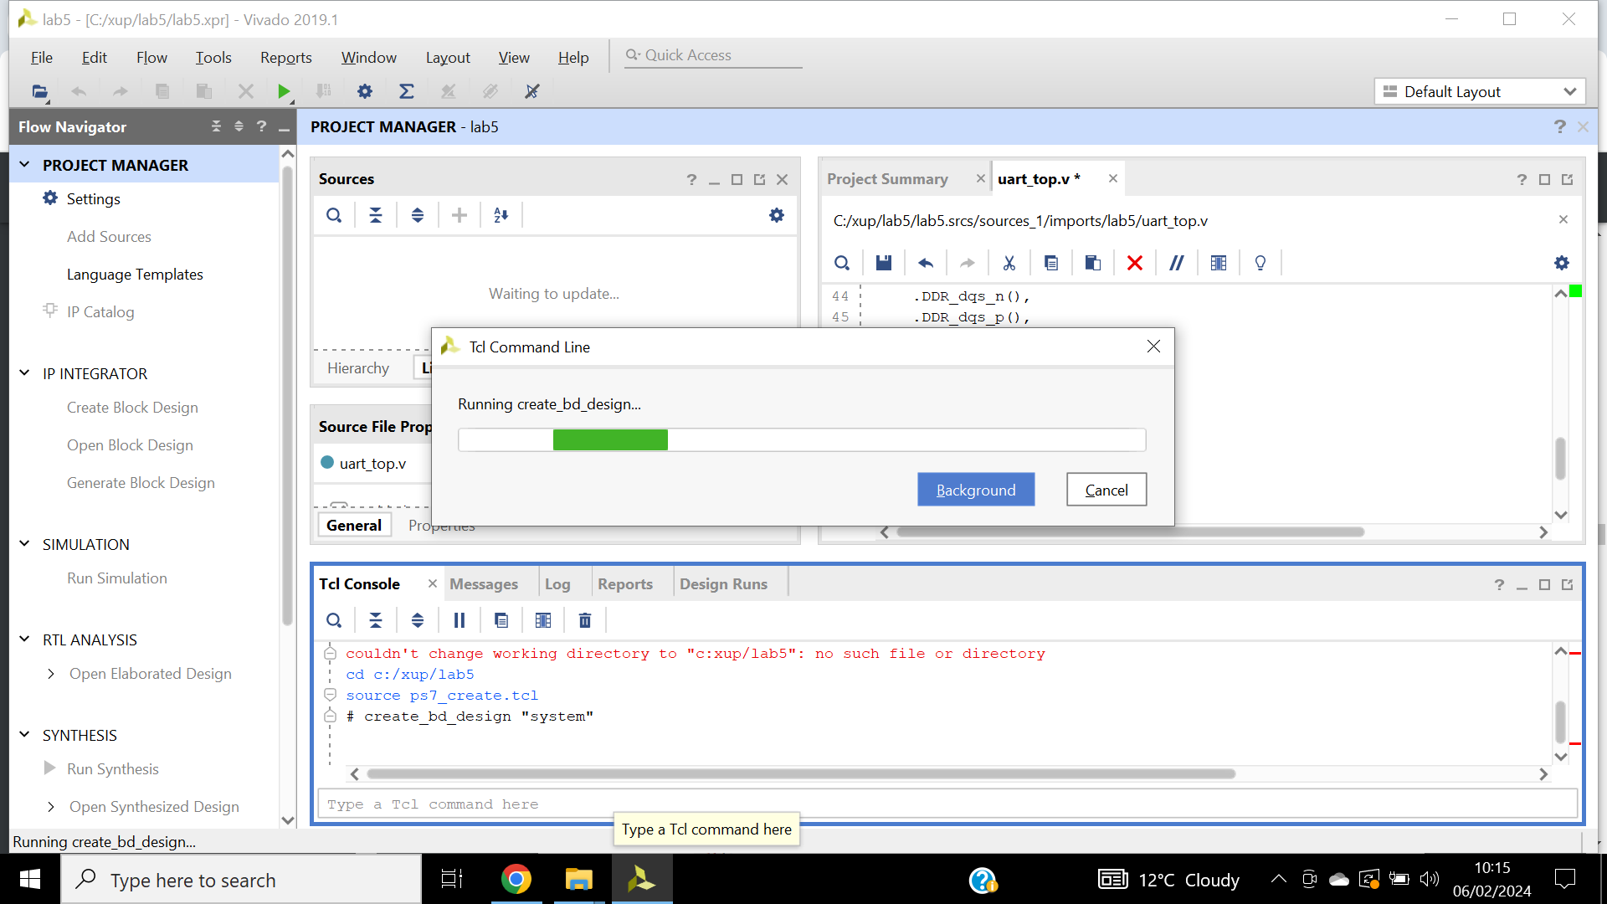

Figure 88: Changing the lab directory and generating the PS design.

Figure 89: Uart_led entry, changing clock_rate, on-board clock of 125 Mhz.

Step 3:

Synthesis is complete. The constraint window identifies the missing timing constraints depicted in figure 90.

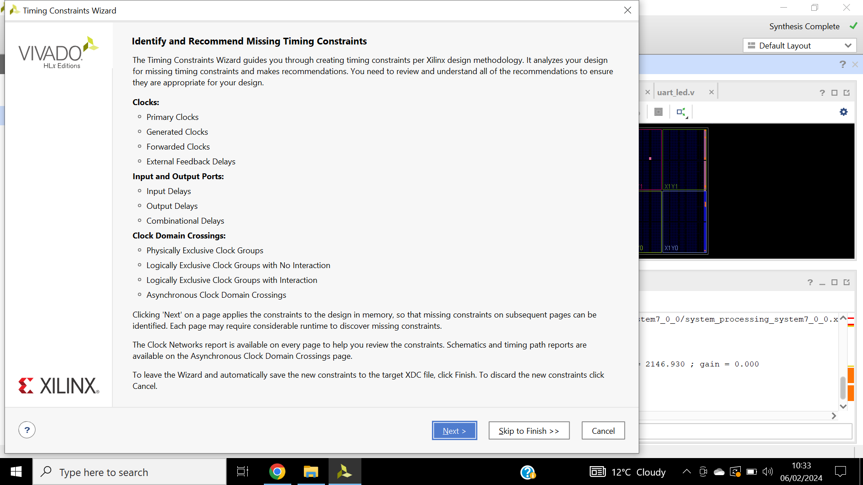

Figure 90: Timing wizard missing constraints.

Figure 91 and 92 shows the wizard identified input and output delays for the pins. Wizard generated clk_pin constraints for 8ns period, 7 new constraints instantiation shown in figure 93.

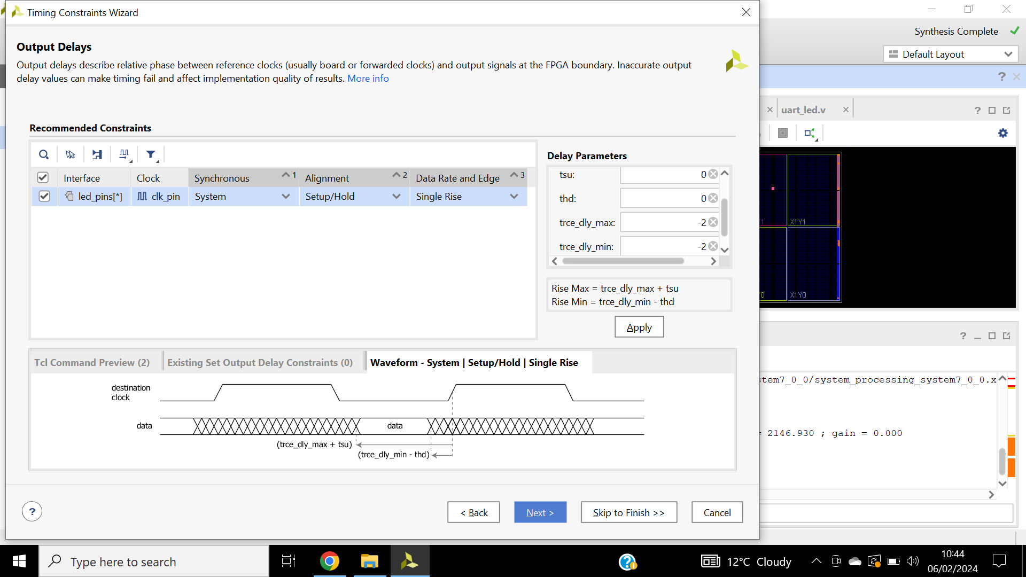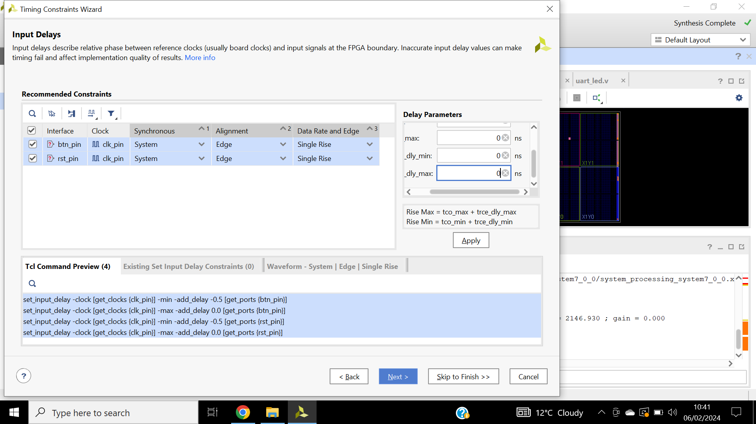

Figure 91: Output delays, of -2ns for timing closure.

Figure 92: Input delays for btn_pin and rst_pin- tco min is -0.5.

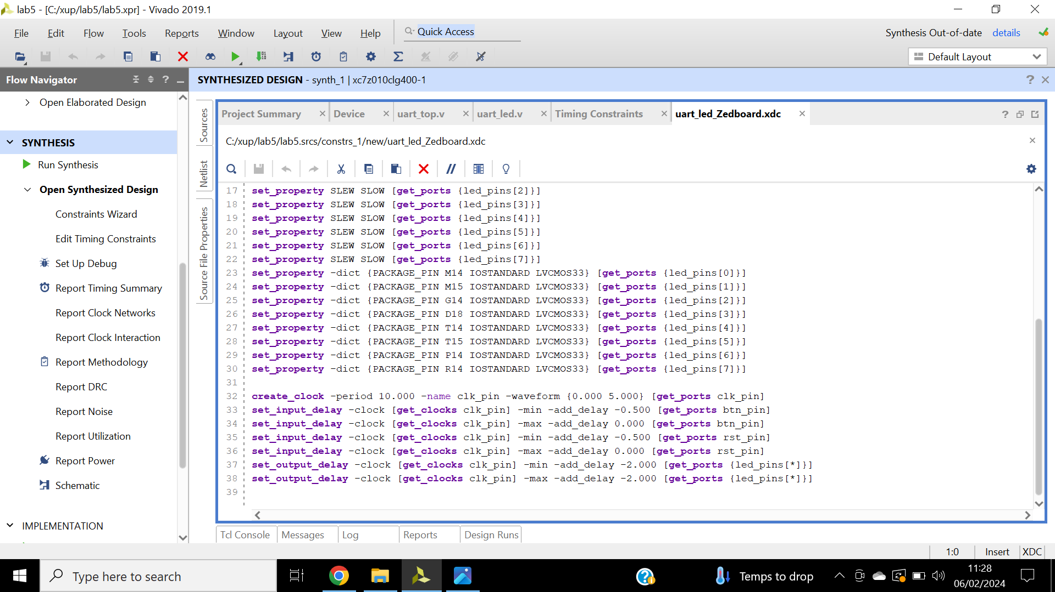

Figure 93: Uart_led_.xdc, additional constraints added.

Step 4:

Implementation is complete. Report timing summary is generated, failing paths are seen. Constraints are applied via TCL console, figure 94. Implementation is run again, no more failing paths, figure 95.

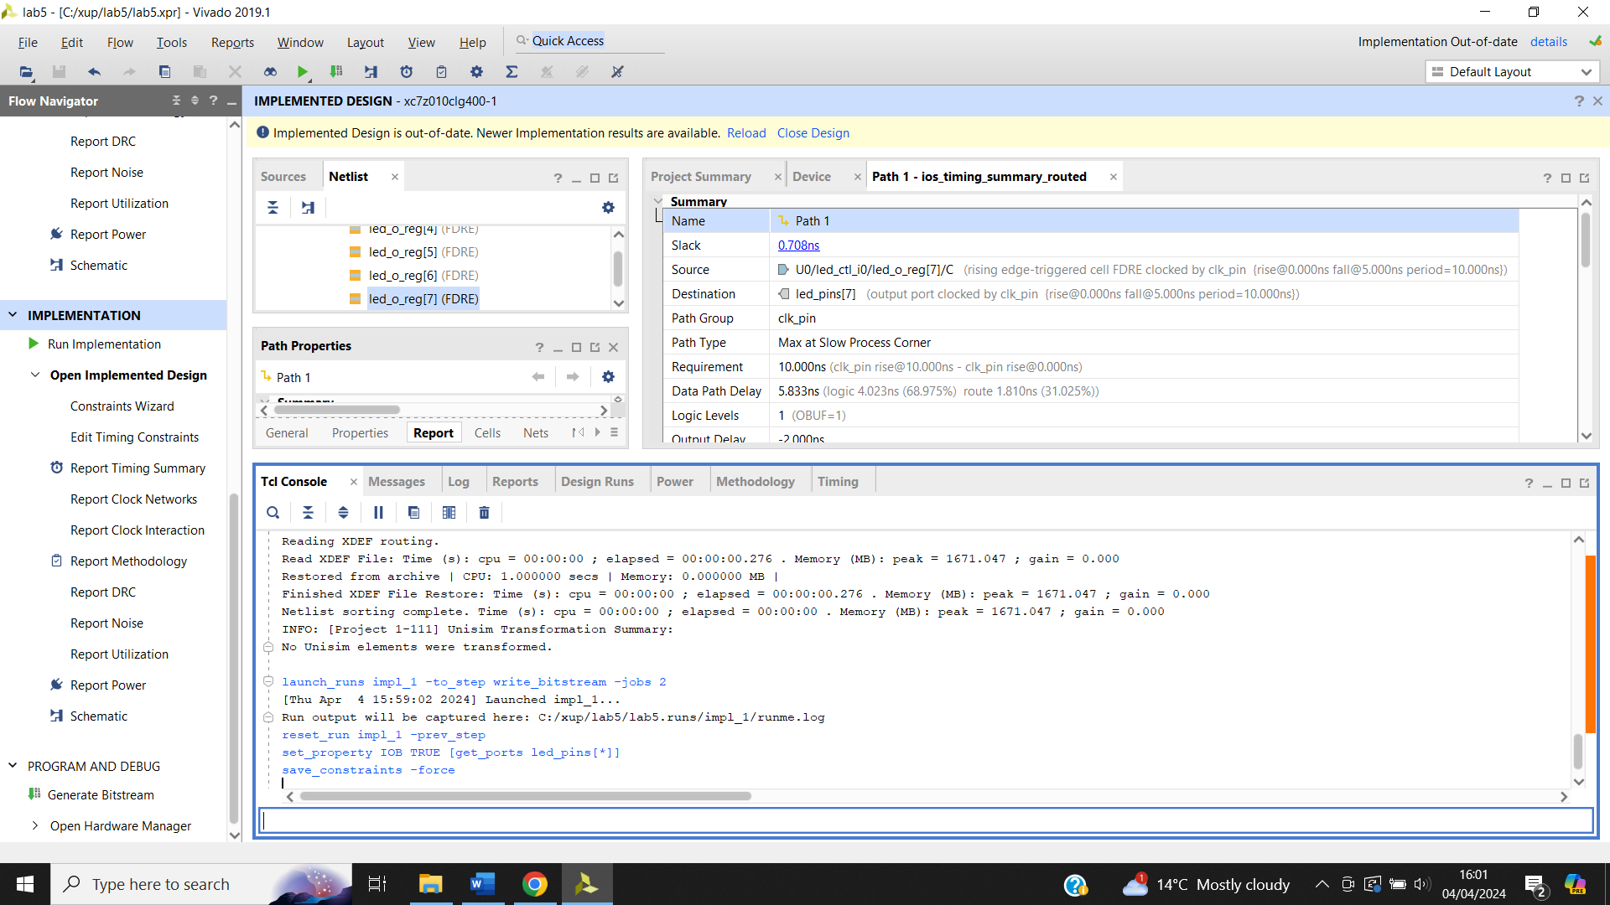

Figure 94: Tcl console constraints.

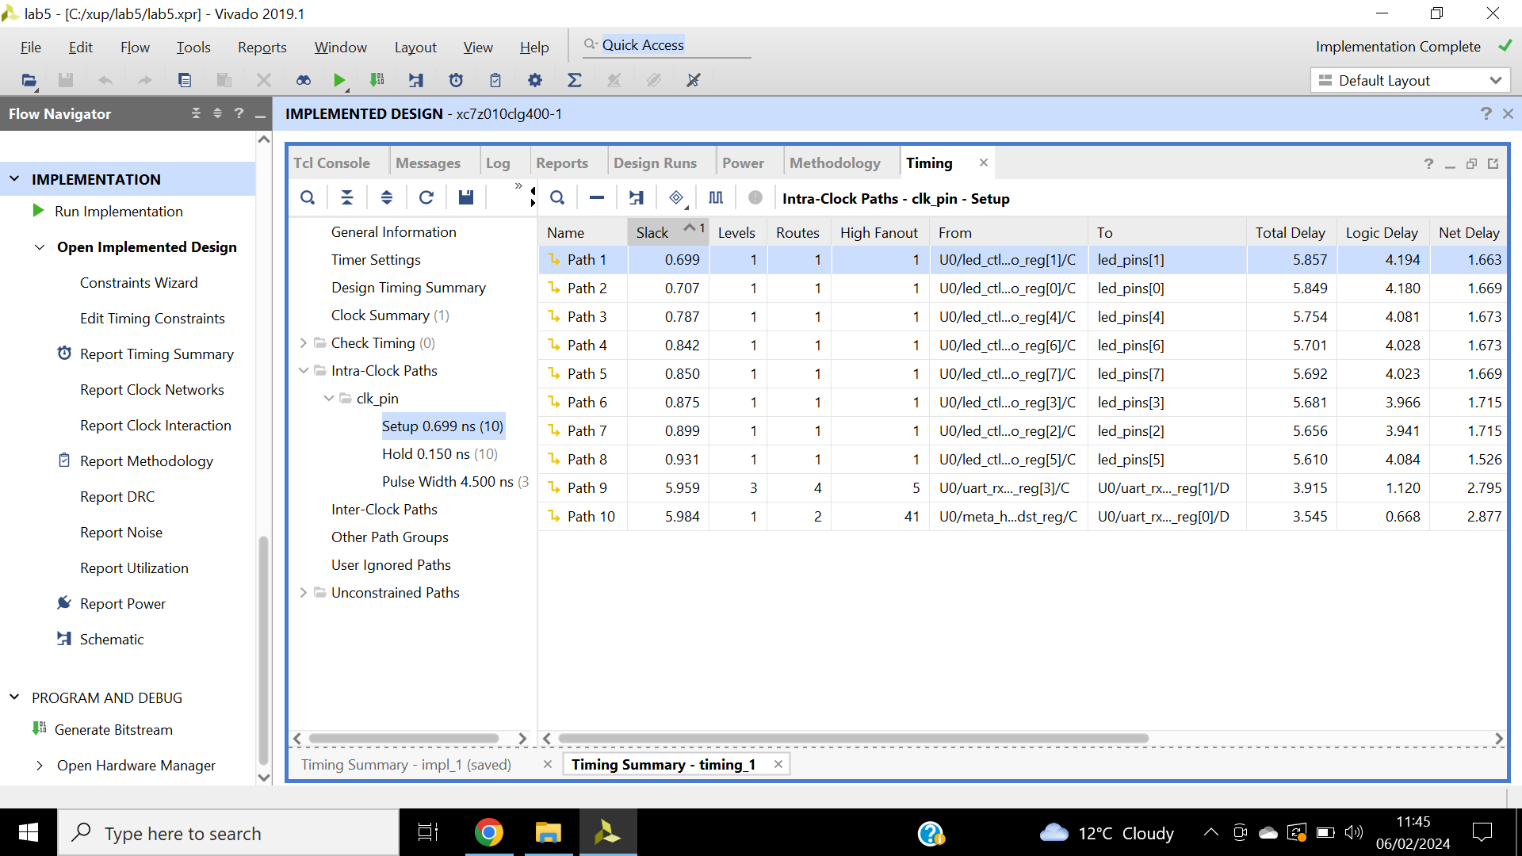

Figure 95: No more failing paths.

Step 5:

Bitstream is generated, board is connected, and device is programmed.

SDK is launched, launch on hardware depicted in figure 96. Functionality is verified by typing characters into the terminal, LED is viewed for output shown in figure 97.

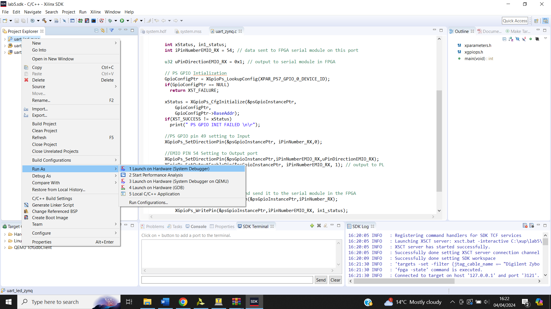

Figure 96: Right click on uart_led_zynq.

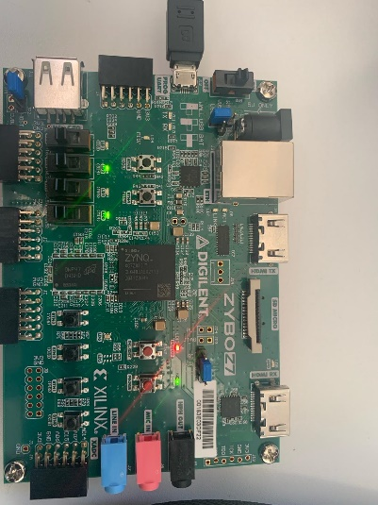

Figure 97: LED character ‘p’.

## **Conclusion**

This lab introduced creating I/O planning projects as well as pin assignments through device view, package pin tabs and tcl commands. Then added the provided source file to the rtl project that was exported and established timing constraints. Post synthesis and implementation timing analysis to validate the design functionality. The use of I/o planning projects have a range of benefits such as flexible design placement, resource utilization as there’s control over placement of I/O decreasing route delay. Also, helps achieve timing closure, by ensuring the critical timing paths meets the required timing constraints.

# **References**

1. Intel (2008). Understanding Metastability in FPGAs. *Altera Corporation*. <https://doi.org/file:///C:/Users/sfiqo/Downloads/wp-01082-quartus-ii-metastability.pdf>